**Phase 1: Planning the design and estimating cost**

Task 1.1: Create an architecture diagram

* Amazon Virtual Private Cloud (Amazon VPC)
* Amazon EC2: Instances, Application Load Balancer, target groups
* AWS CodeCommit: Repository
* AWS CodeDeploy
* AWS CodePipeline: Pipeline
* Amazon Elastic Container Service (Amazon ECS): Services, containers, tasks
* Amazon Elastic Container Registry (Amazon ECR): Repository
* AWS Cloud9 environment
* AWS Identity and Access Management (IAM): Roles
* Amazon Relational Database Service (Amazon RDS)
* Amazon CloudWatch: Logs

Task 1.2: Develop a cost estimate

使用 [AWS Pricing Calculator](https://calculator.aws.amazon.com/) 来估算你这个架构一整年在 **us-east-1 区域** 运行 12 个月的费用。

**Phase 2: Analyzing the infrastructure of the monolithic application**

Task 2.1: Verify that the monolithic application is available

Open the EC2 and find the public address for the web page use <http://44.203.52.17/> to check.

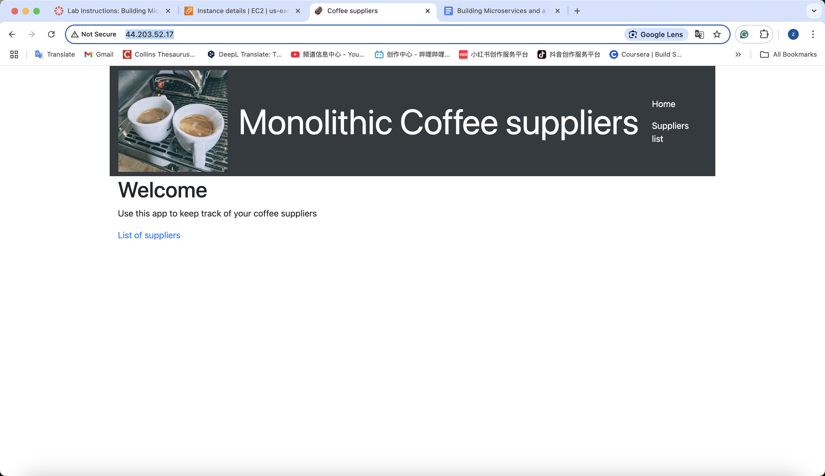

Task 2.2: Test the monolithic web application

First, choose suppliers list link to new page, and punch add a new supplier button to add. After added, edit it and save the change.

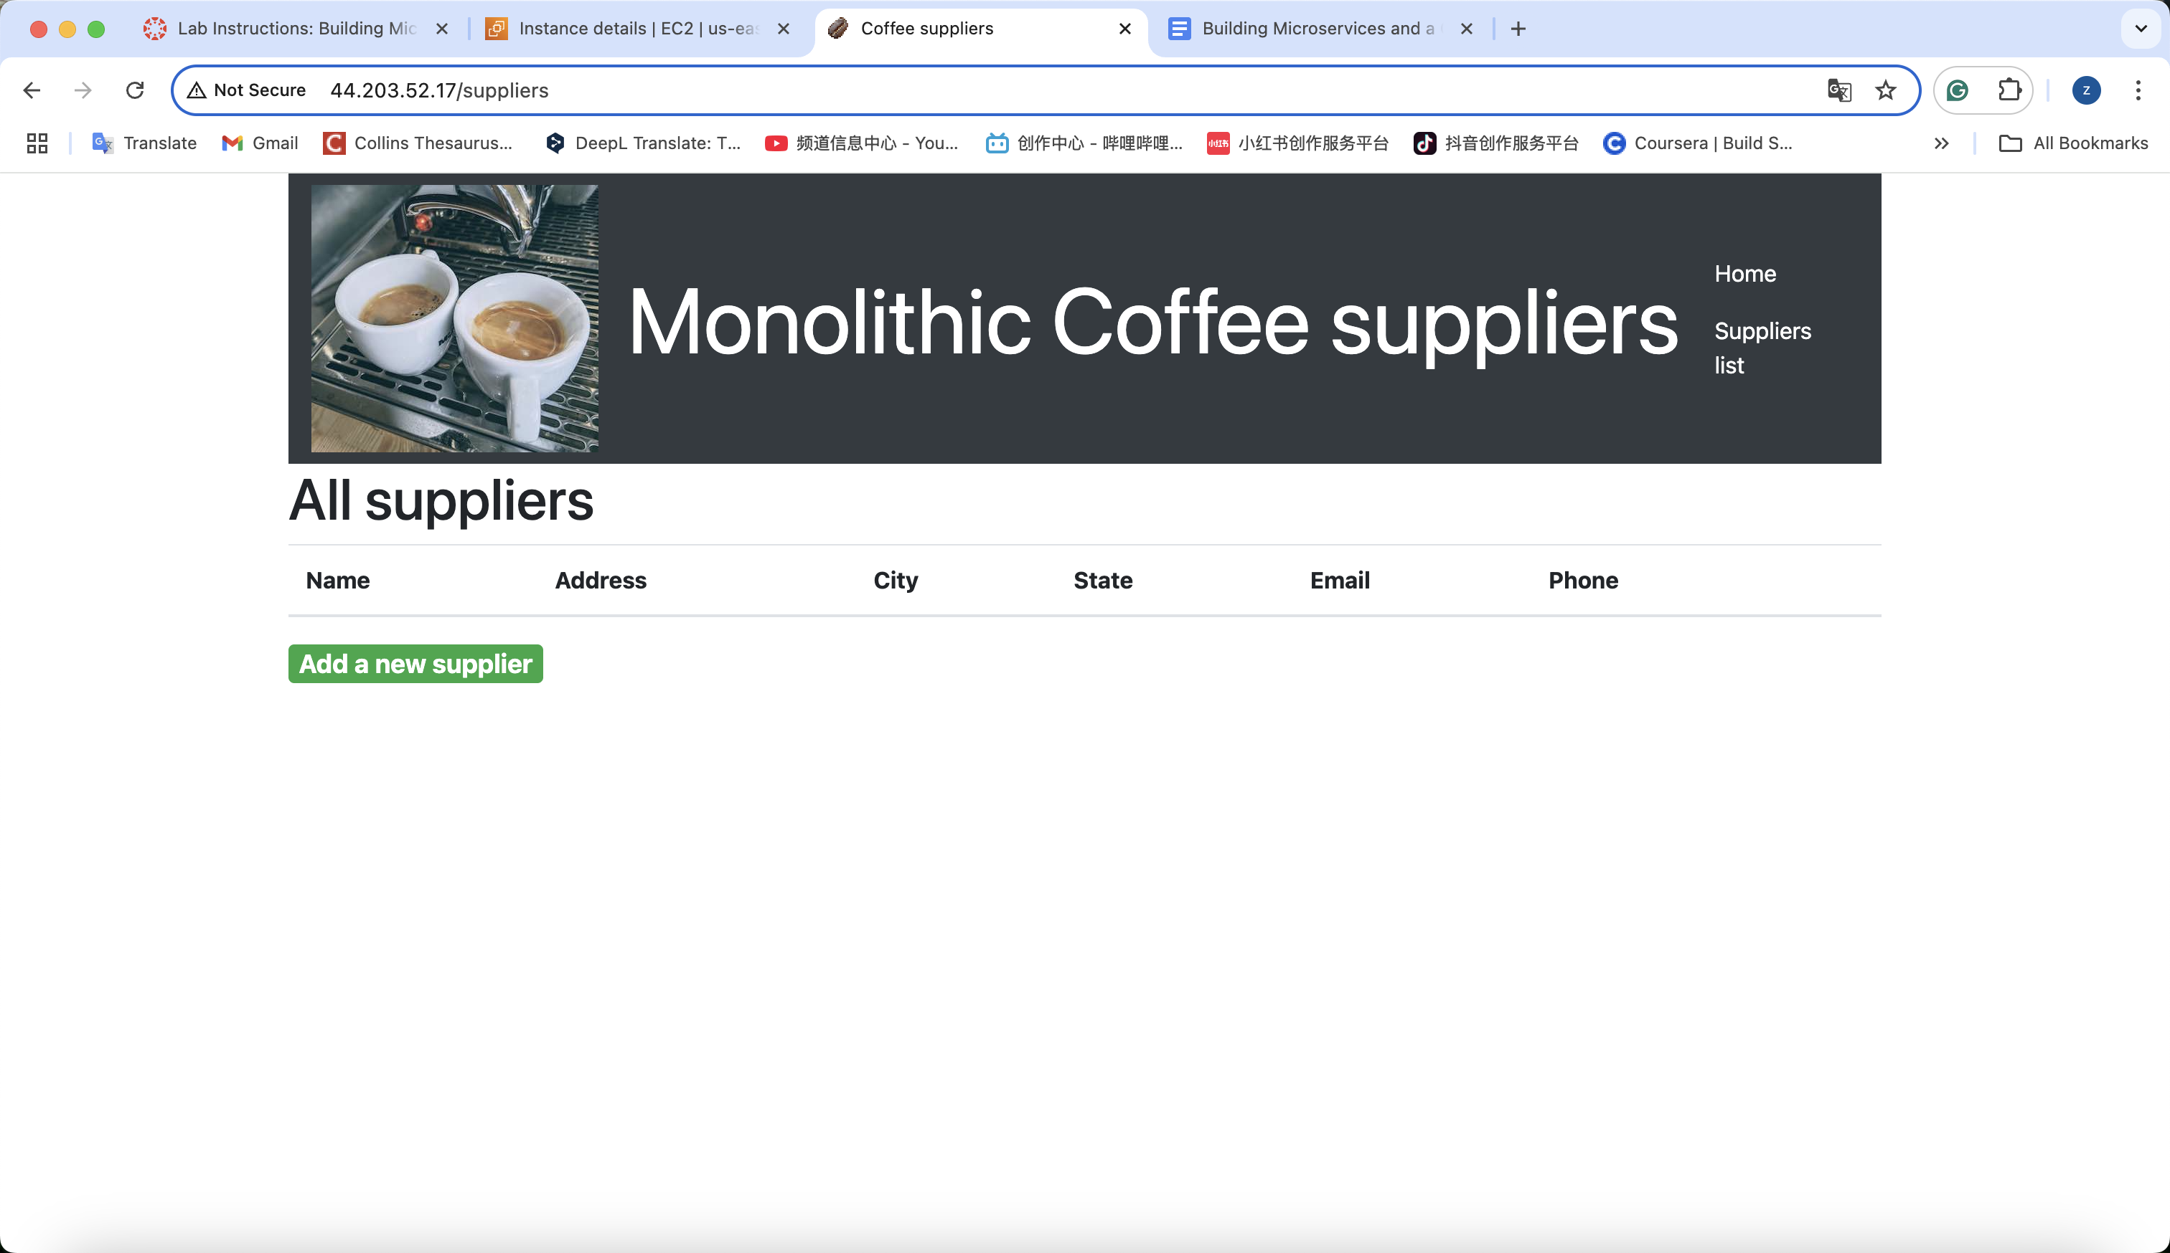

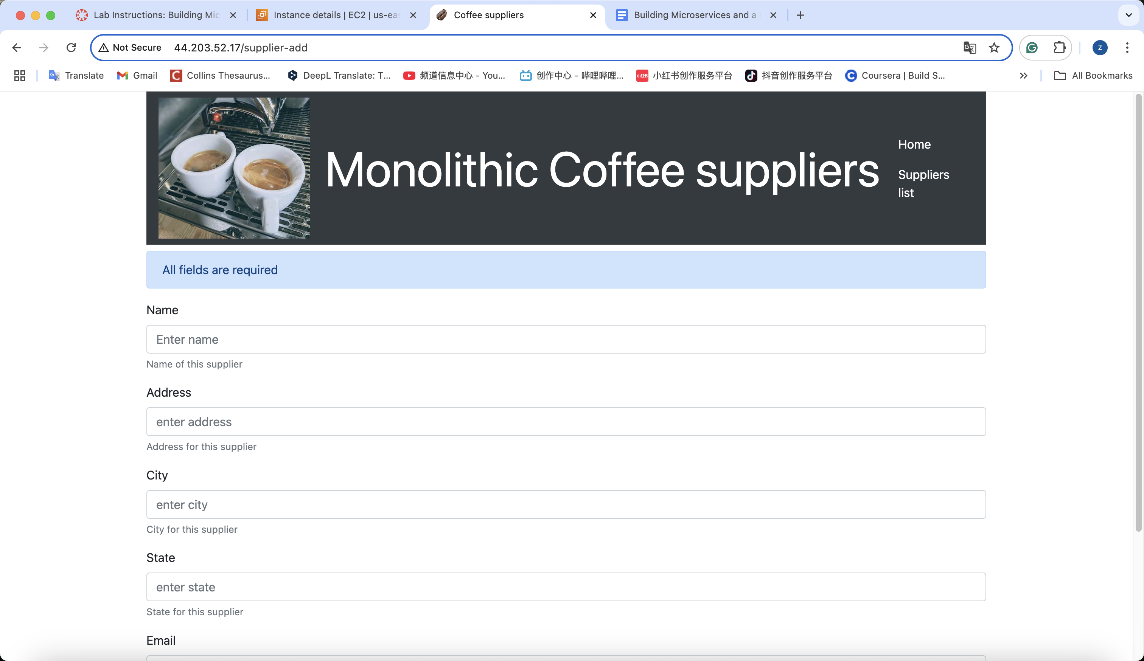

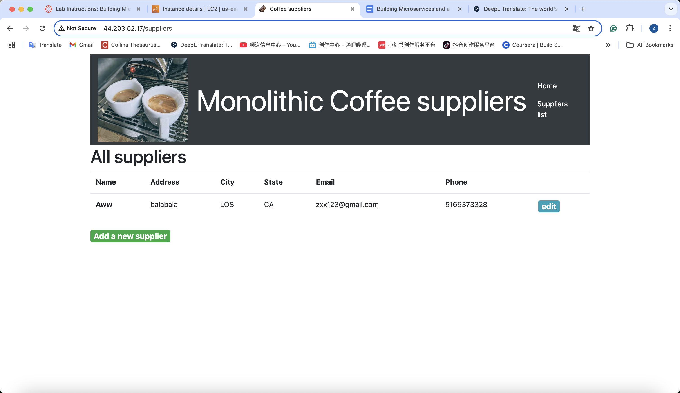

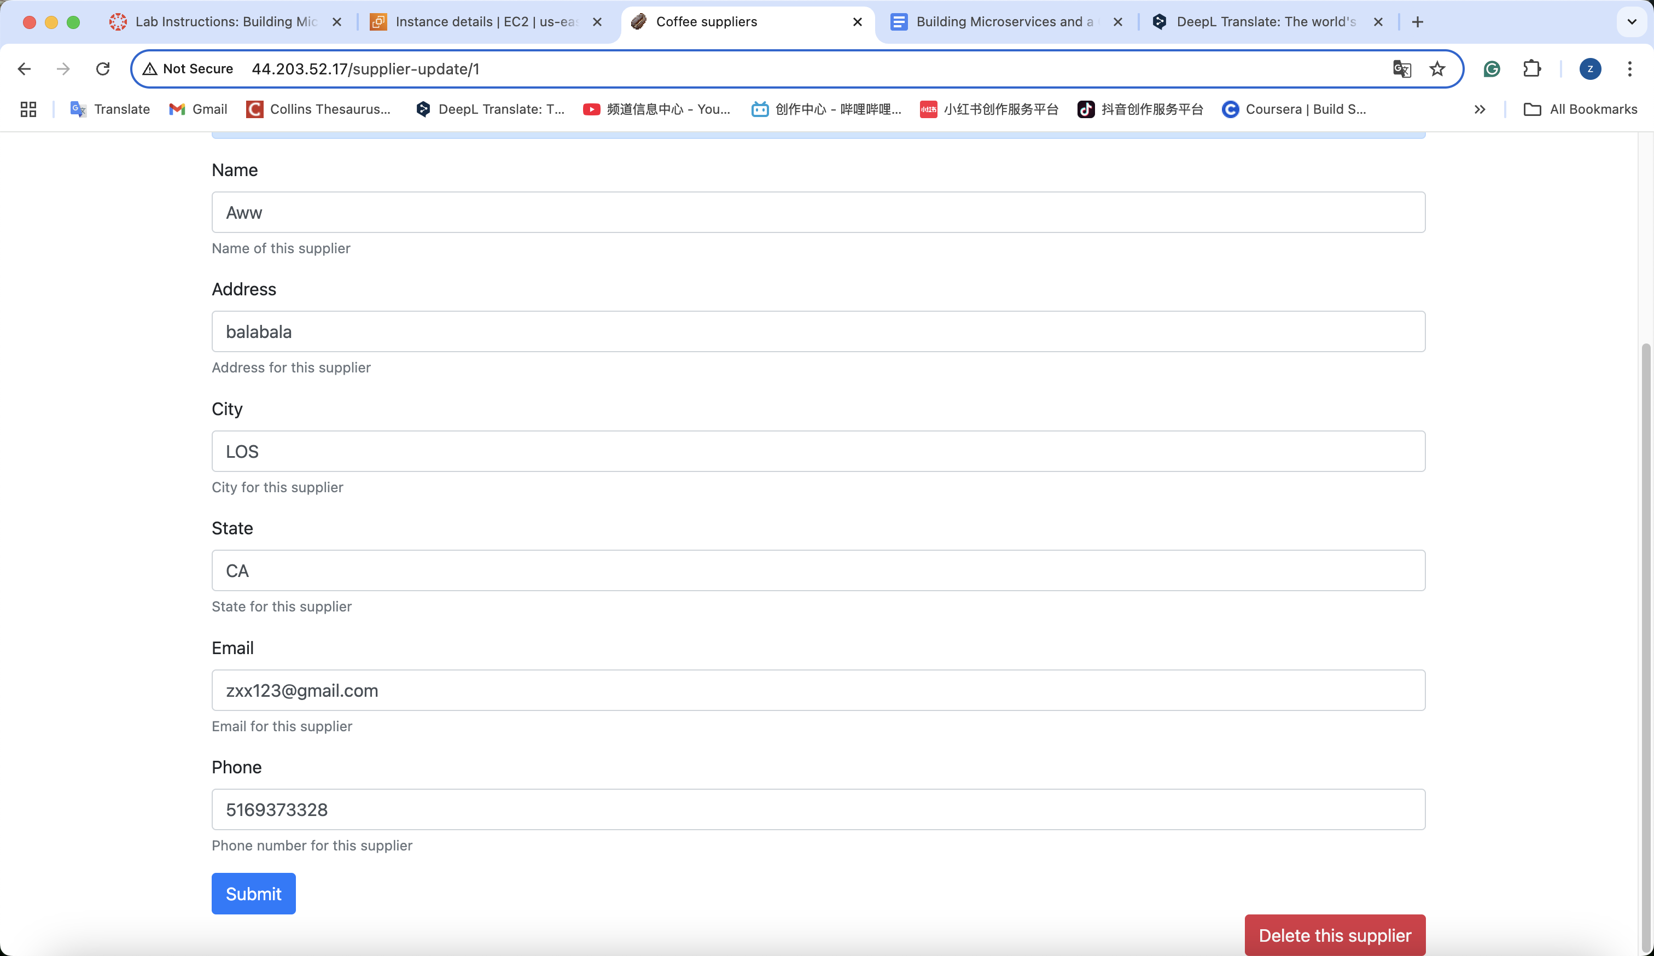

Task 2.3: Analyze how the monolithic application runs

First, connect it and go terminal page



What did you notice in the command output? What port and protocol is the *node* daemon using?  
After use sudo lsof -i :80,

It show the node.js is using 80 to hearing this position.

Then, ps -ef | head -1; ps -ef | grep node,



What did you notice in the command output? Which user on this EC2 instance is running a *node* process? Does the node process ID (PID) match any of the PIDs from the output of the command that you ran before the last one?

The first line is same PID with former requeset. It show the node index.js is using.

And the second line is the order I just use.

Then, cd ~/resources/codebase_partner

Ls to check the structure of source code.



**Questions for thought:** Based on what you have observed, what can you determine about how and where this node application is running?

The Node.js application is running on an **Amazon EC2 instance** named *MonolithicAppServer*. The process is managed by the root user and running the file index.js. It was likely started automatically through a system script (e.g., systemd or rc.local), which is why its parent process is PID 1.

How do you think it was installed?

package.json, package-lock.json, node_modules folder. This strongly suggests that the application was installed using **Node Package Manager (npm)**.

What prerequisite libraries, if any, were required to make it run?

The application depends on **Node.js** and several Node libraries listed in package.json

Where does the application store data?

The application does **not** store data locally on the EC2 instance. Instead, it connects to an **Amazon RDS MySQL database**, as mentioned in earlier instructions. The data is stored in a **database named COFFEE**, and one of its tables is suppliers.

Afterward, we need to connect a MySQL client to the RDS database.

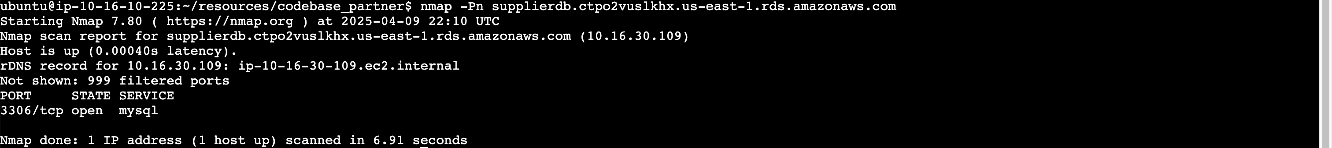

Then in to the MySQL.

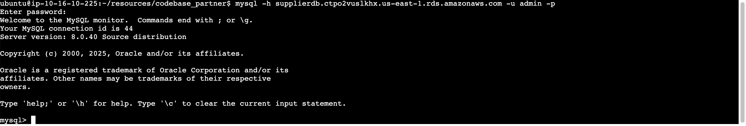

Observe the data in the database

SHOW DATABASES;

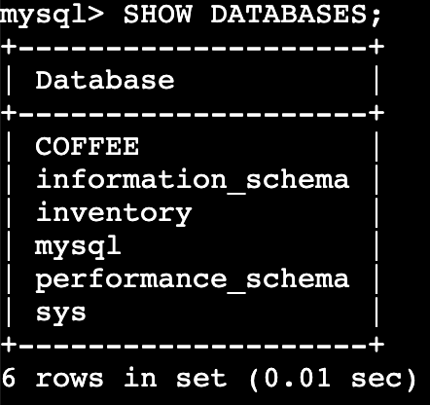

USE COFFEE;

SHOW TABLES;

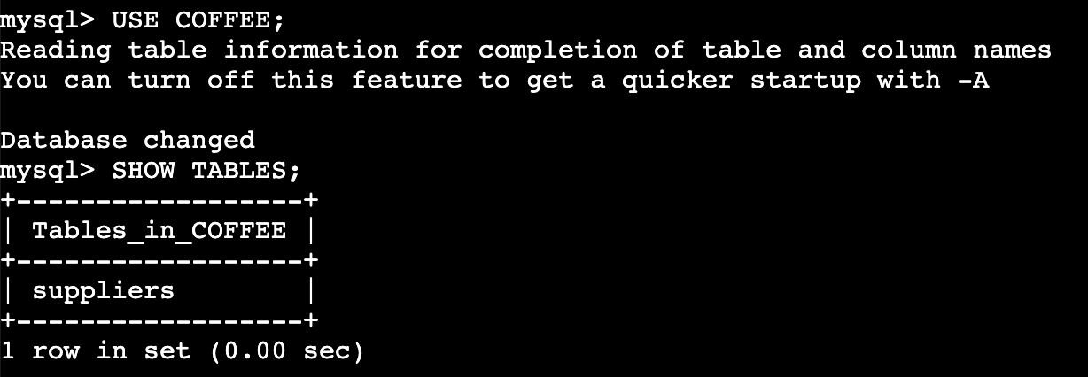

SELECT * FROM suppliers;

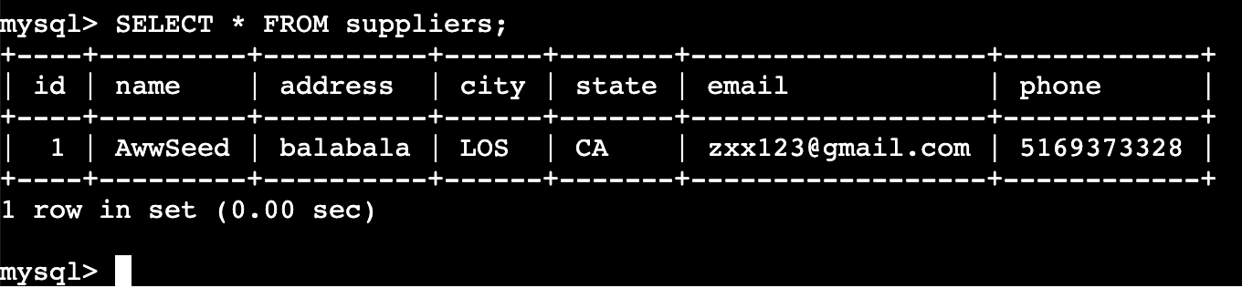

Phase 3: Creating a development environment and checking code into a Git repository

Task 3.1: Create an AWS Cloud9 IDE as your work environment

We need to build a C9 environment.

named MicroservicesIDE and then open the IDE.

It should run as a new EC2 instance of size *t3.small* and run Amazon Linux 2. The instance should support SSH connections and run in the *LabVPC* in *Public Subnet1*.

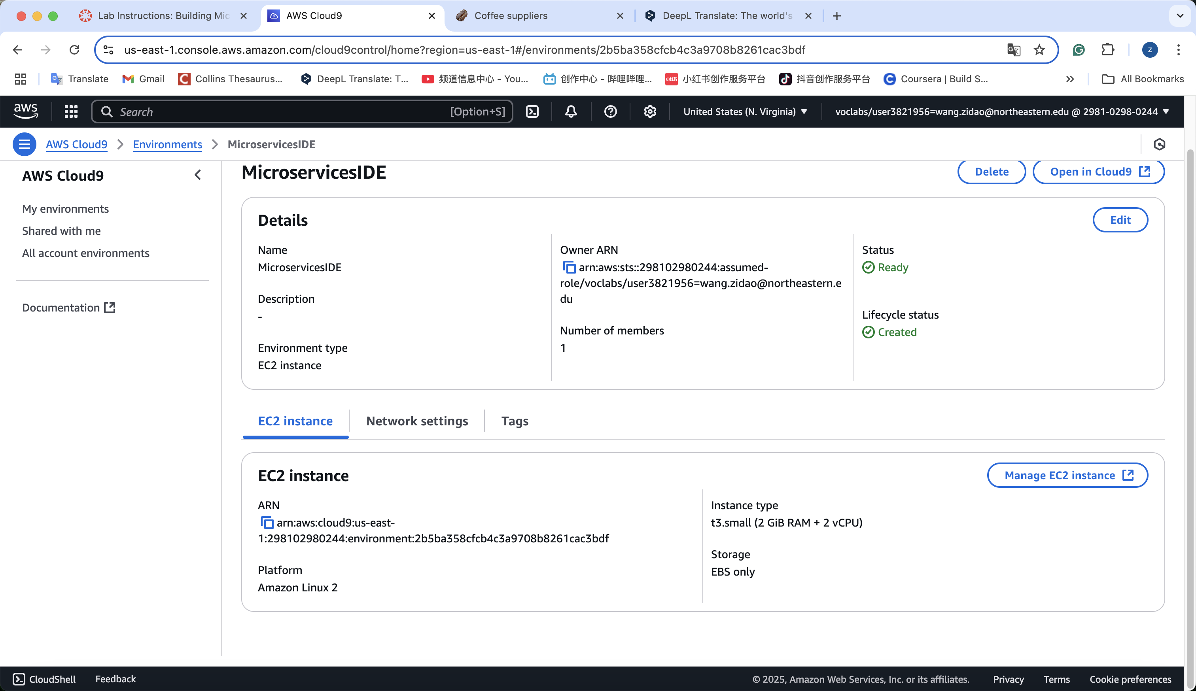

**Task 3.2: Copy the application code to your IDE**

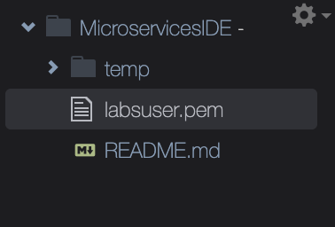

Private IP4: 10.16.10.225

And scp -r -i ~/environment/labsuser.pem ubuntu@10.16.10.225:/home/ubuntu/resources/codebase_partner/* ~/environment/temp/

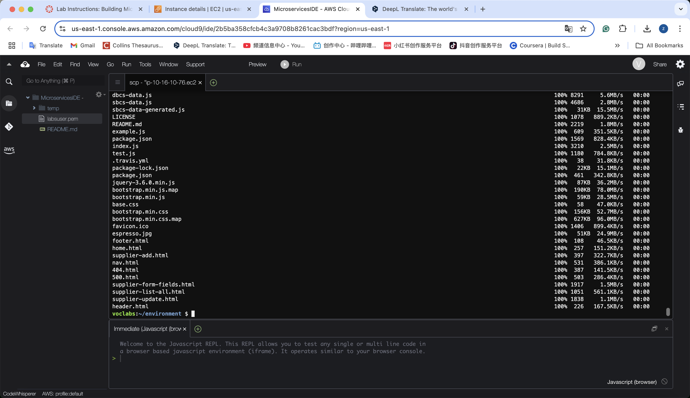

**Task 3.3: Create working directories with starter code for the two microservices**

**Create 2 folders  
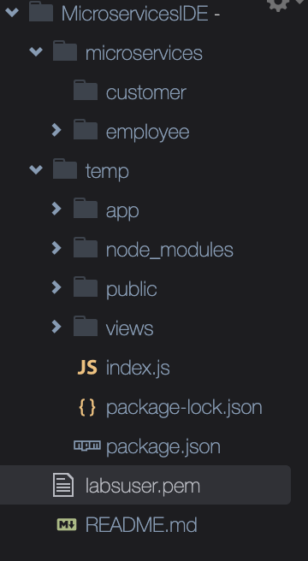**

**Place copy from temp to these two folders  
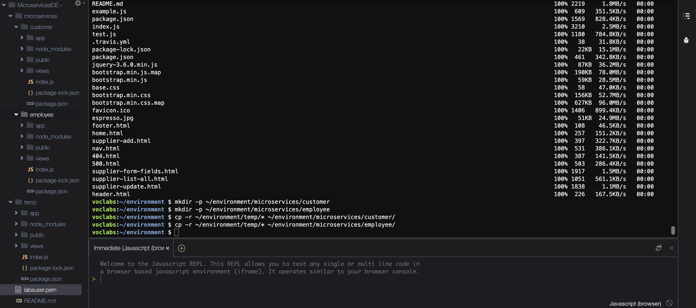**

**And remove the temp folder.**

**Task 3.4: Create a Git repository for the microservices code and push the code to CodeCommit**

1. **Create a CodeCommit repository that is named microservices.**

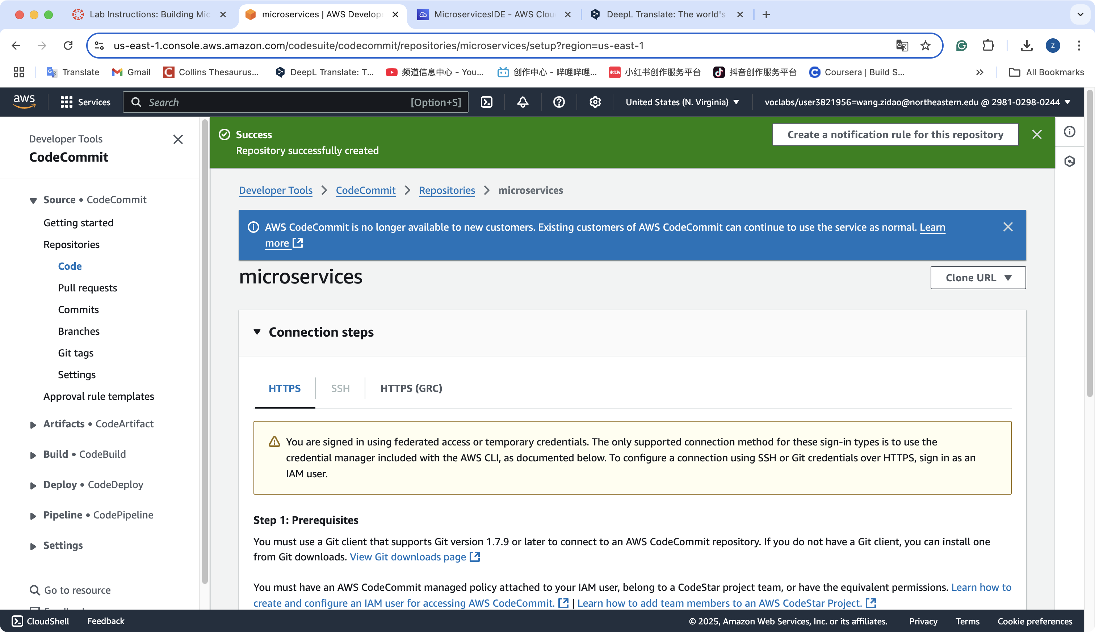

1. **To check the unmodified application code into the microservices CodeCommit repository, run the following commands:**

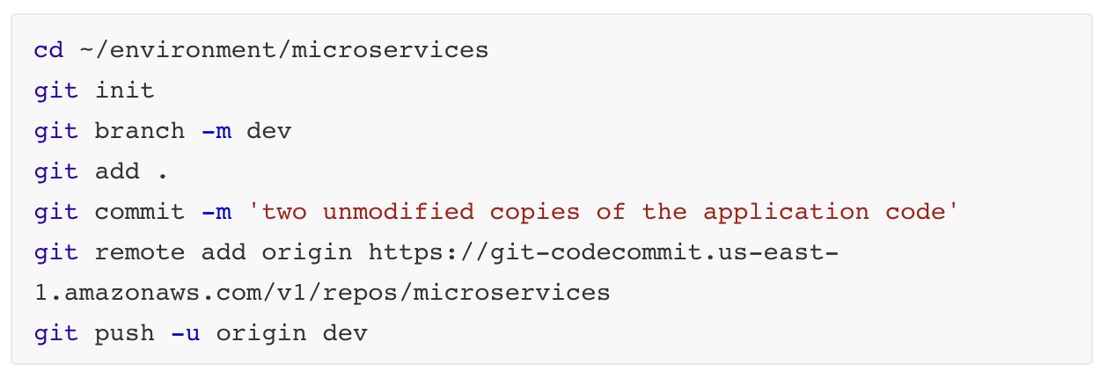

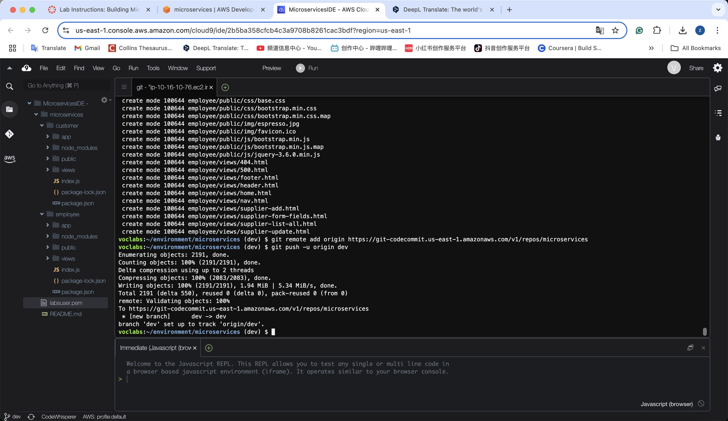

**Configure your Git client to know your username and email address.**



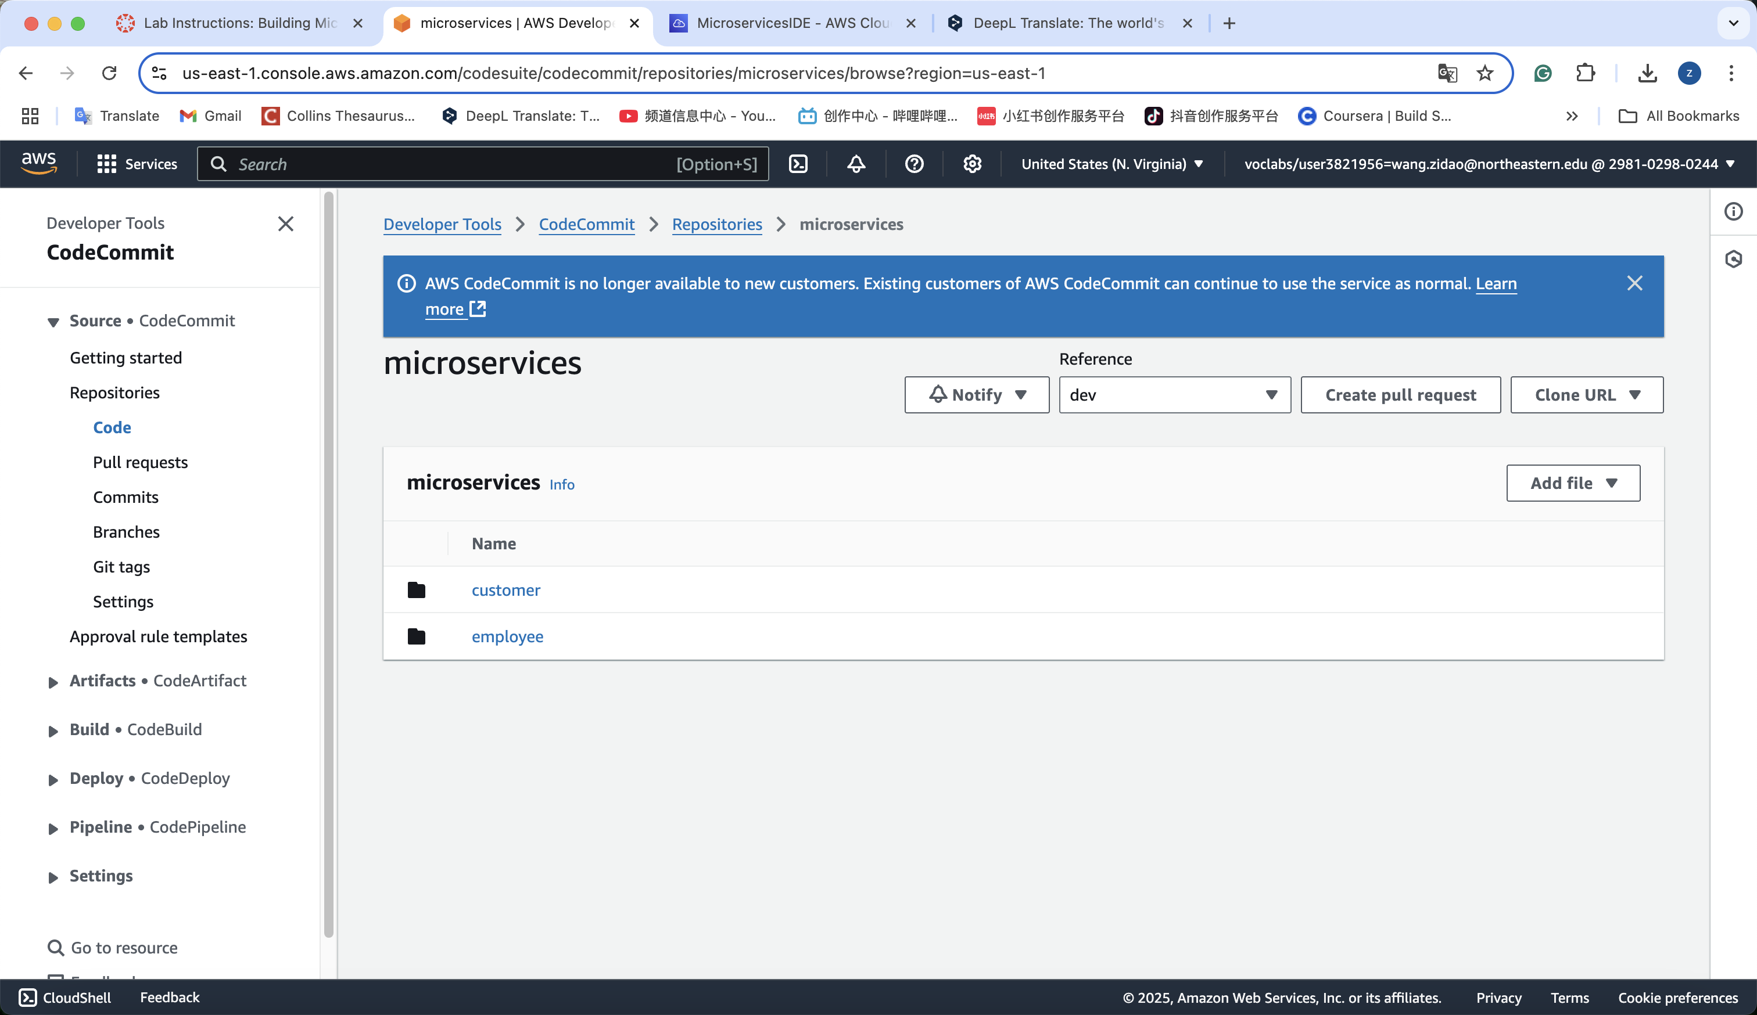

**Phase 4: Configuring the application as two microservices and testing them in Docker containers**

**Task 4.1: Adjust the AWS Cloud9 instance security group settings**

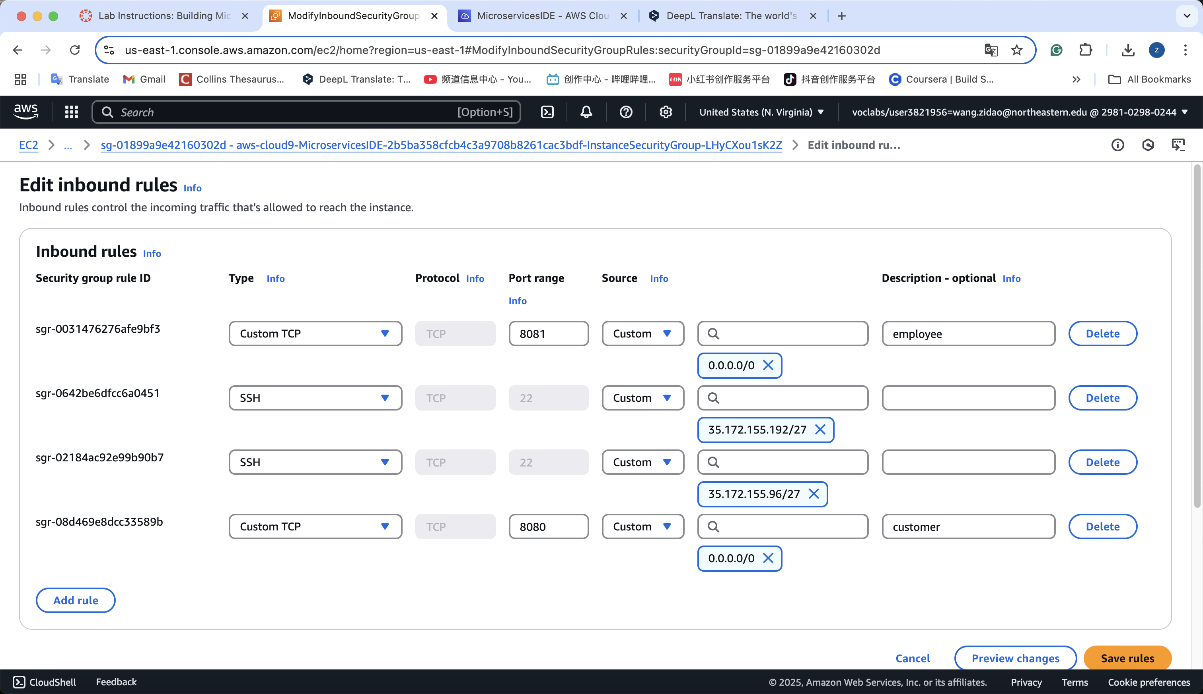

**Task 4.2: Modify the source code of the *customer* microservice**

**1. adjust controller  
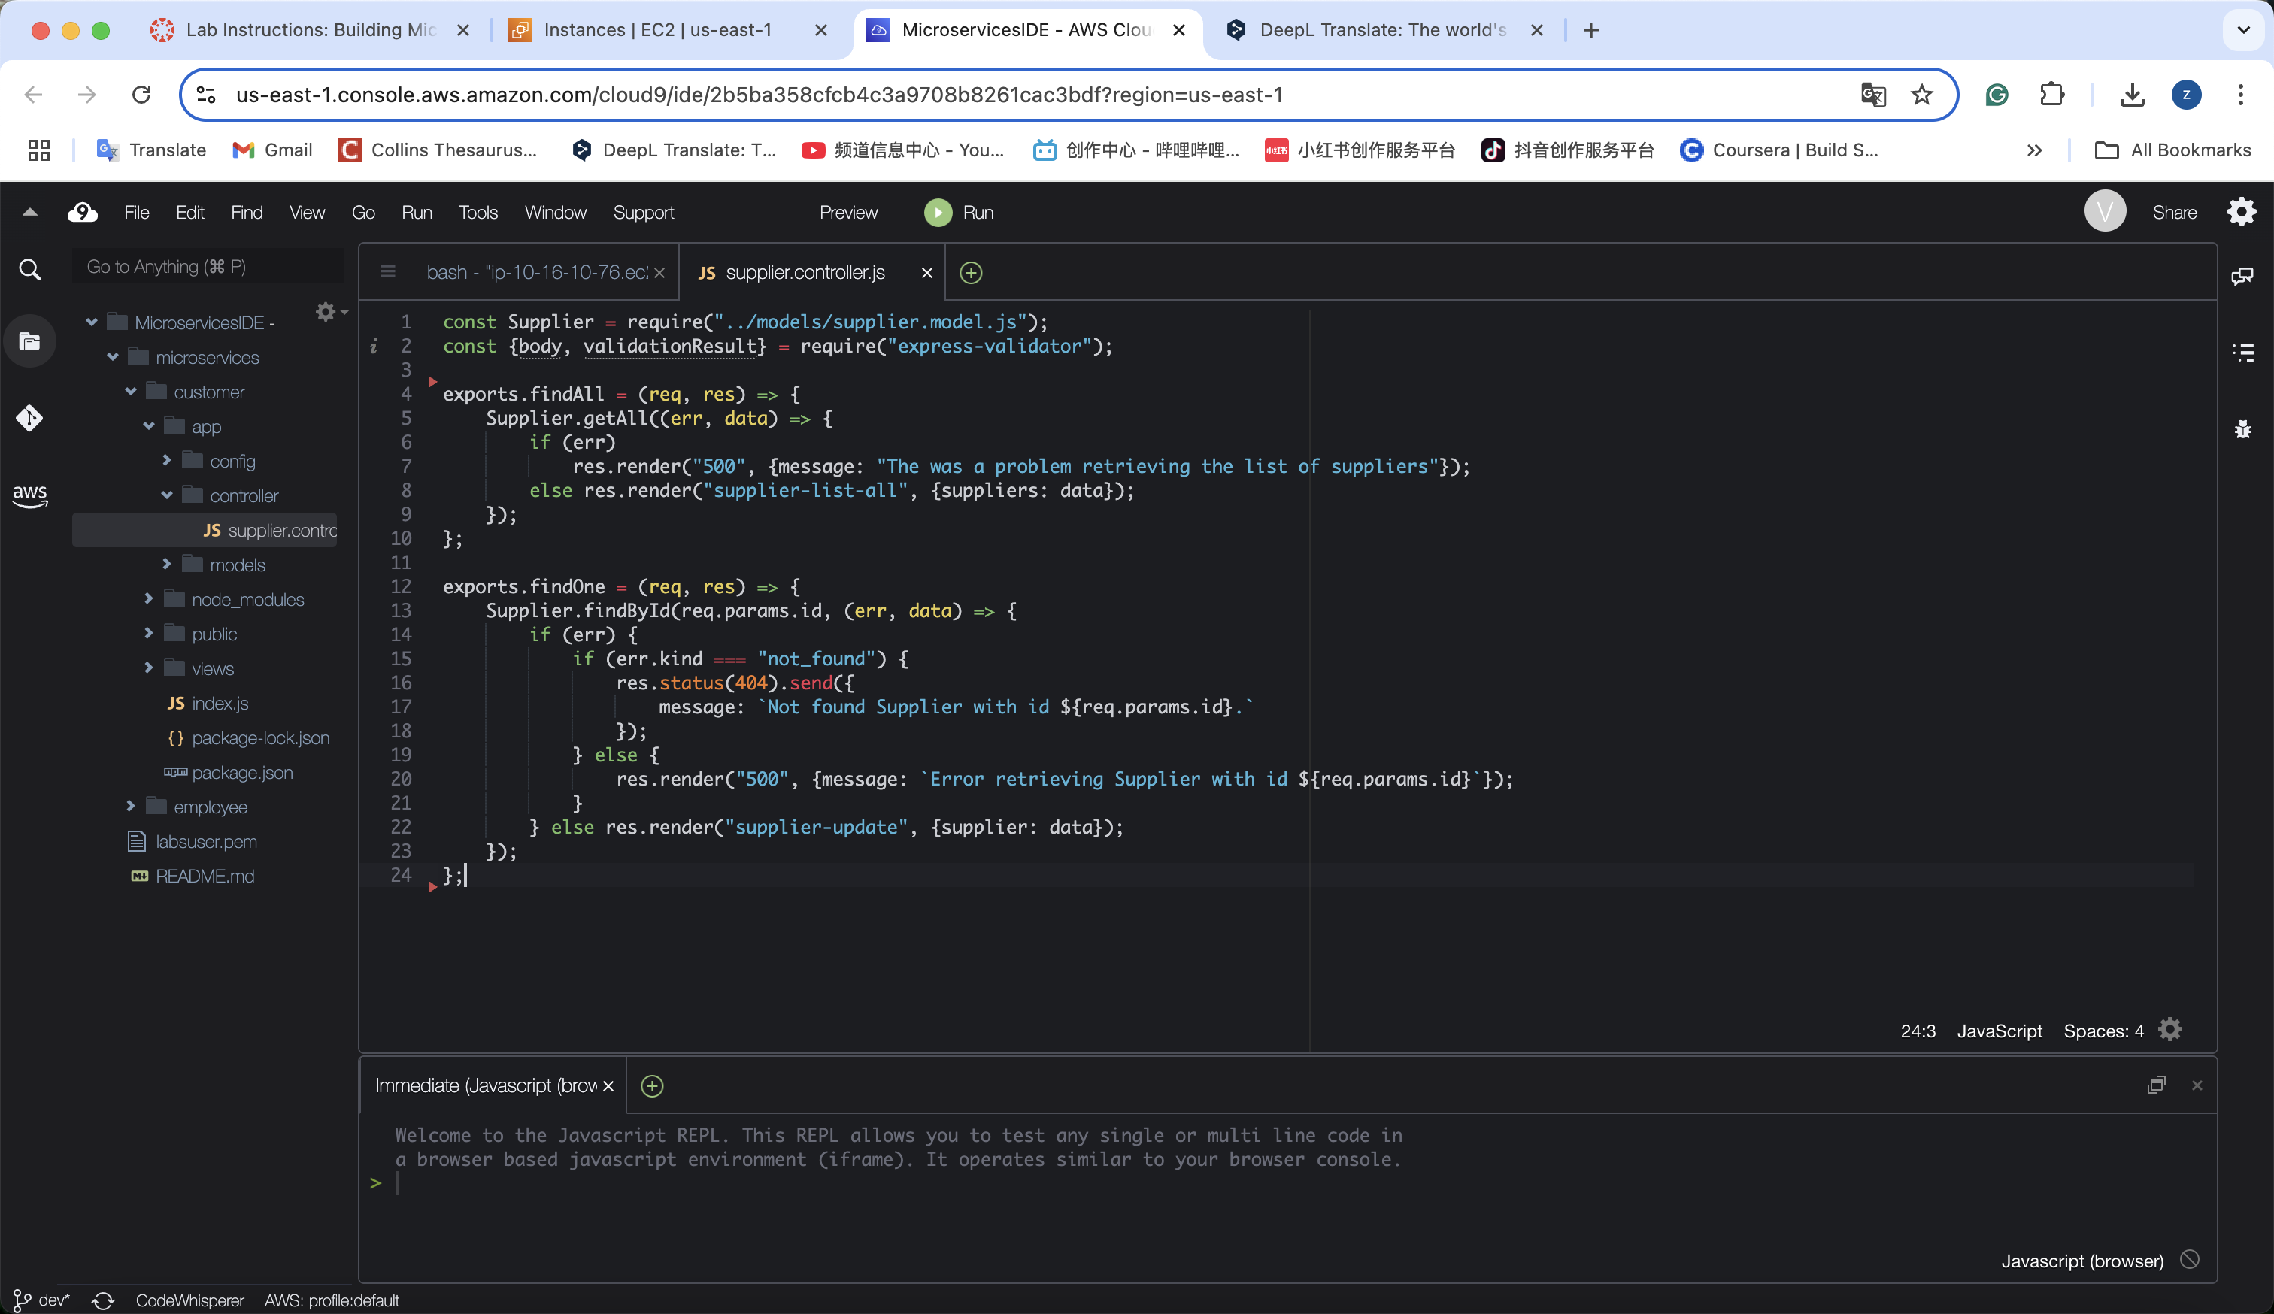**

**2.adjust supplier.model.js**

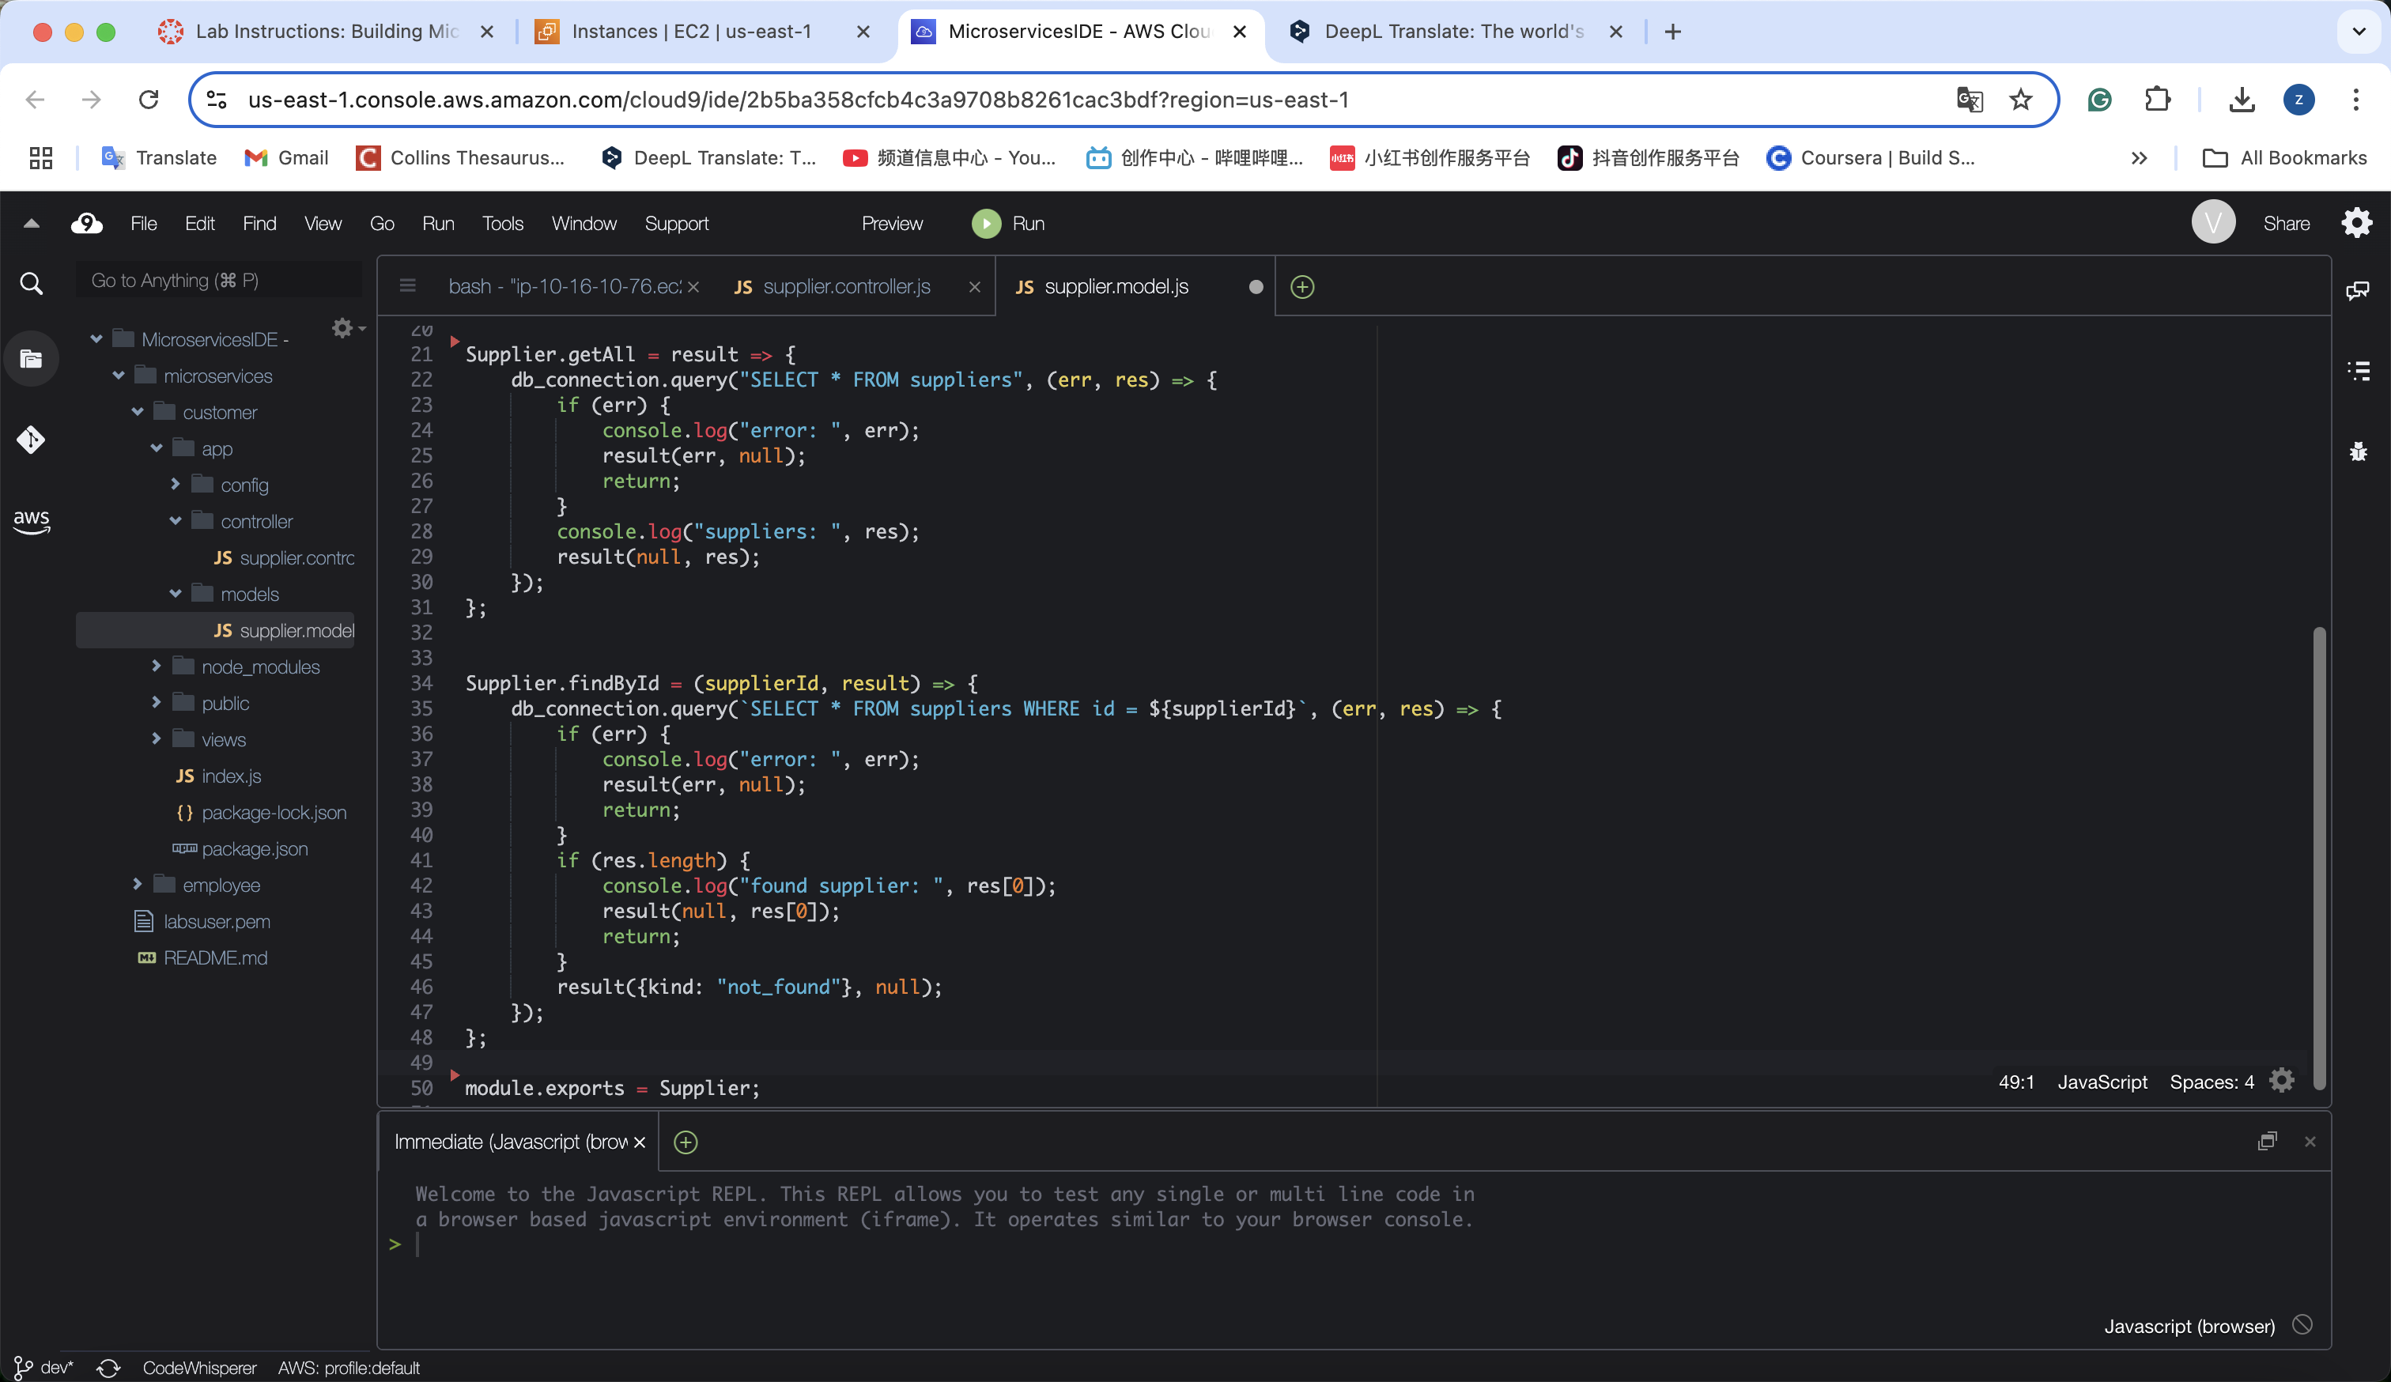

**3. adjust nav.html  
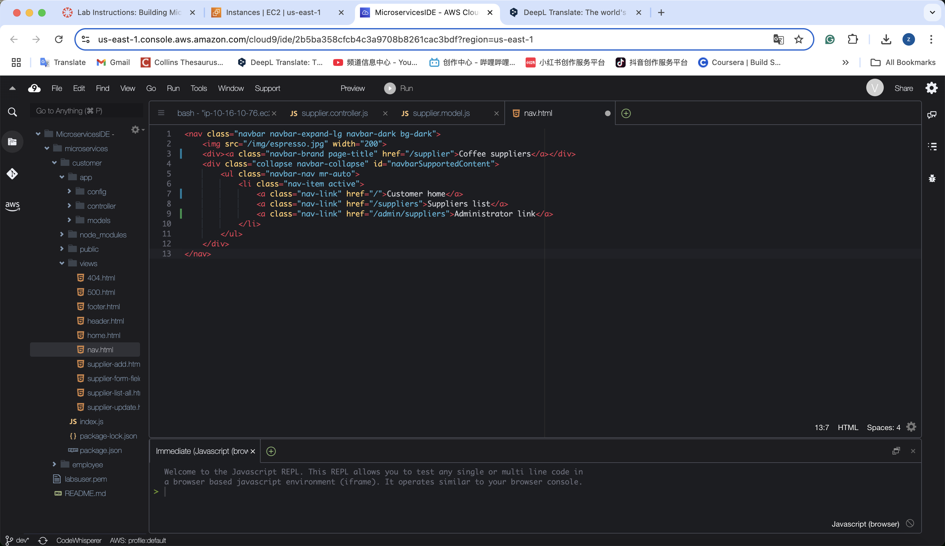**

**4.adjust supplier-list-all.html**

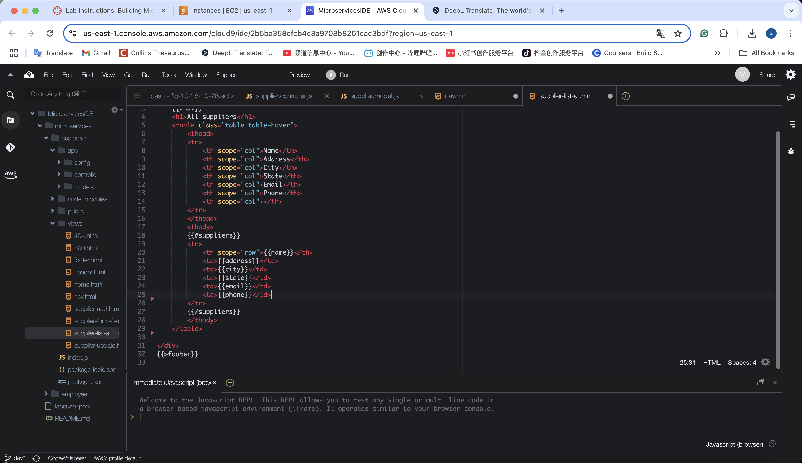

**5. delete other3 file.**

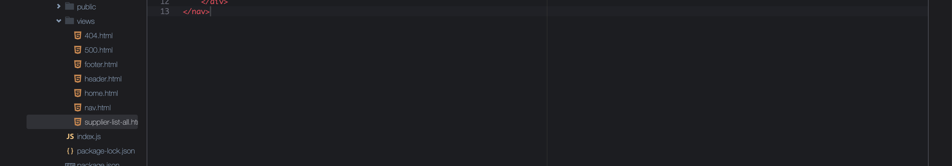

**6. adjust index.js**

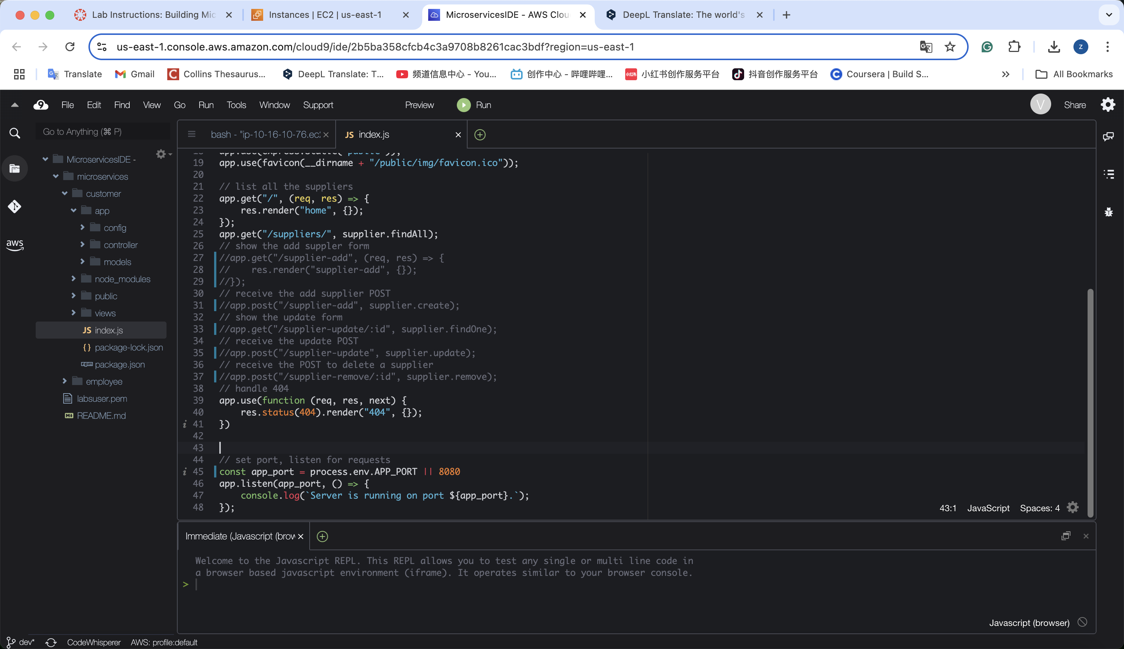

**Task 4.3: Create the *customer* microservice Dockerfile and launch a test container**

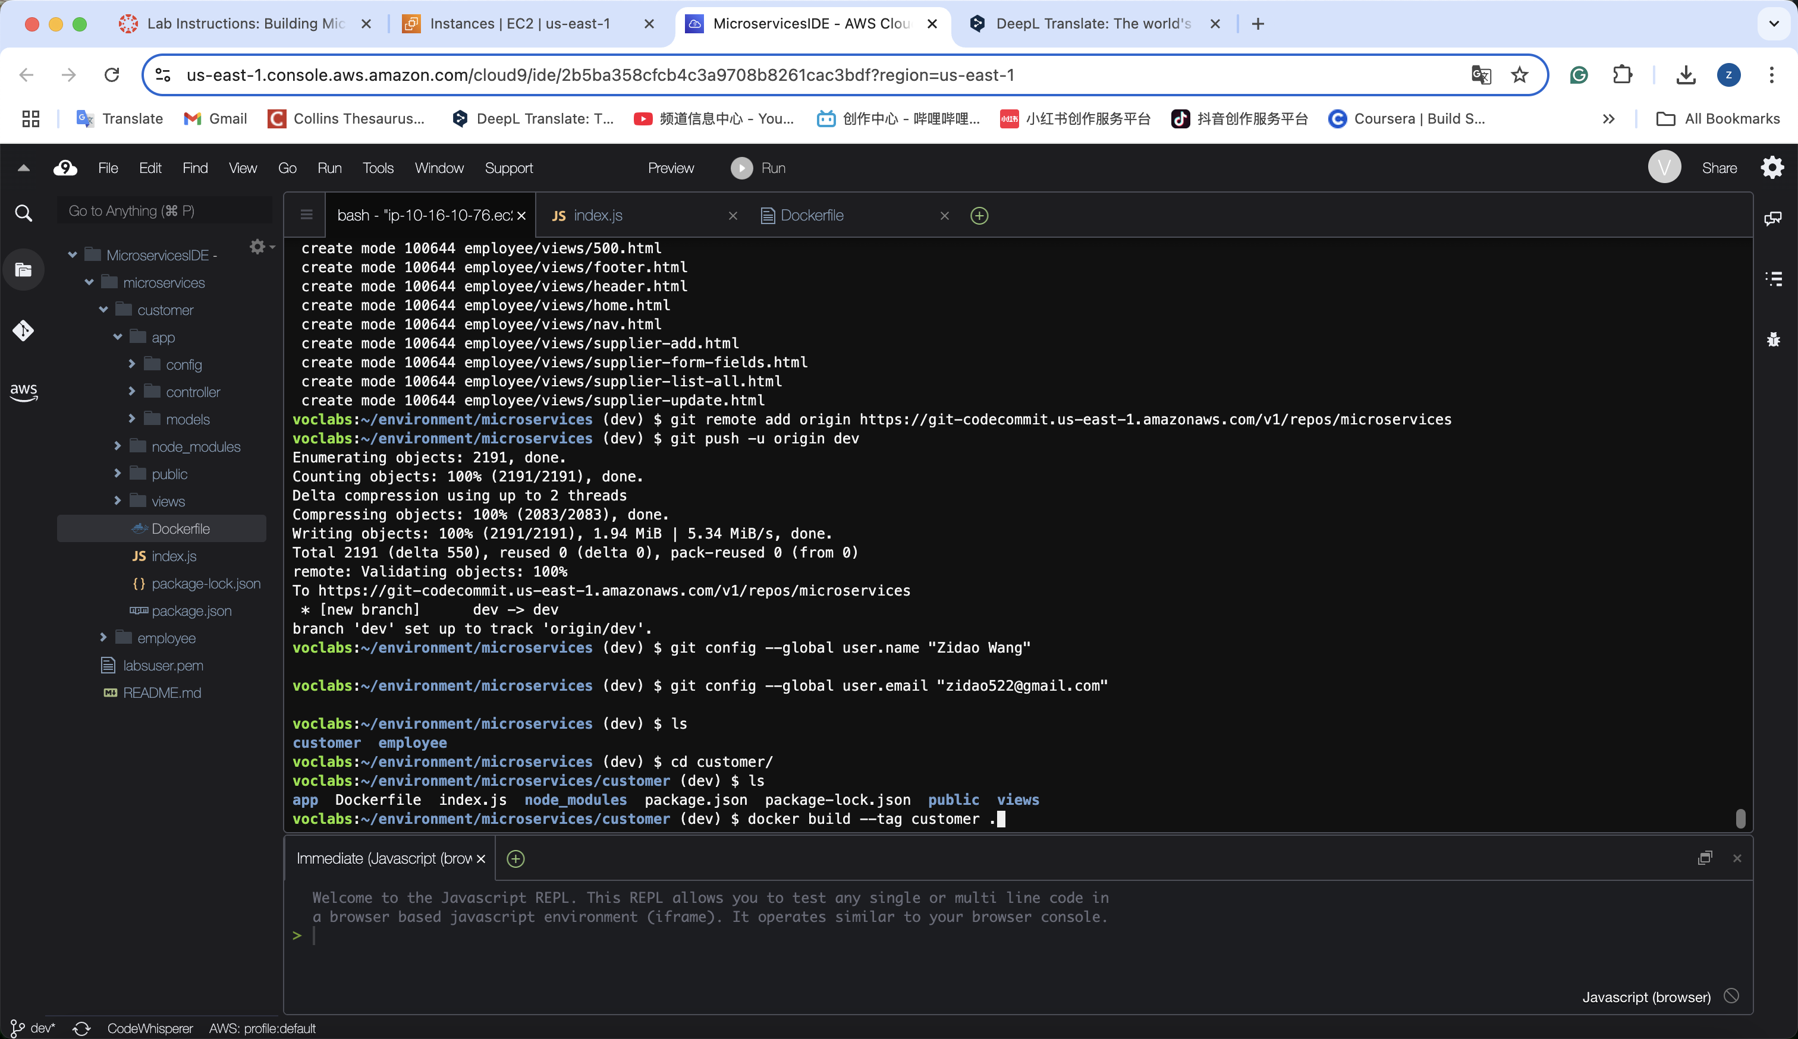

**Check the output:**





* If you close your AWS Cloud9 terminal or stop and restart the project lab environment, and then need to run a command that uses the $dbEndpoint variable, you might need to create the variable again. To test whether the variable is set, run echo $dbEndpoint





* Load the following page in a new browser tab. Replace the IP address placeholder with the public IPv4 address of the AWS Cloud9 instance that you are using: http://<cloud-9-public-IPv4-address>:8080

The web application microservice should load in the browser.

**Important:** If you stop the lab environment and start it again, the public IPv4 address of the AWS Cloud9 instance will change.

**http://<cloud-9-public-IPv4-address>:8080**

**http:// 44.195.45.7:8080**

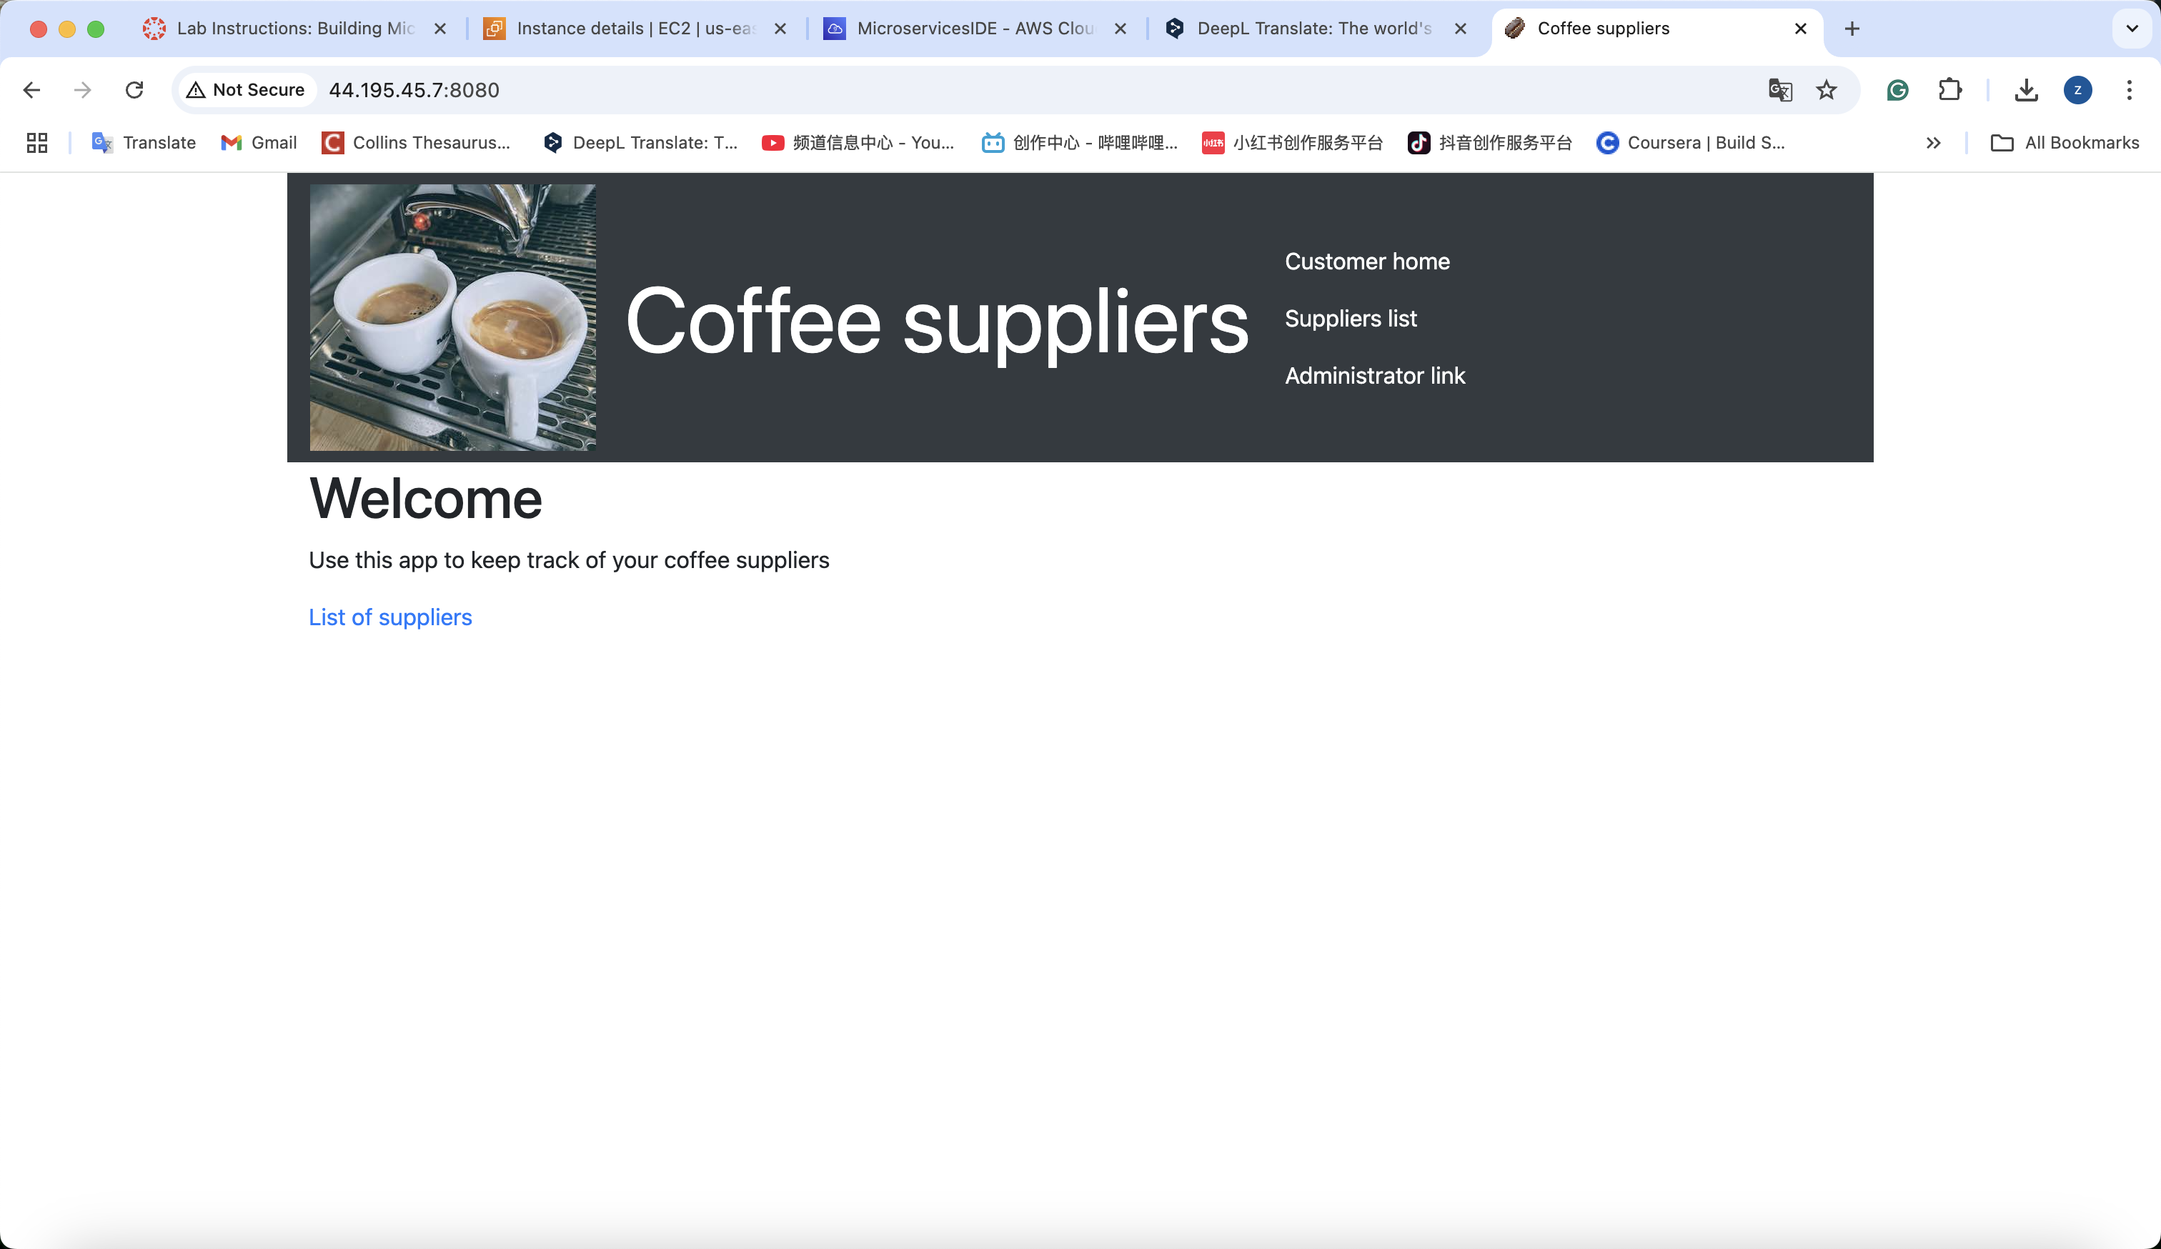

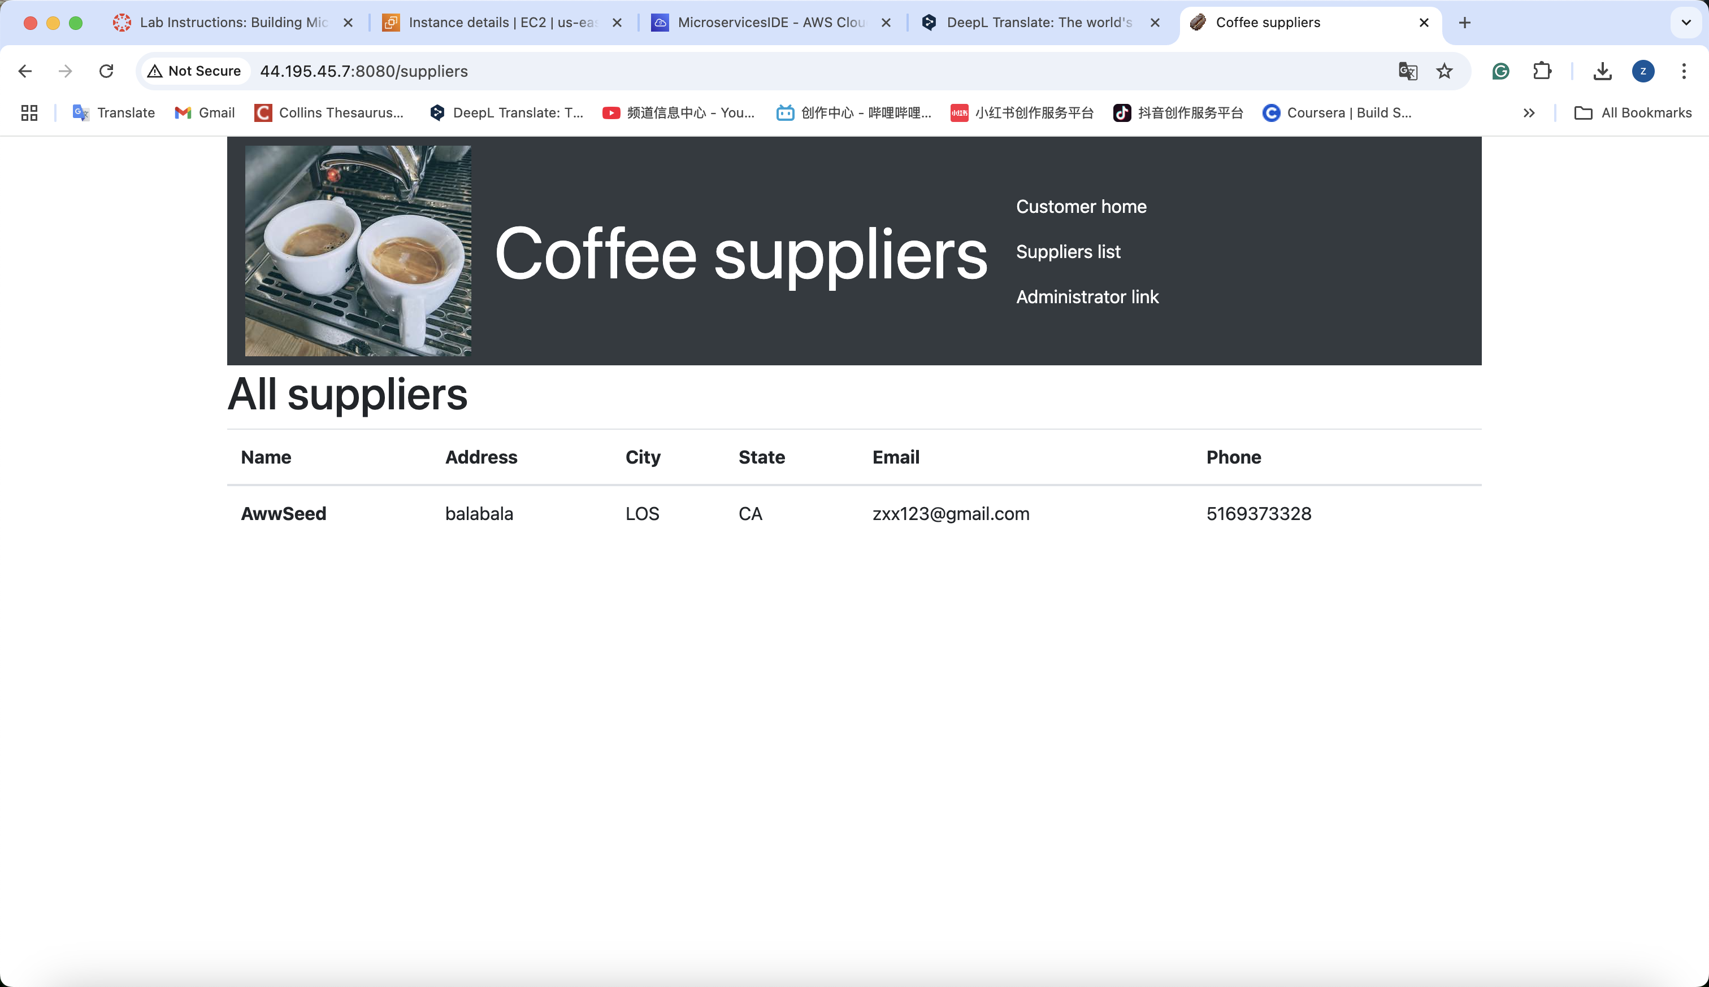

1. **Commit and push your source code changes into CodeCommit.**

**voclabs:~/environment/microservices/customer (dev) $ git add .**

**voclabs:~/environment/microservices/customer (dev) $ git commit -m "Customer's page has been updated. Dockerfile Added."**

**[dev 0d3710b] Customer's page has been updated. Dockerfile Added.**

**9 files changed, 19 insertions(+), 265 deletions(-)**

**create mode 100644 customer/Dockerfile**

**delete mode 100644 customer/views/supplier-add.html**

**delete mode 100644 customer/views/supplier-form-fields.html**

**delete mode 100644 customer/views/supplier-update.html**

**voclabs:~/environment/microservices/customer (dev) $ git push -u origin dev**

**Task 4.4: Modify the source code of the *employee* microservice**

**Change supplier.controller.js function add /admin**



**And change index.js function to add /admin and change line 45 80 to 8081.**

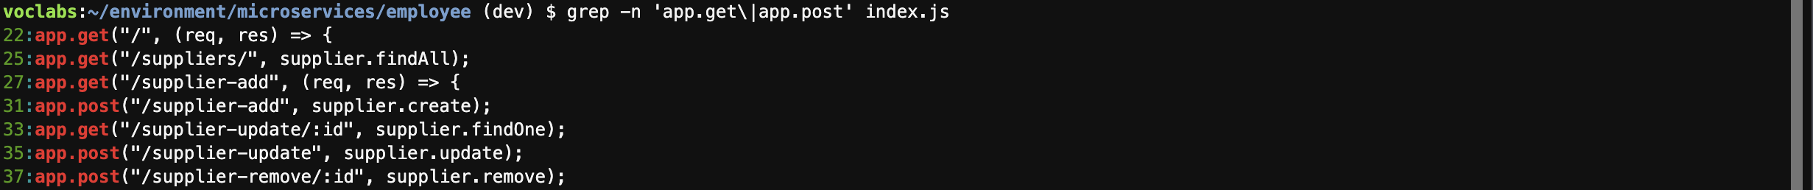

**Change view folder’s 3 files.**



**And change other two files with /admin**



**Change the title of header.html**

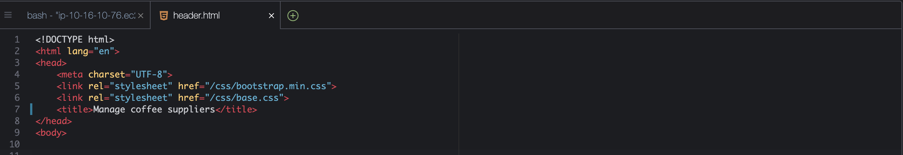

**For nav.html, change name, replace line 7, add new line after line 8**

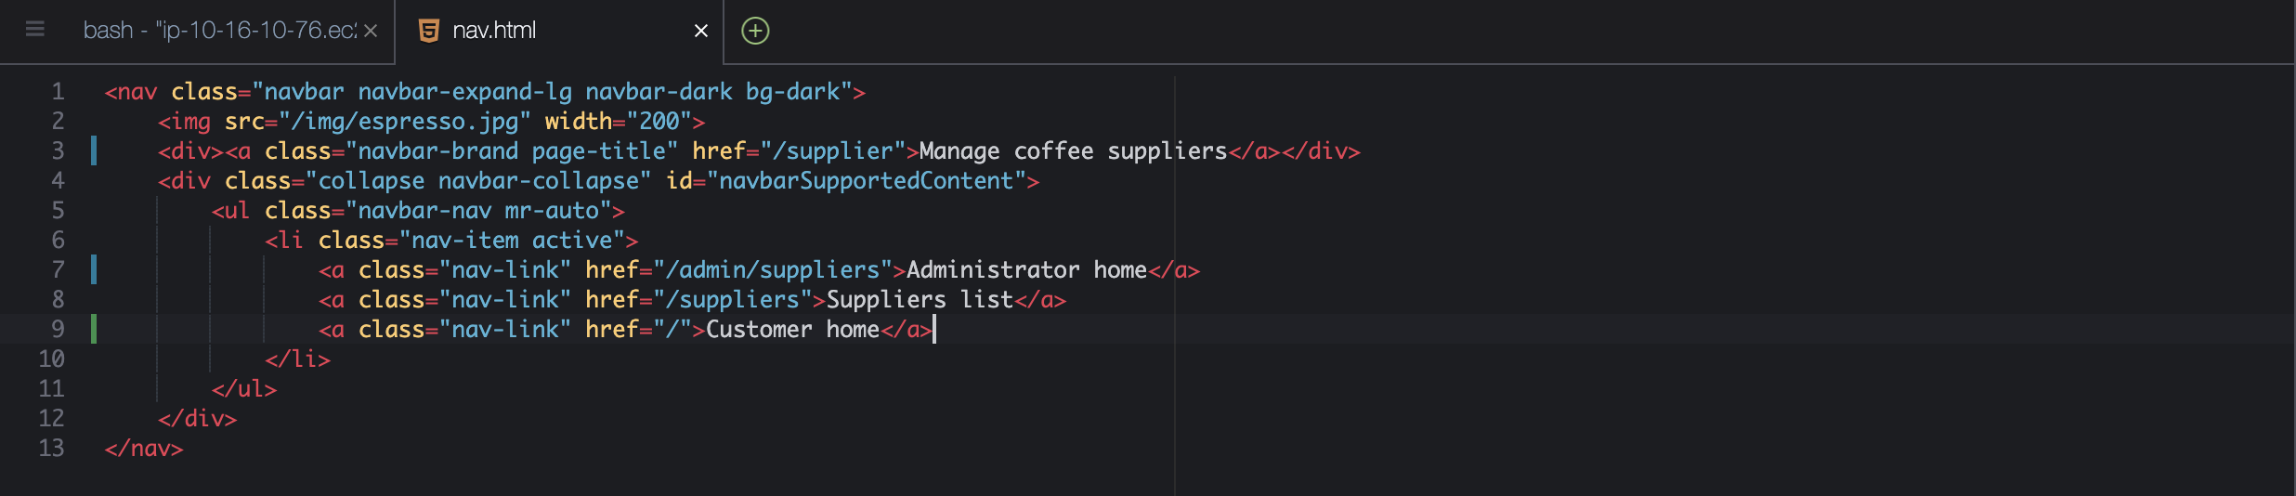

**Duplicate new dockerfile for employee,change the 端口 to 8081 to prevent conflict.**

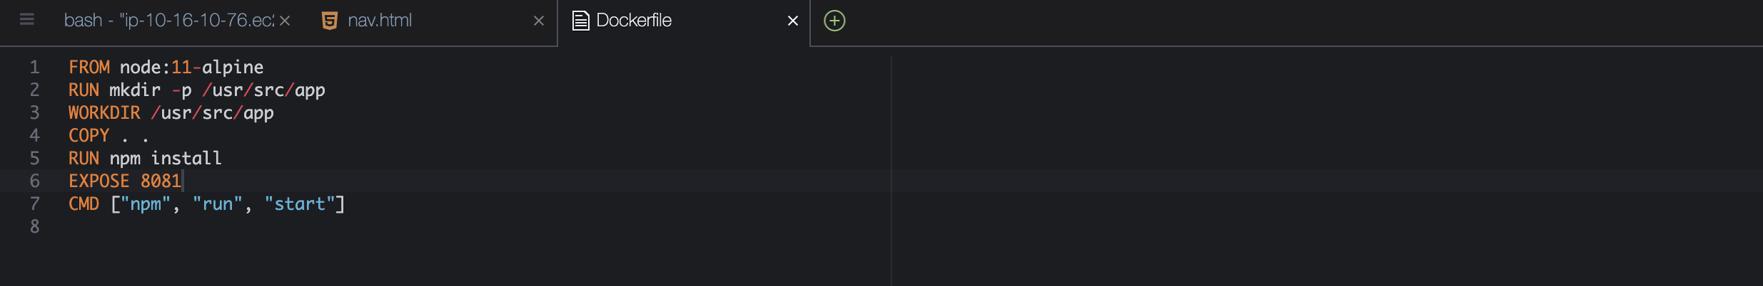

**Run it on the container:**

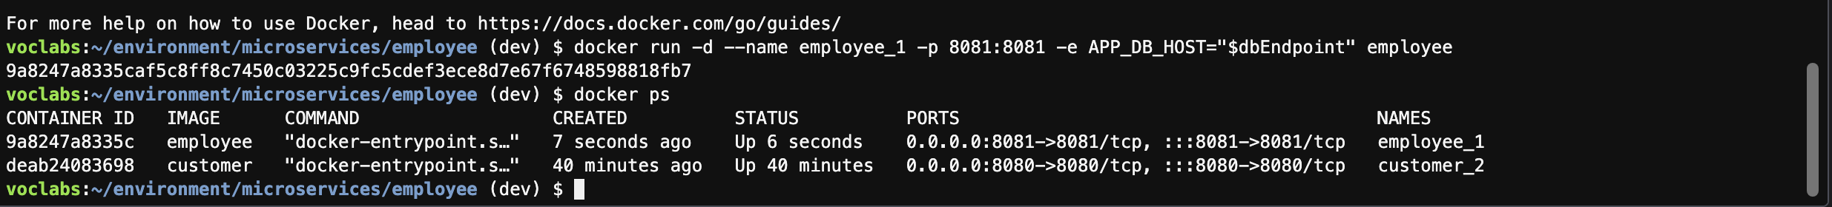

**Note: Links that should take you to the customer microservice will not work. For example, if you choose Customer home or Suppliers list, the pages won't be found because the link assumes that the customer microservice also runs on port 8081 (but it doesn't). You can ignore this issue—these links should work as intended when you deploy the microservices to Amazon ECS later.**

**Task 4.6: Adjust the *employee* microservice port and rebuild the image**

**docker rm -f employee_1**

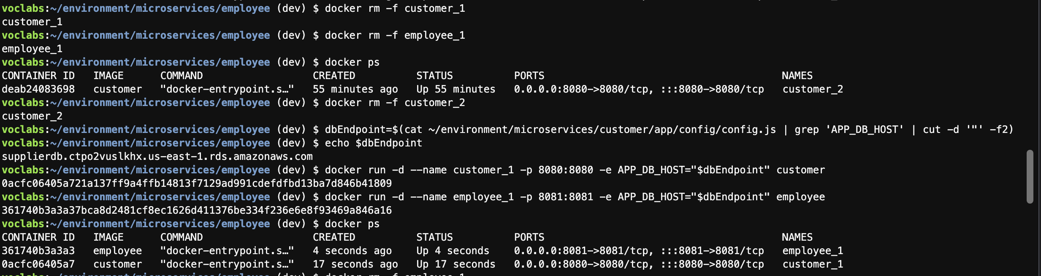

**Task 4.7: Check code into CodeCommit**

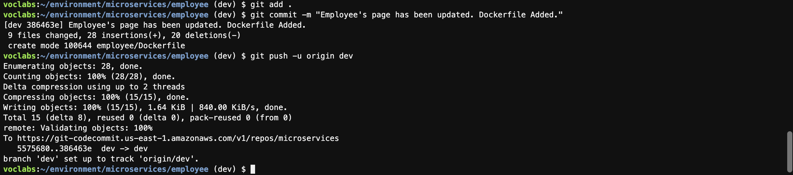

**Phase 5: Creating ECR repositories, an ECS cluster, task definitions, and AppSpec files**

**Task 5.1: Create ECR repositories and upload the Docker images**

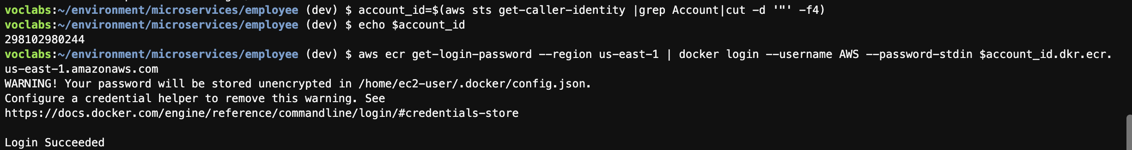

**Create a separate private ECR repositories one for customer and the other named employee.**

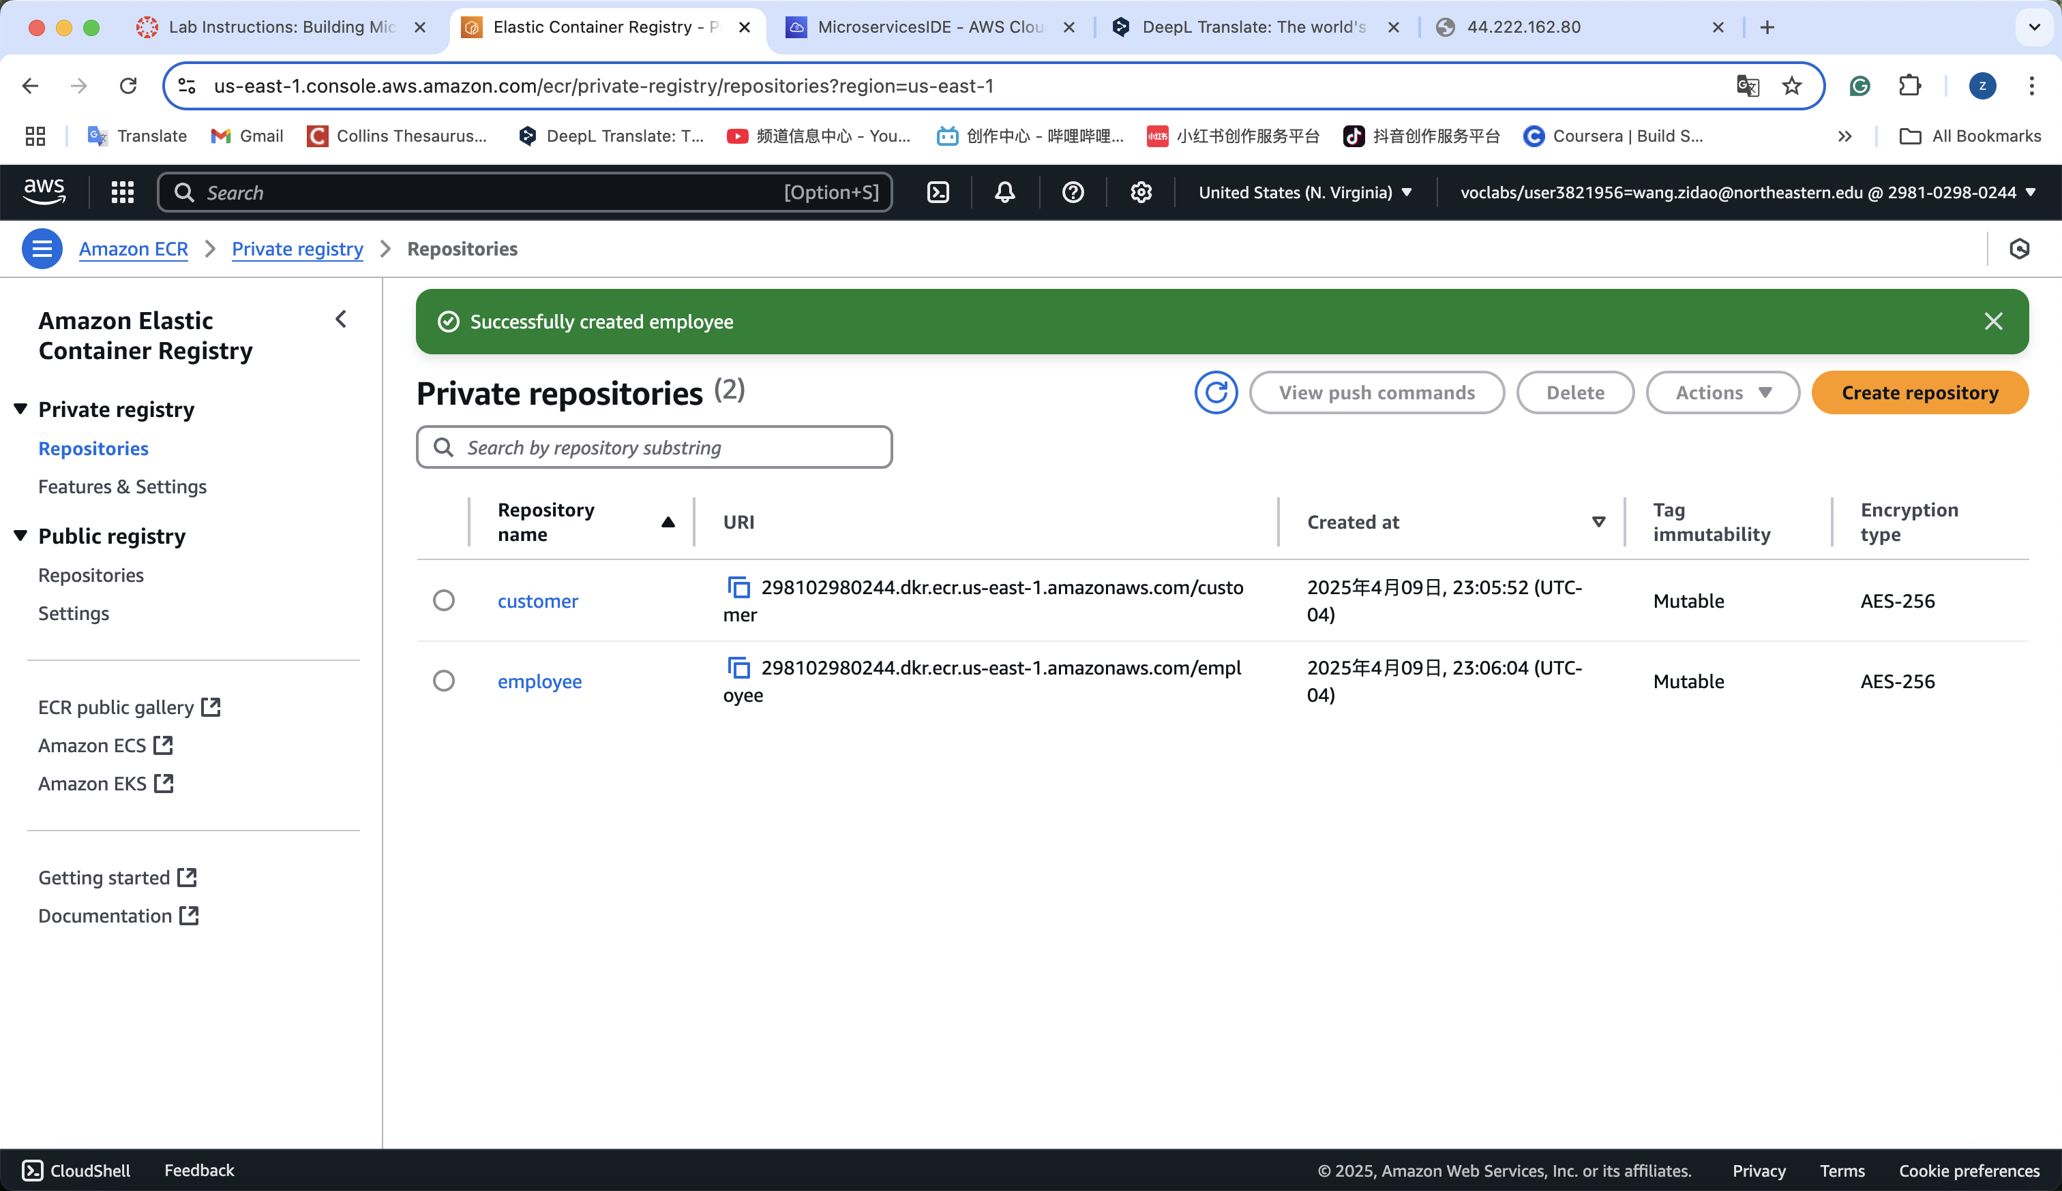

**Tag docker images**





**Replace ME**

**docker push $account_id.dkr.ecr.us-east-1.amazonaws.com/customer:latest**

**docker push $account_id.dkr.ecr.us-east-1.amazonaws.com/employee:latest**

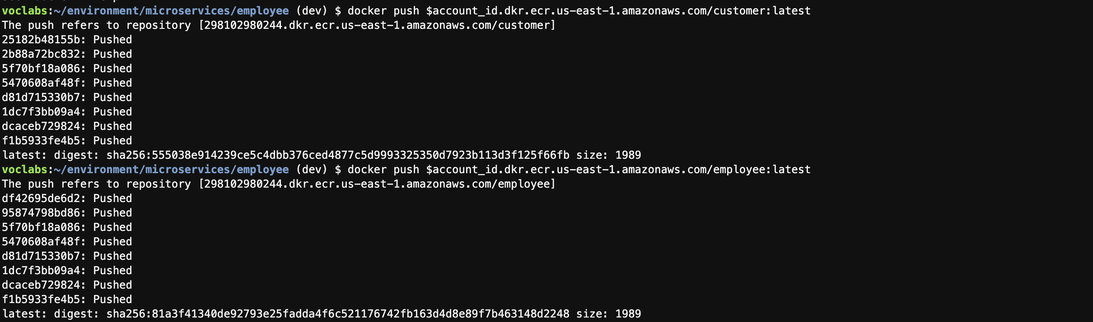

**Confirm that two images are stored in ECR**



**Task 5.2: Create an ECS cluster**

**Create a serverless AWS Fargate cluster that is named microservices-serverlesscluster**

**Ensure that it's configured to use *LabVPC*, *PublicSubnet1*, and *PublicSubnet2* (remove any other subnets). *DON'T* select Amazon EC2 instances or ECS Anywhere. (How?）**

**Important: After choosing the button to create the cluster, in the banner that appears across the top of the page, choose View in CloudFormation. Wait until the stack that creates the cluster attains the status *CREATE_COMPLETE* before you proceed to the next task. *If the stack fails to create for any reason and therefore rolls back*, repeat these steps to try again. It should succeed the second time.**

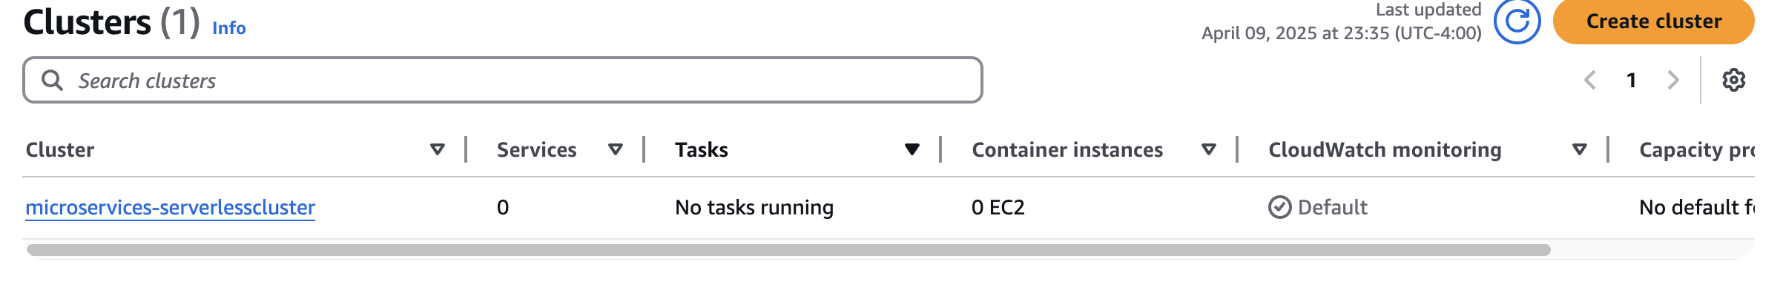

**Task 5.3: Create a CodeCommit repository to store deployment files**

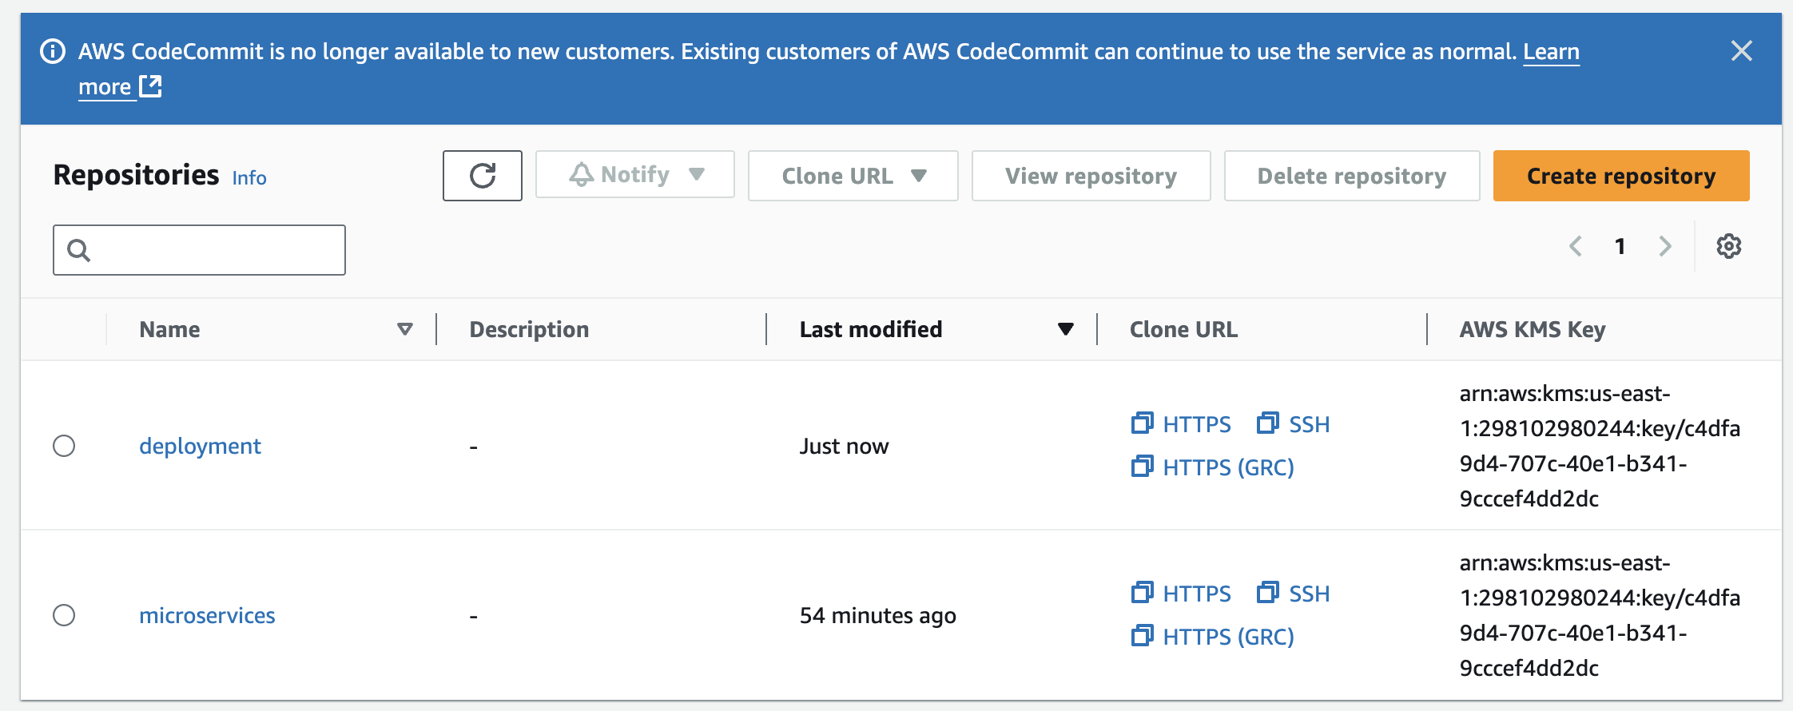

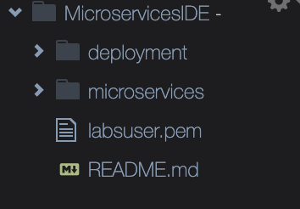

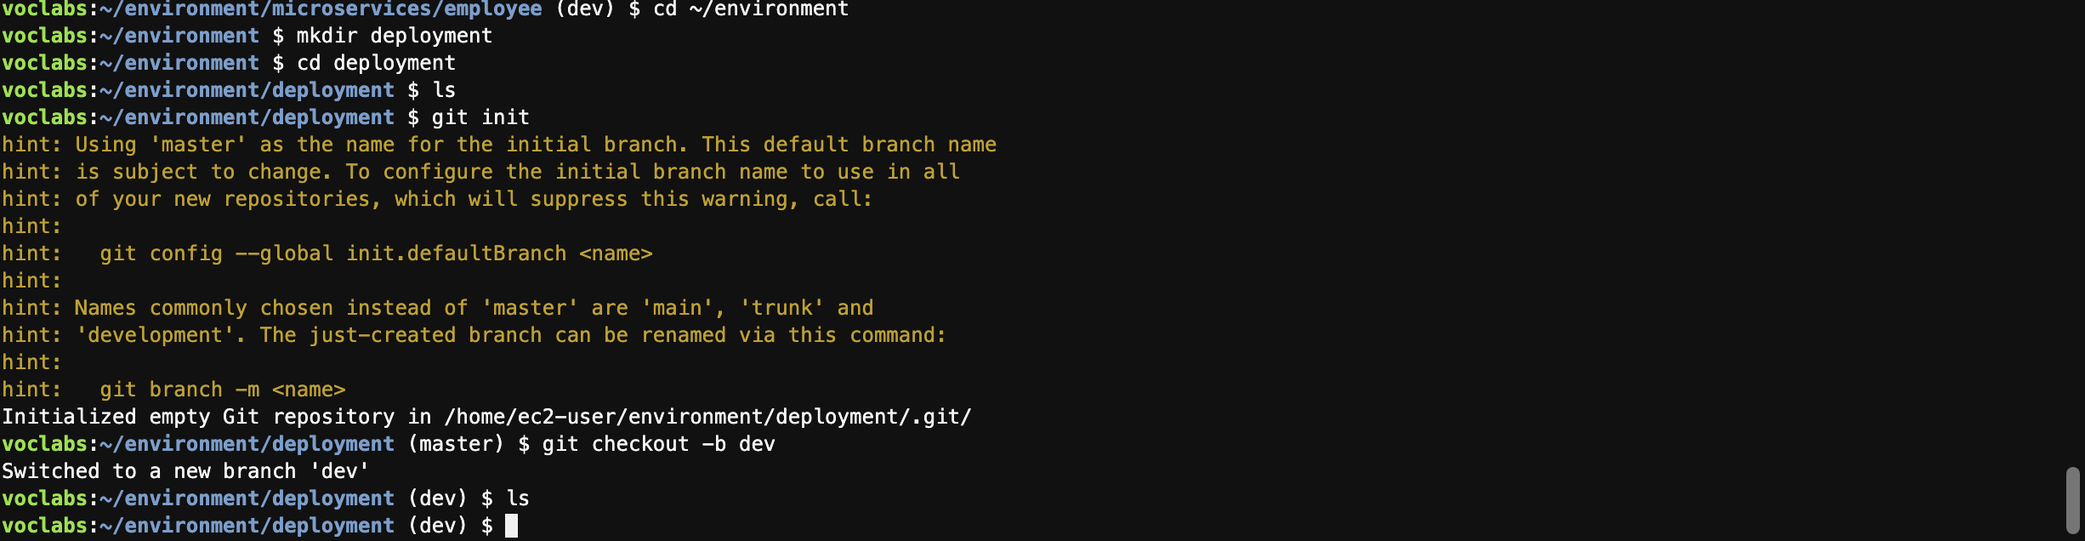

**Task 5.4: Create task definition files for each microservice and register them with Amazon ECS**

**aws ecs register-task-definition --cli-input-json "file:///home/ec2-user/environment/deployment/taskdef-customer.json"**

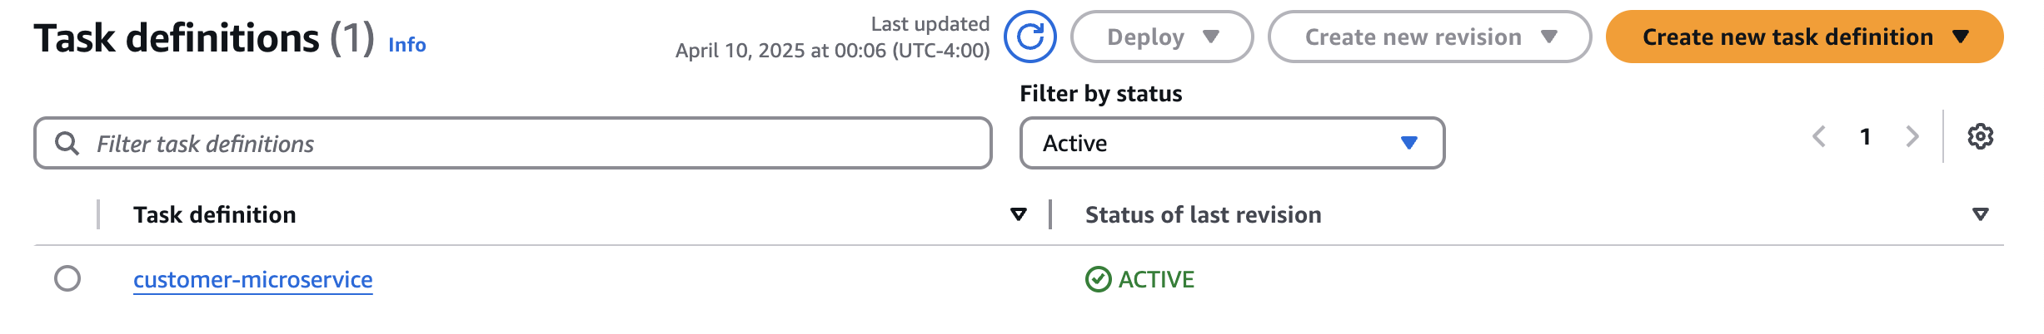

**Do same thing for employee**

**aws ecs register-task-definition --cli-input-json** **file:///home/ec2-user/environment/deployment/taskdef-employee.json**

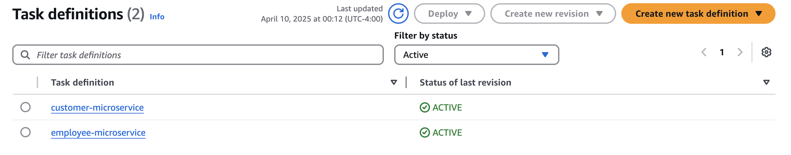

**Task 5.5: Create AppSpec files for CodeDeploy for each microservice**

***DON'T* modify <TASK_DEFINITION>. This setting will be updated automatically when the pipeline runs.**

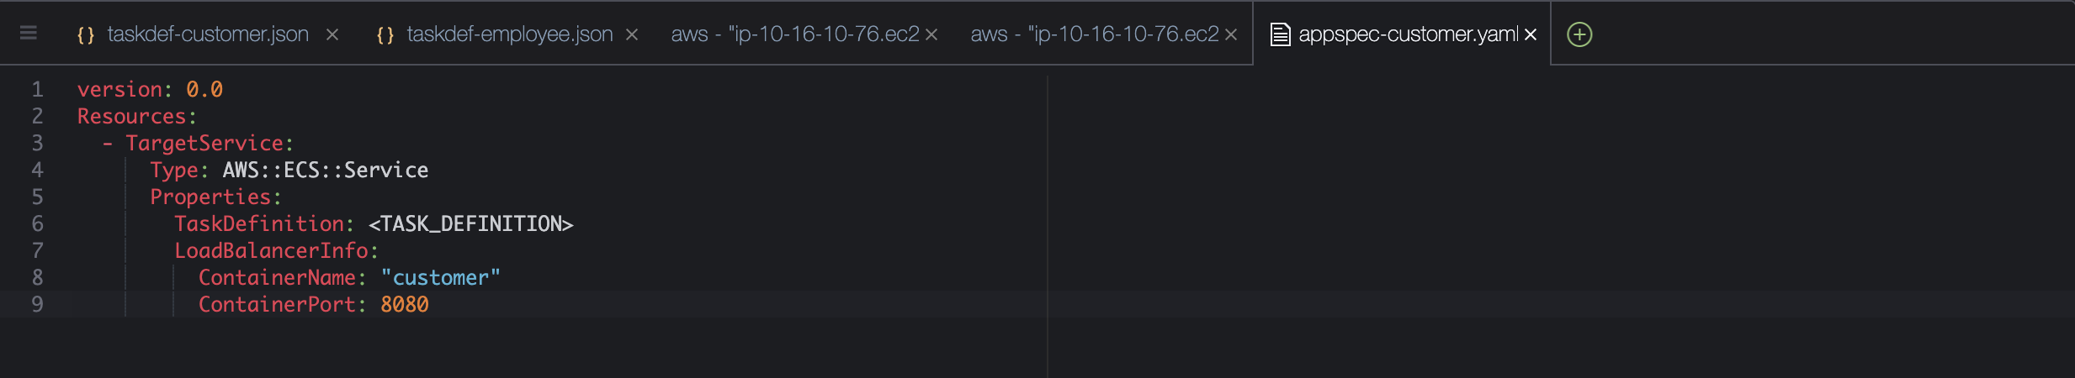

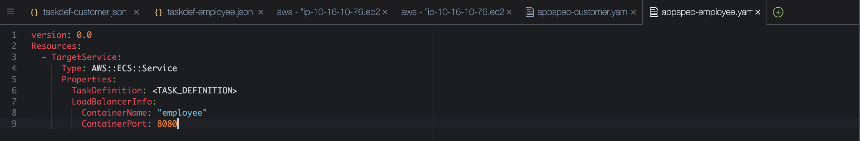

**Note: This file is in YAML format. In YAML, indentation is important. Verify that the code in your file maintains the indentation levels as shown in the previous code block.**

1. **Edit the taskdef-customer.json file.**
   * **Modify line 5 to match the following line:**

**"image": "<IMAGE1_NAME>",**

* + **Save the change.**

**Analysis: <IMAGE1_NAME> is not a valid image name, which is why you originally set the image name to *customer* before running the AWS CLI command to register the first revision of the file with Amazon ECS. However, at this point in the project, it's important to set the image value to a placeholder text value. Later in this project, when you configure a pipeline, you will identify IMAGE1_NAME as placeholder text that can be dynamically updated. In summary, CodePipeline will set the correct image name dynamically at runtime.**

1. **Edit the taskdef-employee.json file.**
   * **Modify line 5 to match the following line:**

**"image": "<IMAGE1_NAME>",**

* + **Save the change.**

1. **Push all four files to CodeCommit.**

**Note: Pushing the latest files to CodeCommit is essential. Later, when you create the CI/CD pipeline, the pipeline will pull these files from CodeCommit and use the details in them as instructions to deploy updates for your microservices to the Amazon ECS cluster.**

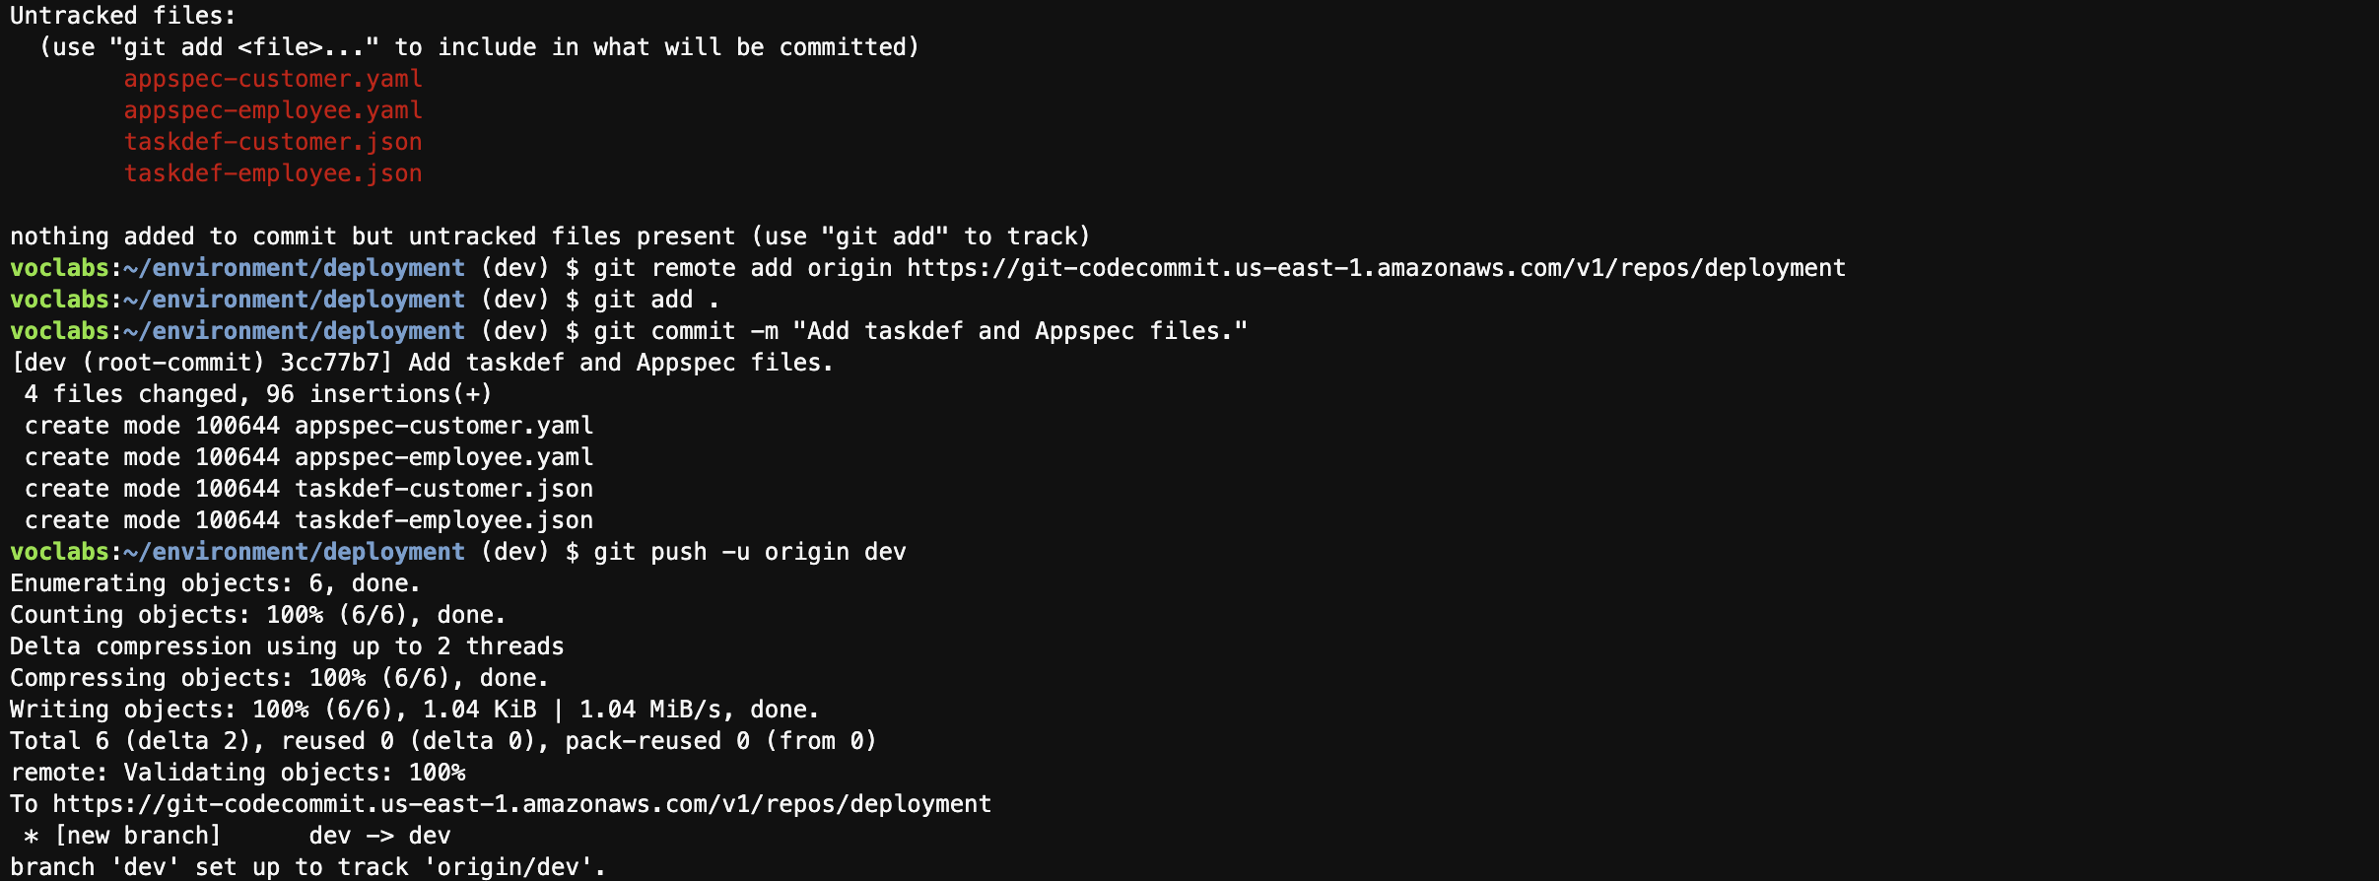

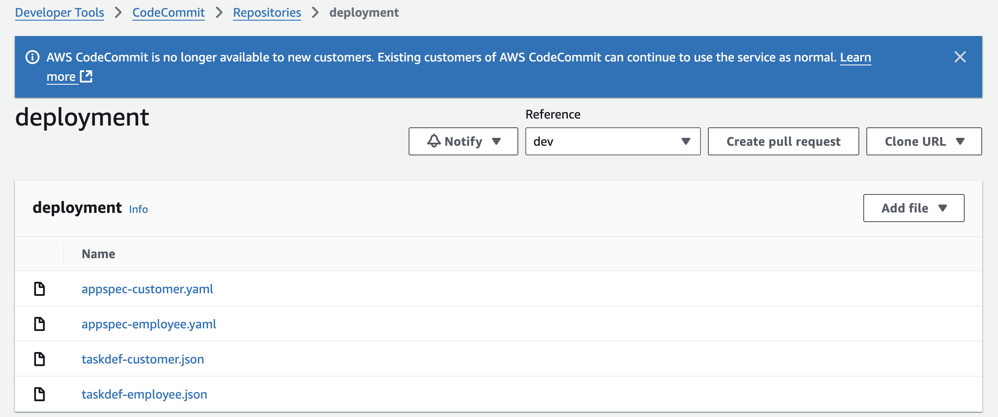

**Phase 6: Creating target groups and an Application Load Balancer**

**Task 6.1: Create four target groups**

1. **Create the first target group for the *customer* microservice.**
   * **Navigate to the Amazon EC2 console.**
   * **In the navigation pane, choose Target Groups.**
   * **Choose Create target group and configure the following:**
     + **Choose a target type: Choose IP addresses.**
     + **Target group name: Enter customer-tg-one**
     + **Protocol: Choose HTTP.**
     + **Port: Enter 8080**
     + **VPC: Choose LabVPC.**
     + **Health check path: Enter /**
   * **Choose Next.**
   * **On the Register targets page, accept all defaults (don't register any targets), and choose Create target group.**

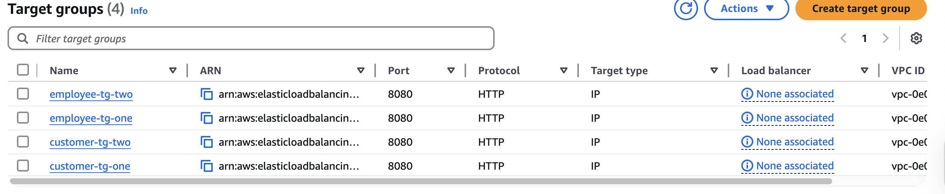

**Task 6.2: Create a security group and an Application Load Balancer, and configure rules to route traffic**

1. **Create a new EC2 security group named microservices-sg to use in *LabVPC*. Add inbound rules that allow TCP traffic from any IPv4 address on ports 80 and 8080.**

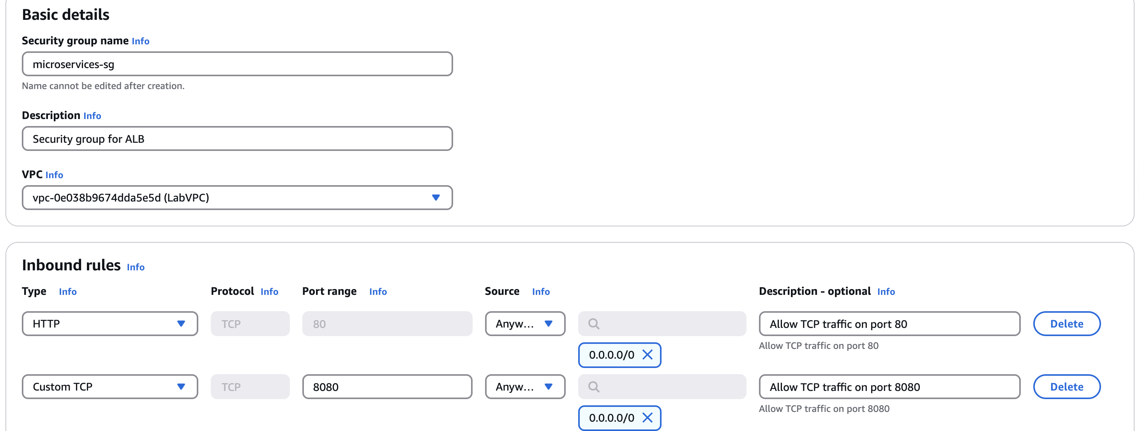

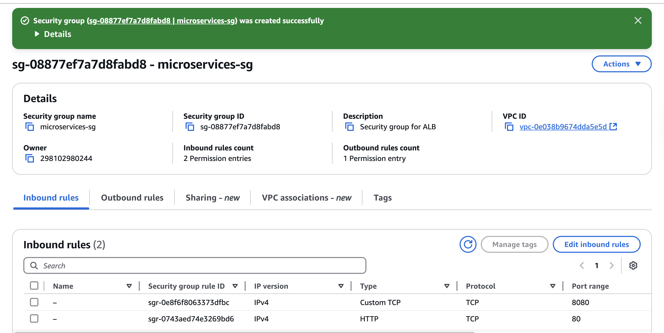

1. **In the Amazon EC2 console, create an Application Load Balancer named microservicesLB.**
   * **Make it internet facing for IPv4 addresses.**
   * 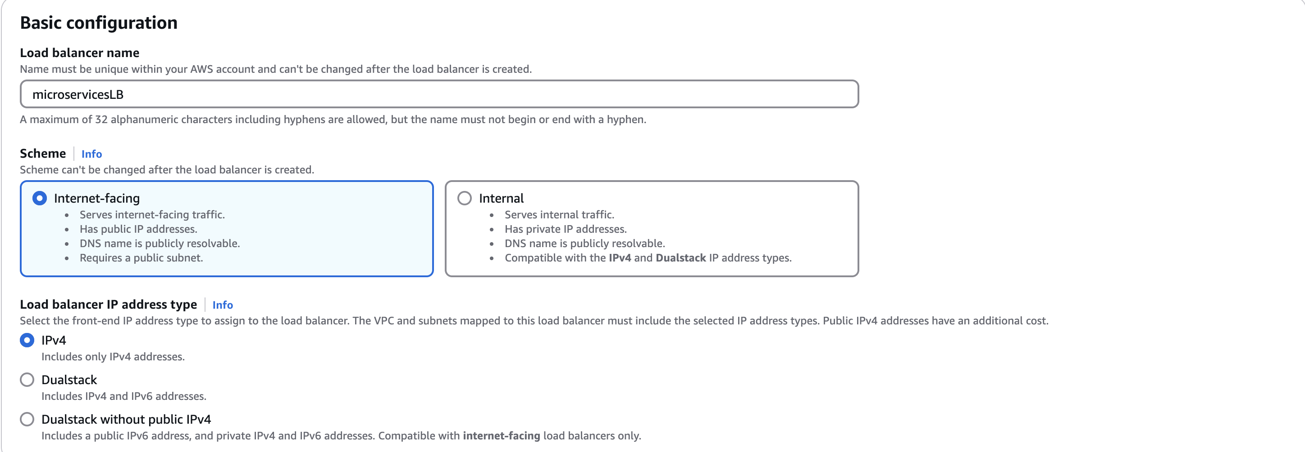
   * **Use *LabVPC*, *Public Subnet1*, *Public Subnet2*, and the *microservices-sg* security group.**
   * 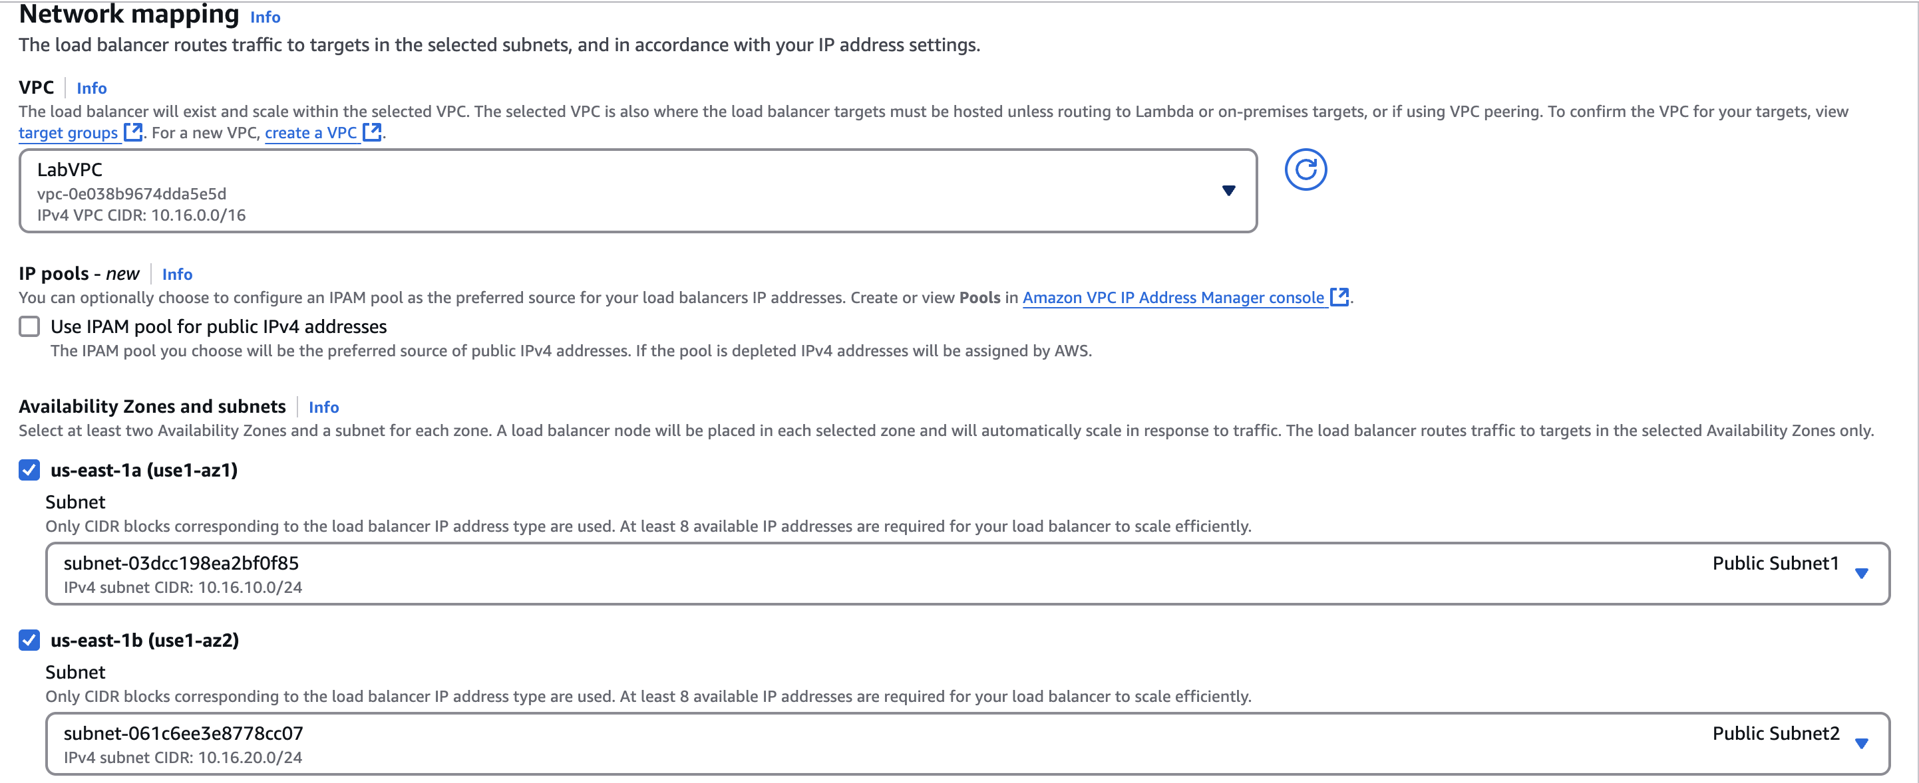
   * 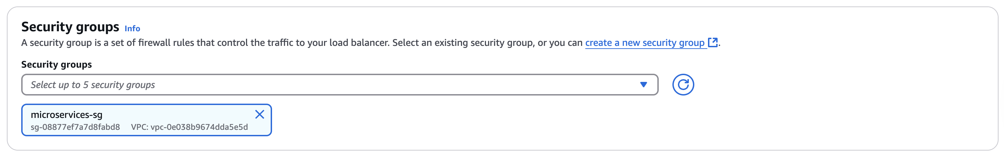
   * **Configure two listeners on it. The first should listen on *HTTP:80* and forward traffic to *customer-tg-two* by default. The second should listen on *HTTP:8080* and forward traffic to *customer-tg-one* by default.**
   * 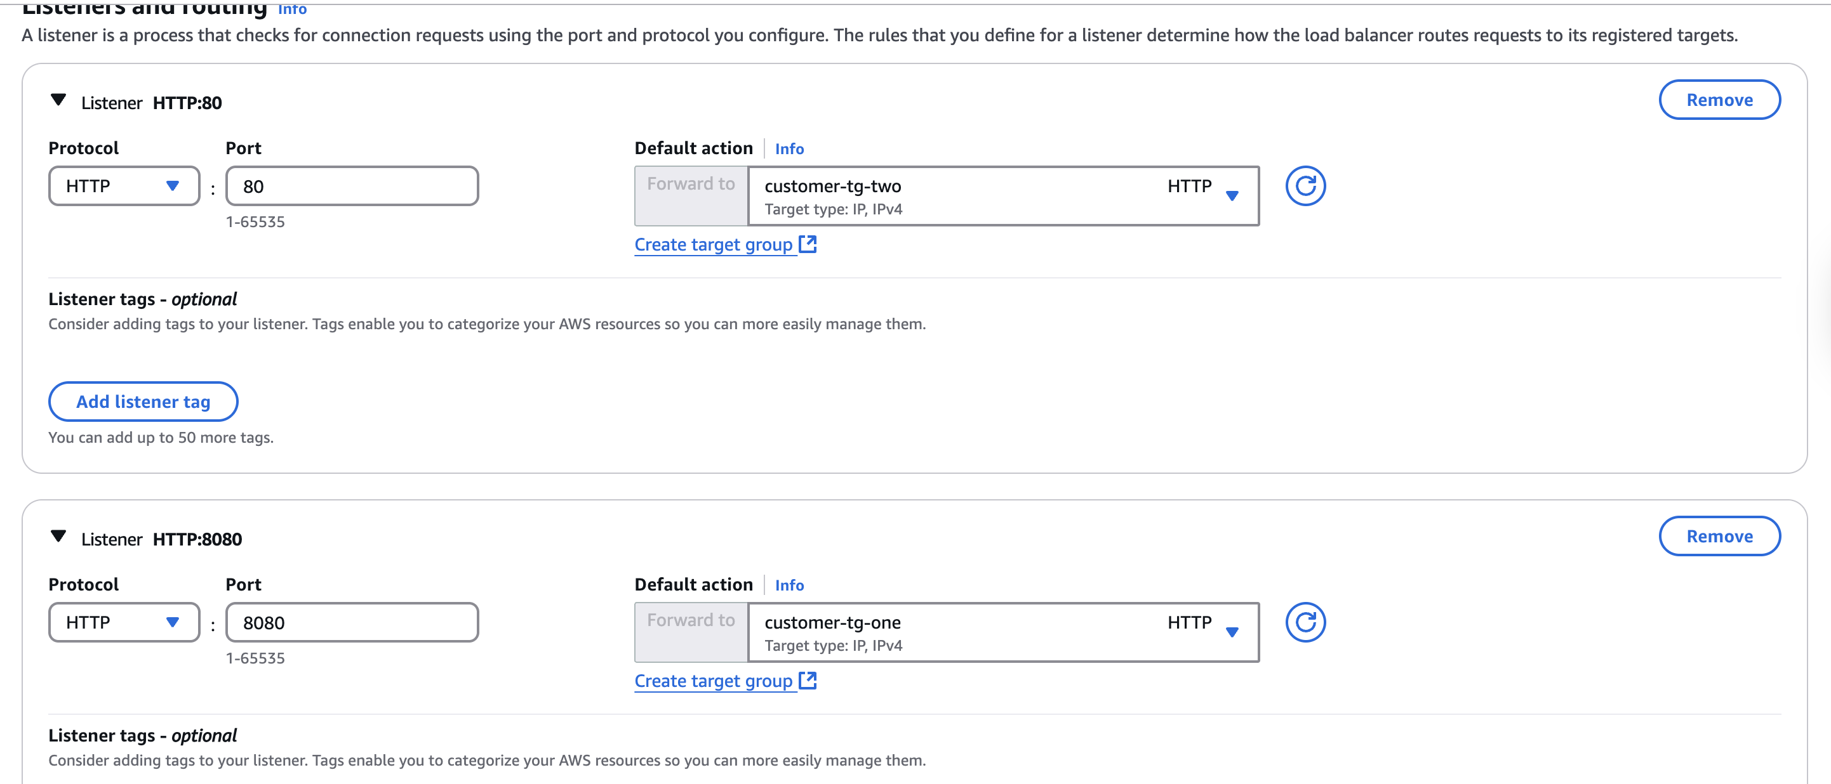

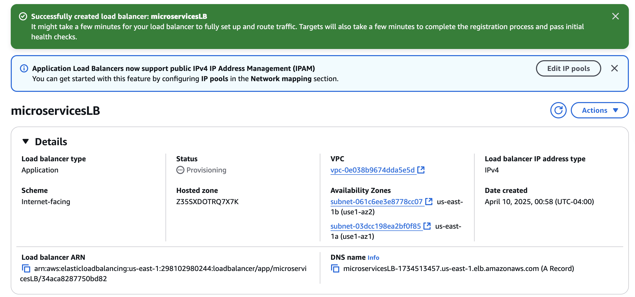

1. **Add a second rule for the *HTTP:80* listener. Define the following logic for this new rule:**
   * **IF Path is /admin/\***
   * **THEN Forward to... the employee-tg-two target group.**

**The settings should be the same as shown in the following image:**

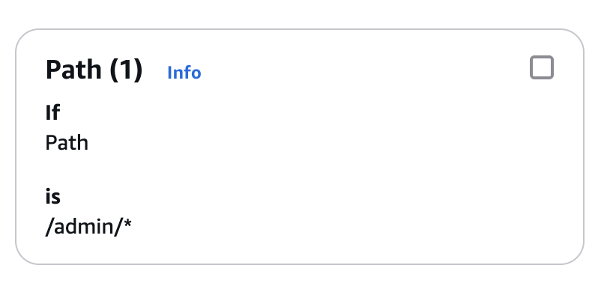 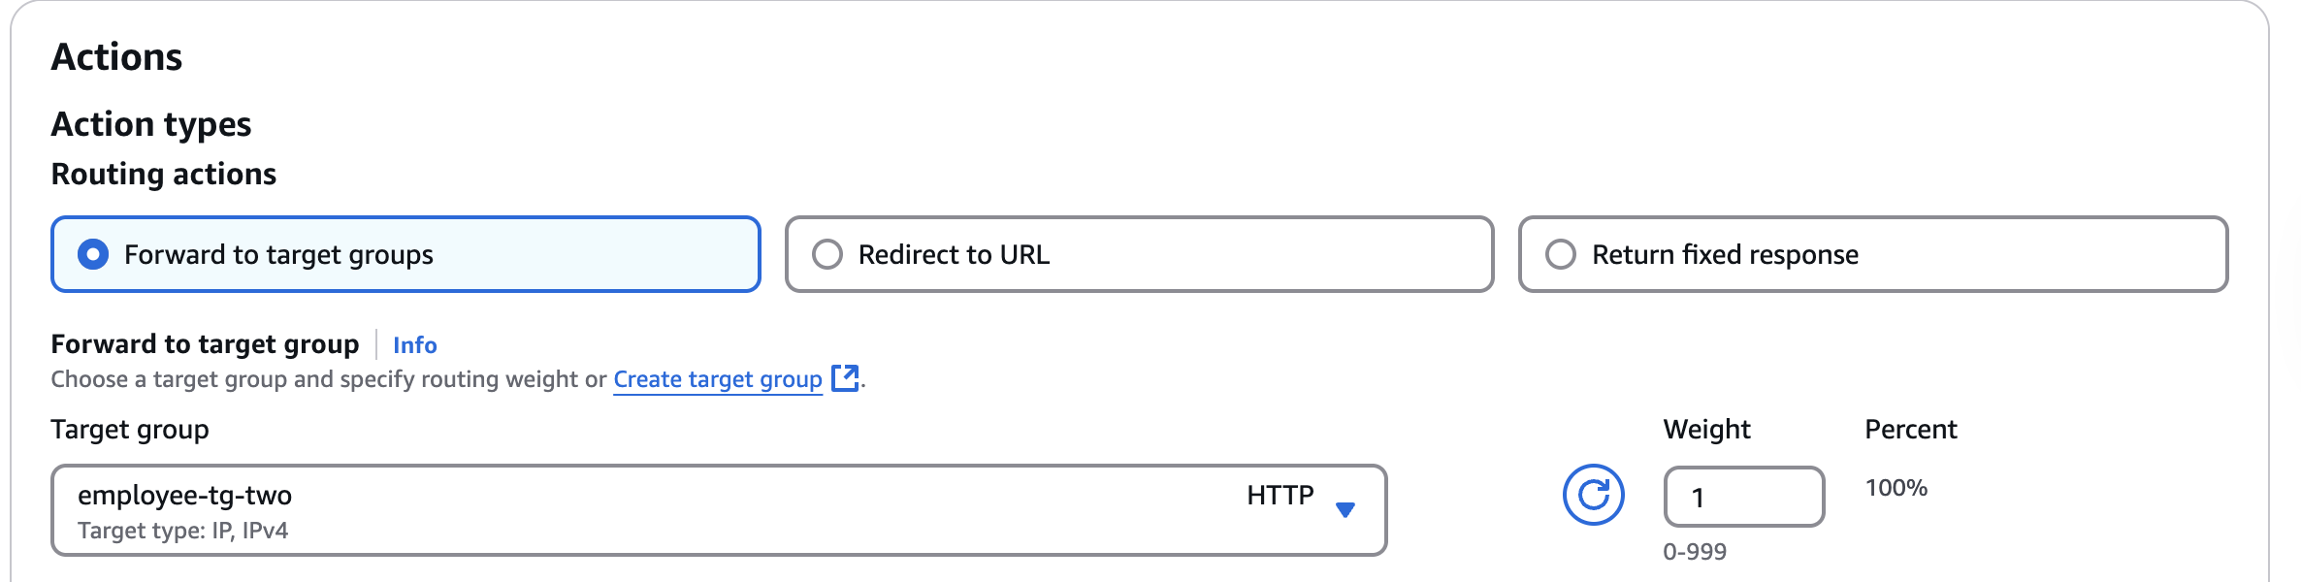

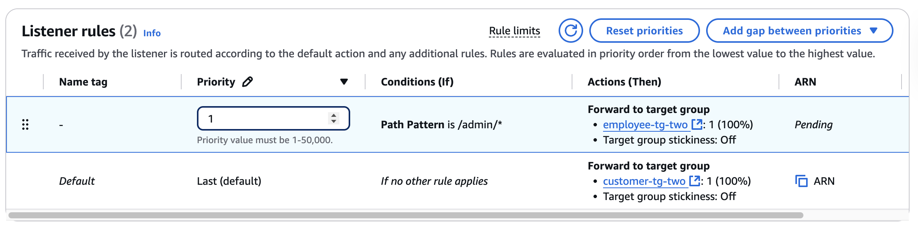

1. **Add a second rule for the *HTTP:8080* listener. Define the following logic for this new rule:**
   * **IF Path is /admin/\***
   * **THEN Forward to the employee-tg-one target group.**

**The settings should be the same as shown in the following image:**

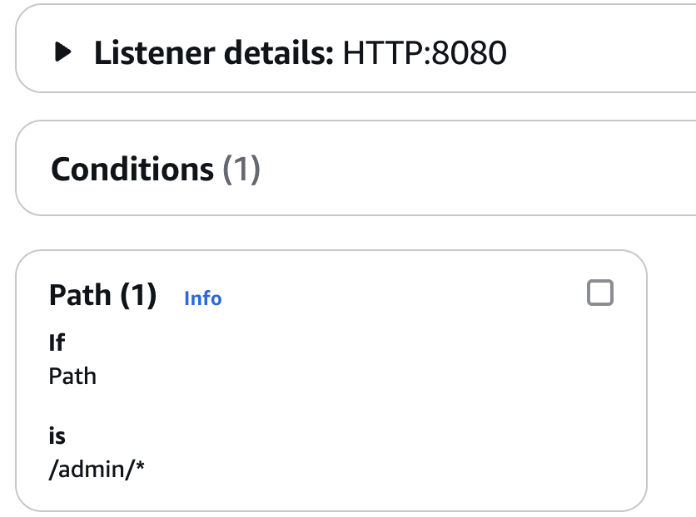

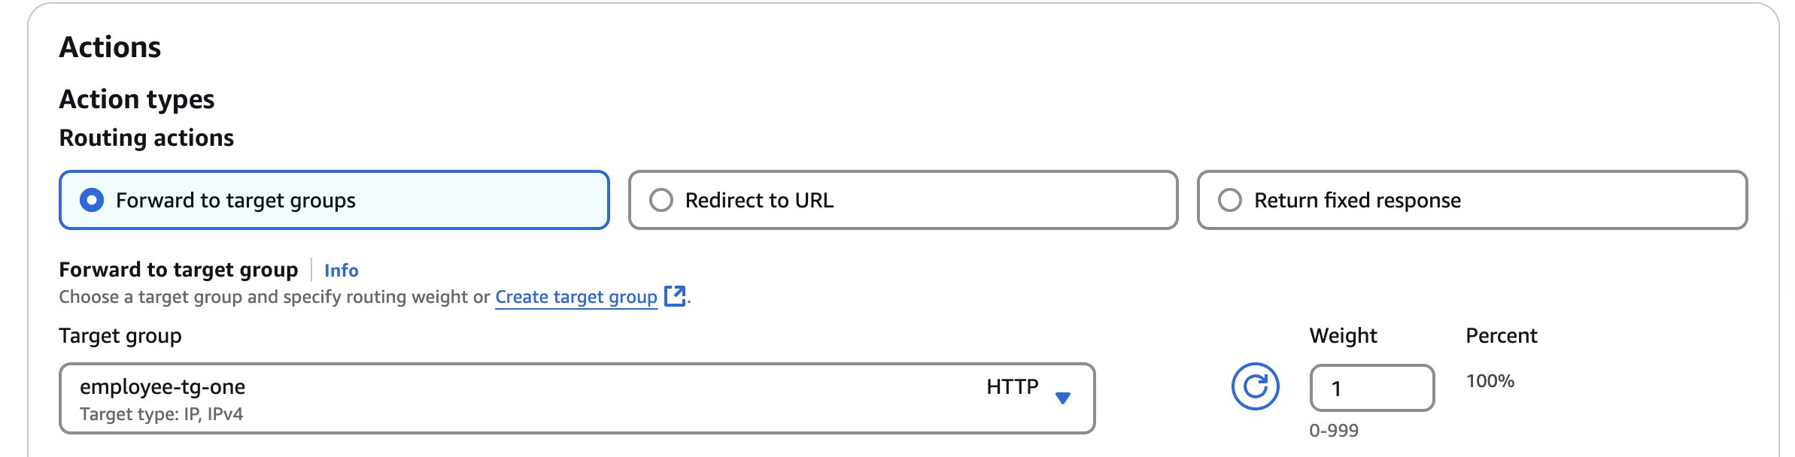

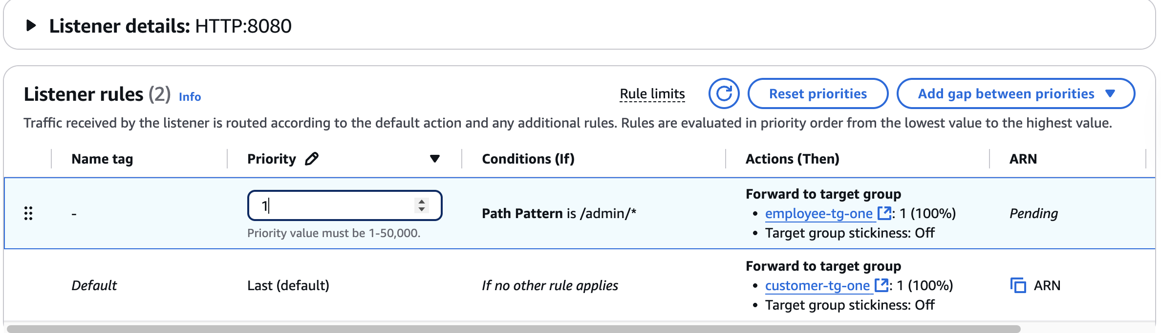

**Phase 7: Creating two Amazon ECS services**

1. **In AWS Cloud9, create a new file named create-customer-microservice-tg-two.json in the deployment directory.**
2. **Paste the following JSON code into the file:**

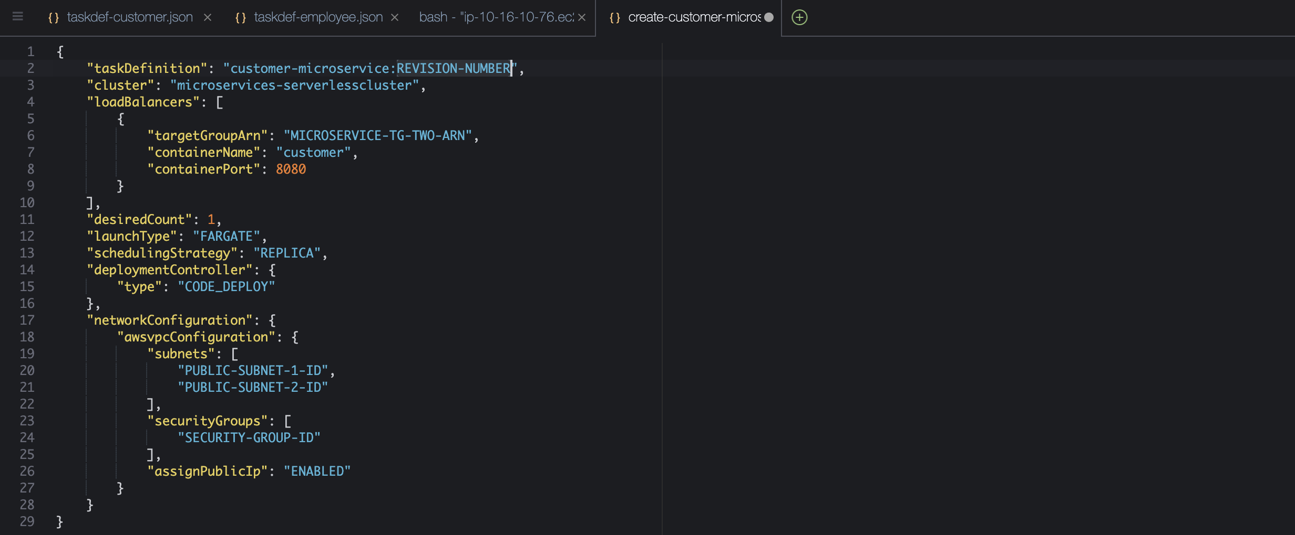

1. **Edit the create-customer-microservice-tg-two.json file:**
   * **Replace REVISION-NUMBER with the number of the latest revision of the *customer-microservice* task definition that is registered with Amazon ECS.**
     + **If this is the first time that you are completing this step, the revision number should be 1.**
     + **If you are repeating this step, find the latest revision number in the Amazon ECS console by choosing Task definitions, and then choosing customer-microservice.**
   * **Replace MICROSERVICE-TG-TWO-ARN with the actual ARN of the *customer-tg-two* target group.**
   * **arn:aws:elasticloadbalancing:us-east-1:298102980244:targetgroup/customer-tg-two/6ac97896b3b17508**
   * **Replace PUBLIC-SUBNET-1-ID with the actual subnet ID of *Public Subnet1*.**
   * **subnet-03dcc198ea2bf0f85**
   * **Replace PUBLIC-SUBNET-2-ID with the actual subnet ID of *Public Subnet2*.**
   * **subnet-061c6ee3e8778cc07**
   * **Replace SECURITY-GROUP-ID with the actual security group ID of *microservices-sg*.**
   * **sg-08877ef7a7d8fabd8**
   * **Save the changes.**

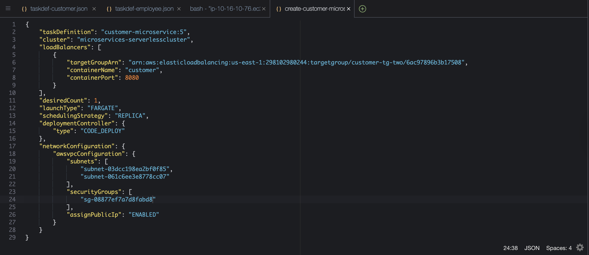

1. **To create the Amazon ECS service for the *customer* microservice, run the following commands:**

**cd ~/environment/deployment**

**aws ecs create-service --service-name customer-microservice --cli-input-json file://create-customer-microservice-tg-two.json**

**Troubleshooting tip: If you are repeating this step and previously created the ECS service, you might receive an error about the creation of the service not being idempotent. To resolve this error, force delete the service from the Amazon ECS console, wait for it to drain, and then run the commands again.**

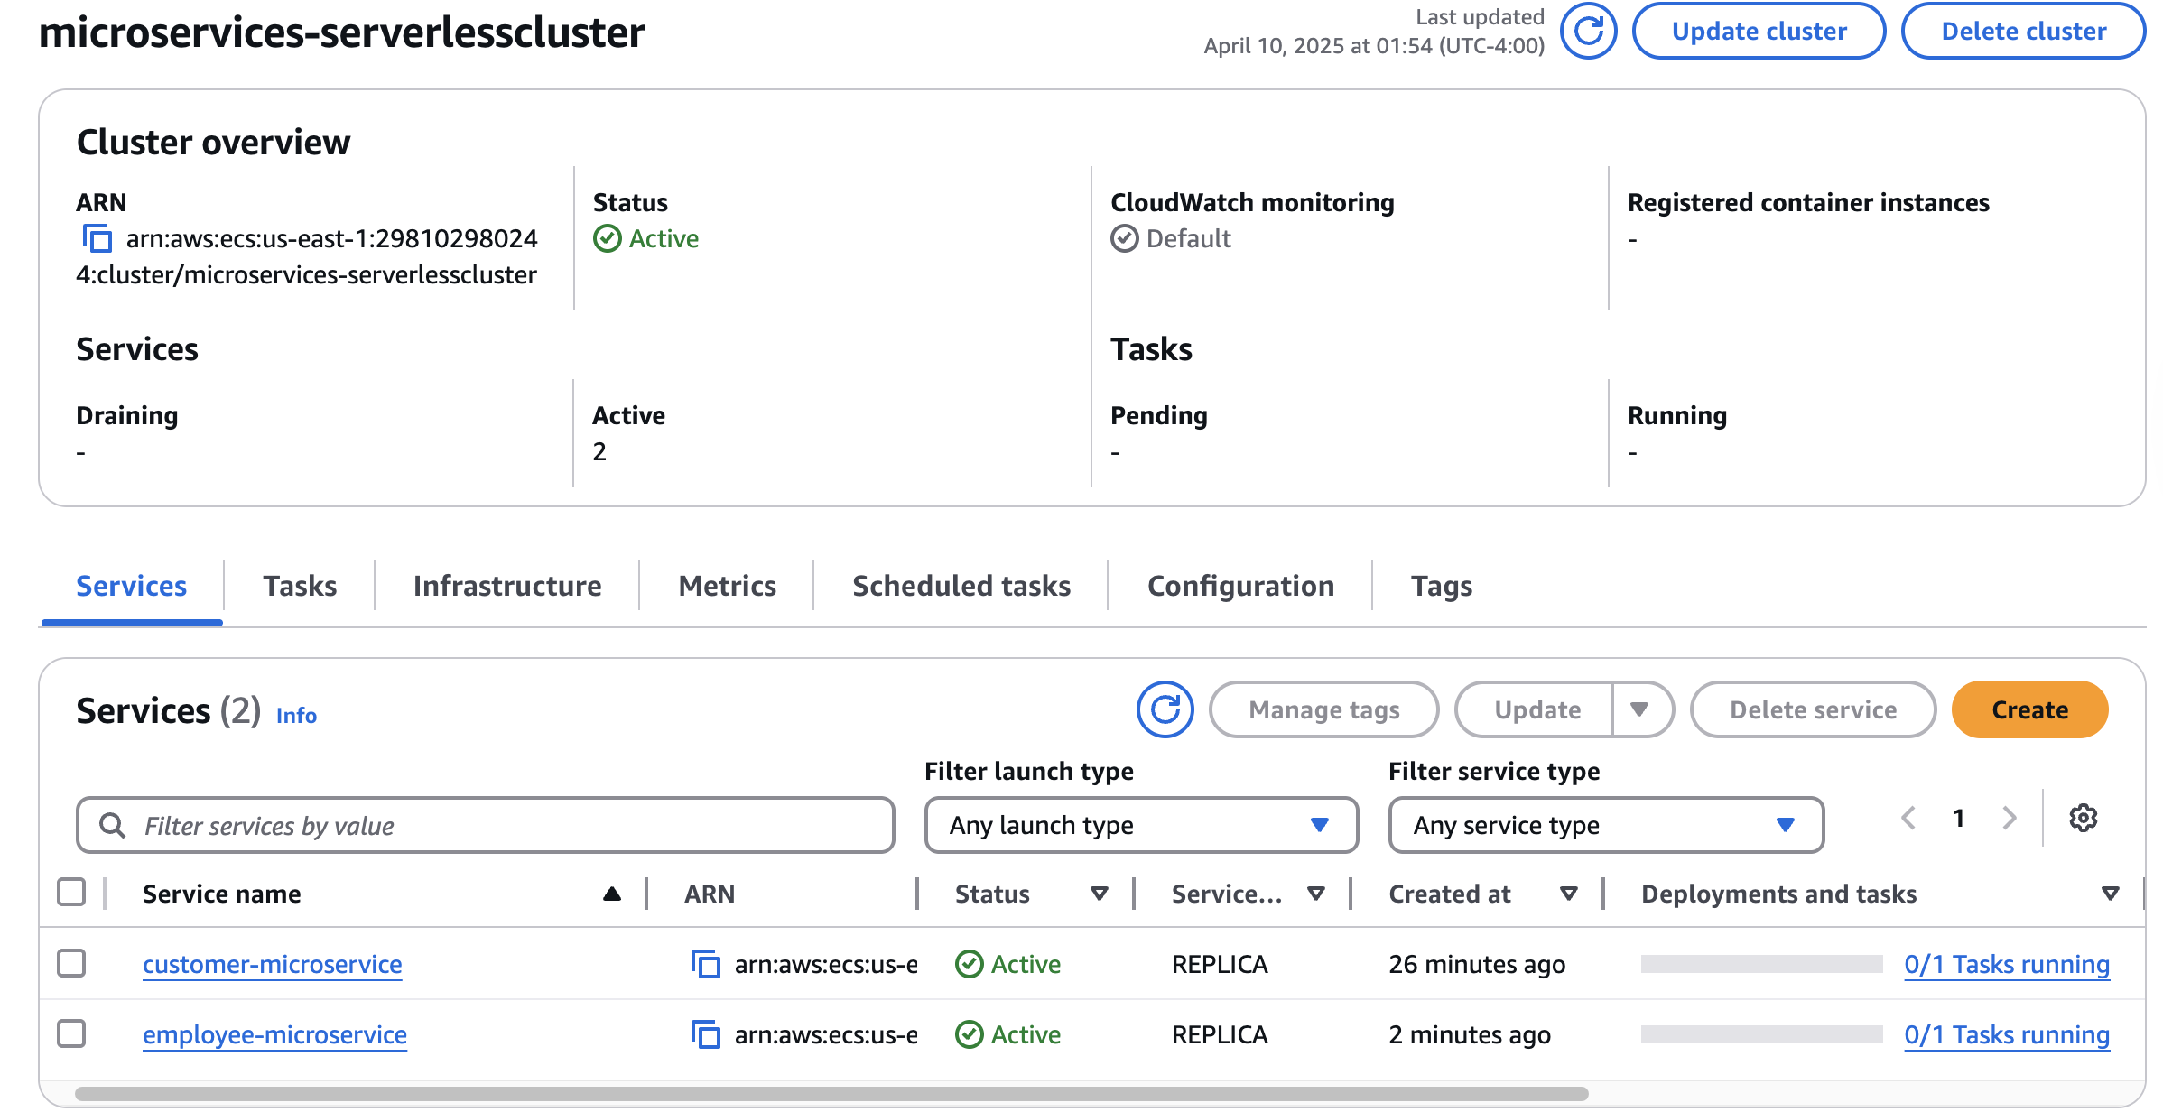

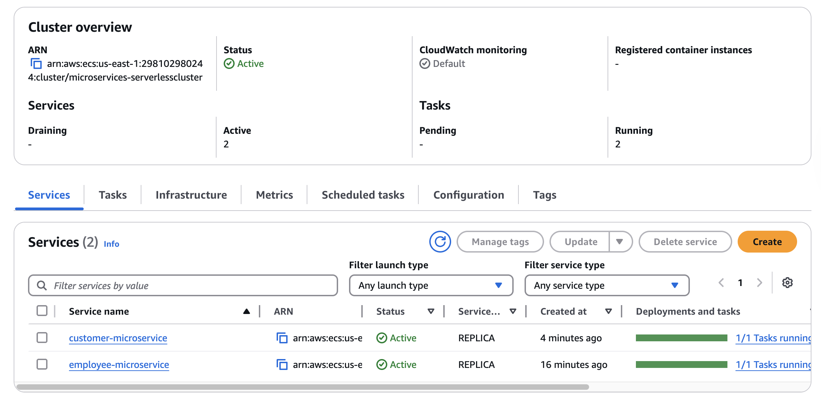

**Phase 8: Configuring CodeDeploy and CodePipeline**

**Task 8.1: Create a CodeDeploy application and deployment groups**

1. **Use the CodeDeploy console to create a CodeDeploy application with the name microservices that uses Amazon ECS as the compute platform.**

**Tip: See** [**Create an Application for an Amazon ECS Service Deployment (Console)**](https://docs.aws.amazon.com/codedeploy/latest/userguide/applications-create-ecs.html) **in the *AWS CodeDeploy User Guide*.**

**Important: *DON'T* create a deployment group yet. You will do that in the next step.**

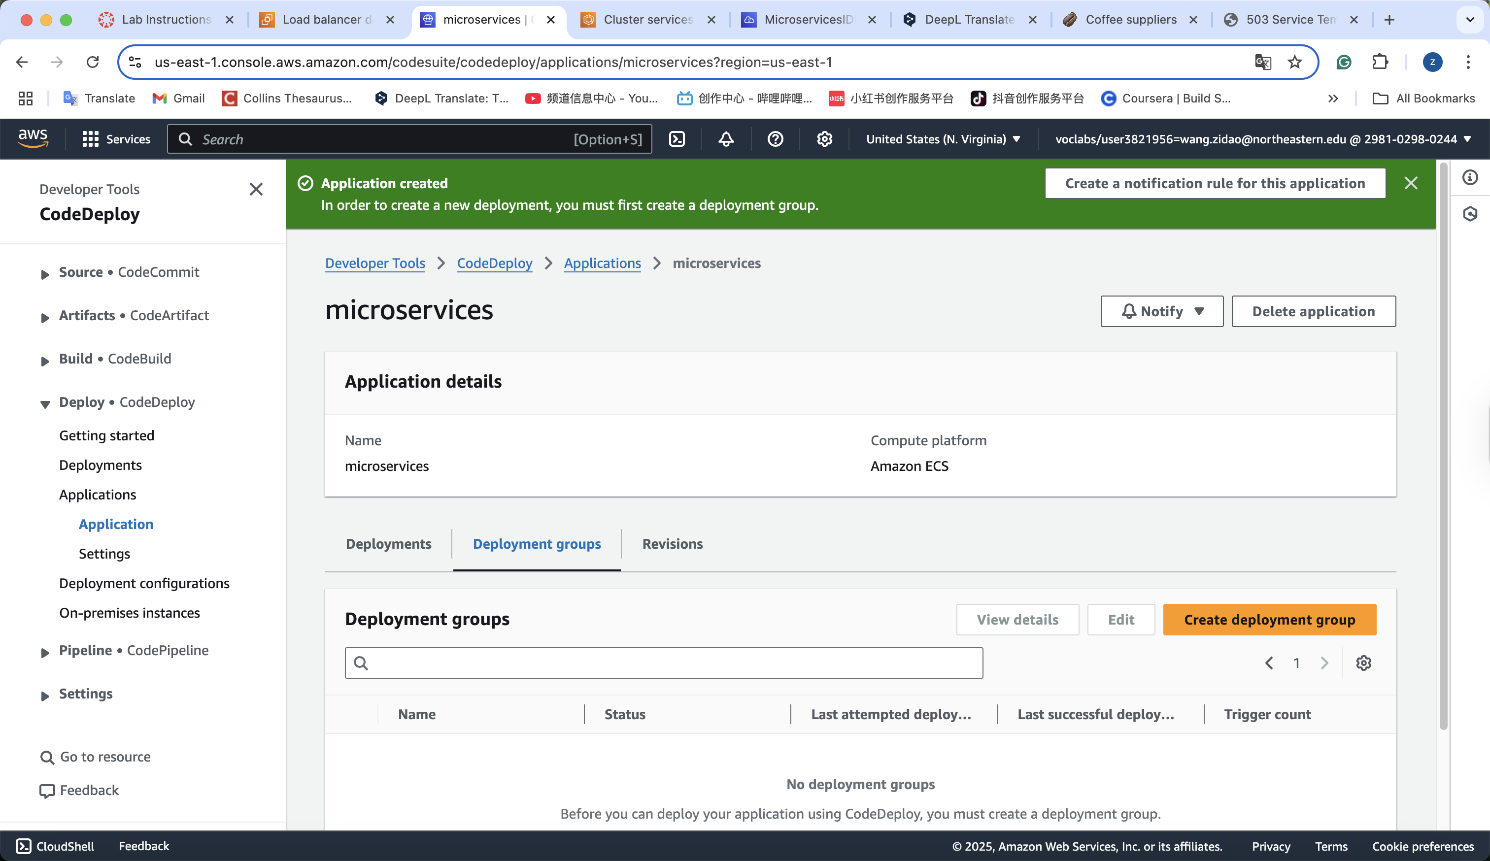

1. **Create a CodeDeploy deployment group for the *customer* microservice.**
   * **On the *microservices* application detail page, choose the Deployment groups tab.**
   * **Choose Create deployment group and configure the following:**
     + **Deployment group name: Enter microservices-customer**
     + 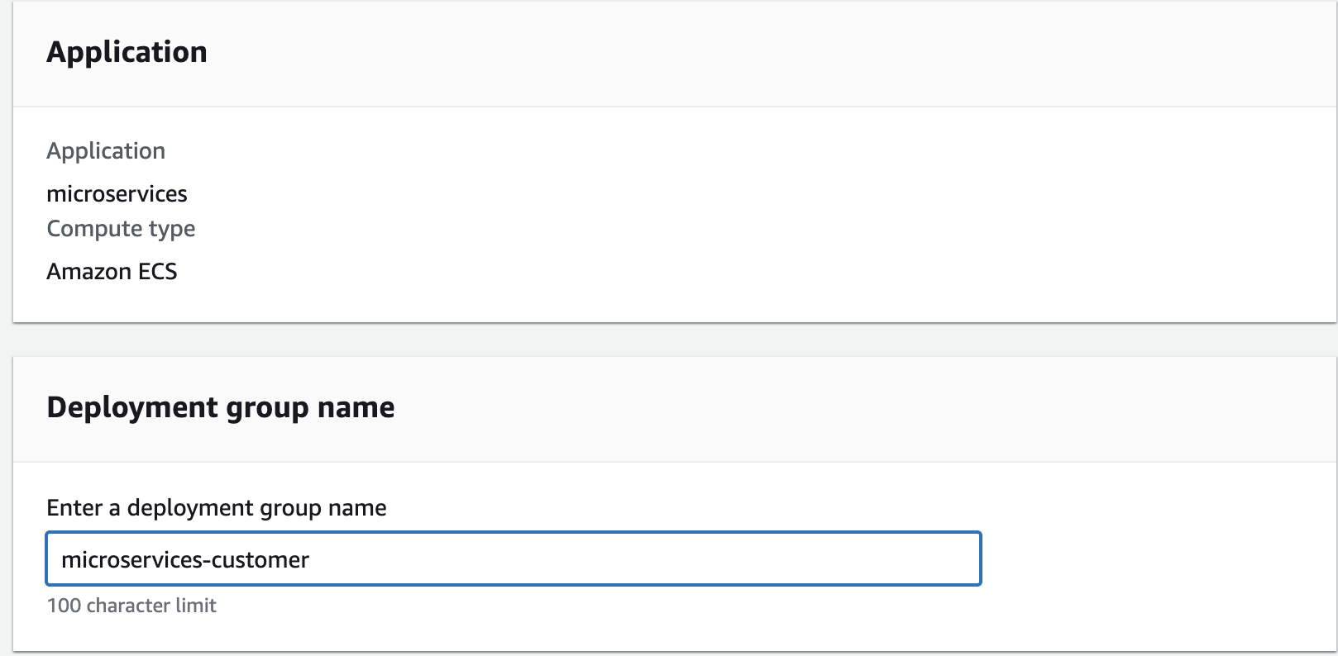
     + **Service role: Place your cursor in the search box, and choose the ARN for DeployRole.**
     + **In the Environment configuration section:**
       - **ECS cluster name: Choose microservices-serverlesscluster.**
       - **ECS service name: Choose customer-microservice.**
       - 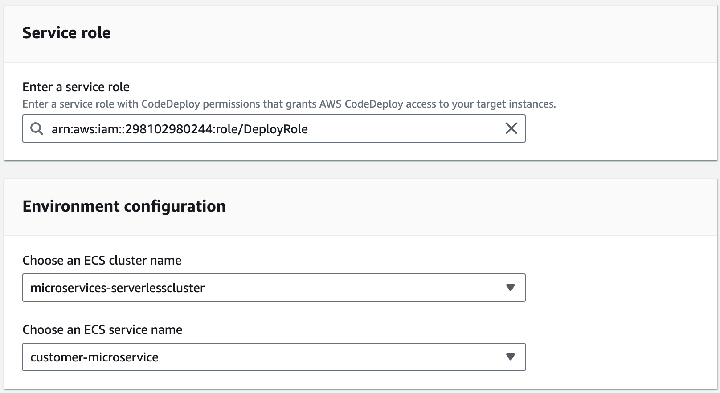
     + **In the Load balancers section:**
       - **Load balancer: Choose microservicesLB.**
       - **Production listener port: Choose HTTP:80.**
       - **Test listener port: Choose HTTP:8080.**
       - **Target group 1 name: Choose customer-tg-two.**
       - **Target group 2 name: Choose customer-tg-one.**
       - 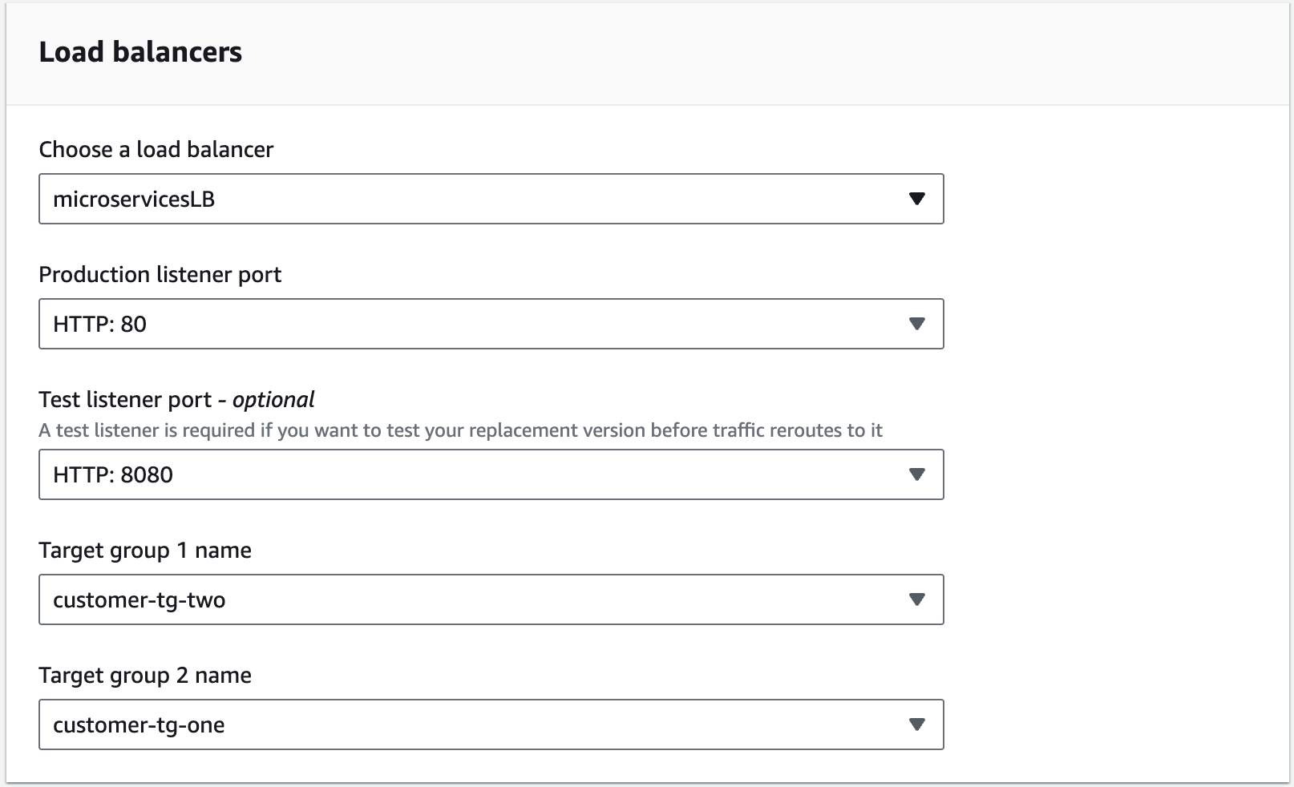
     + **In the Deployment settings section:**
       - **Traffic rerouting: Choose Reroute traffic immediately.**
       - **Deployment configuration: Choose CodeDeployDefault.ECSAllAtOnce.**
       - **Original revision termination: Days: 0, Hours: 0, Minutes: 5**
       - 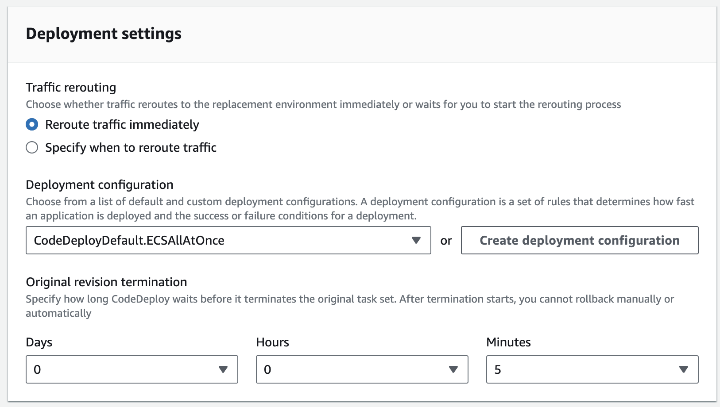
     + **Choose Create deployment group.**
     + 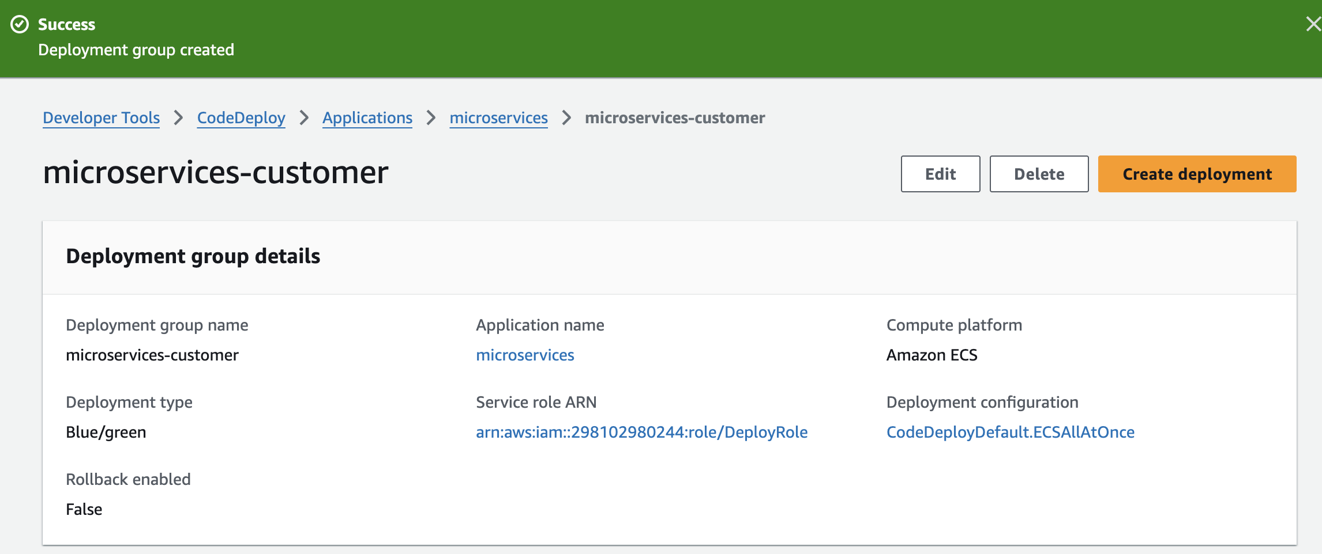

**Redo all for employee.**

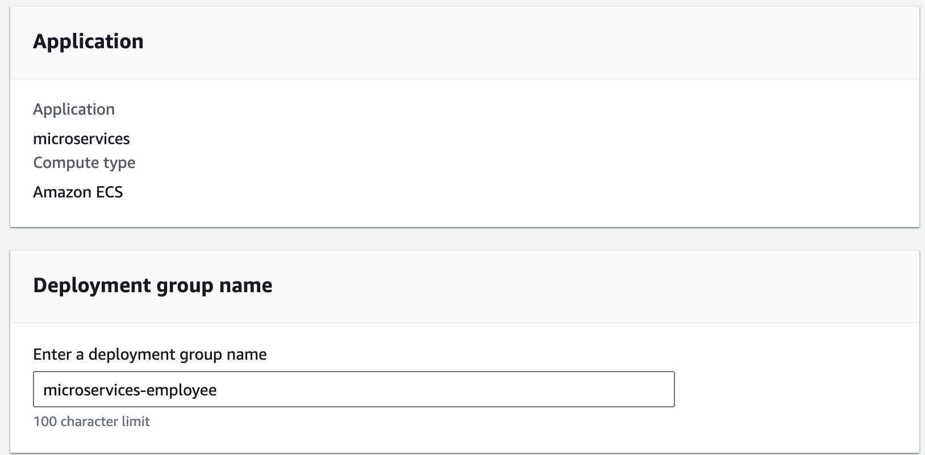

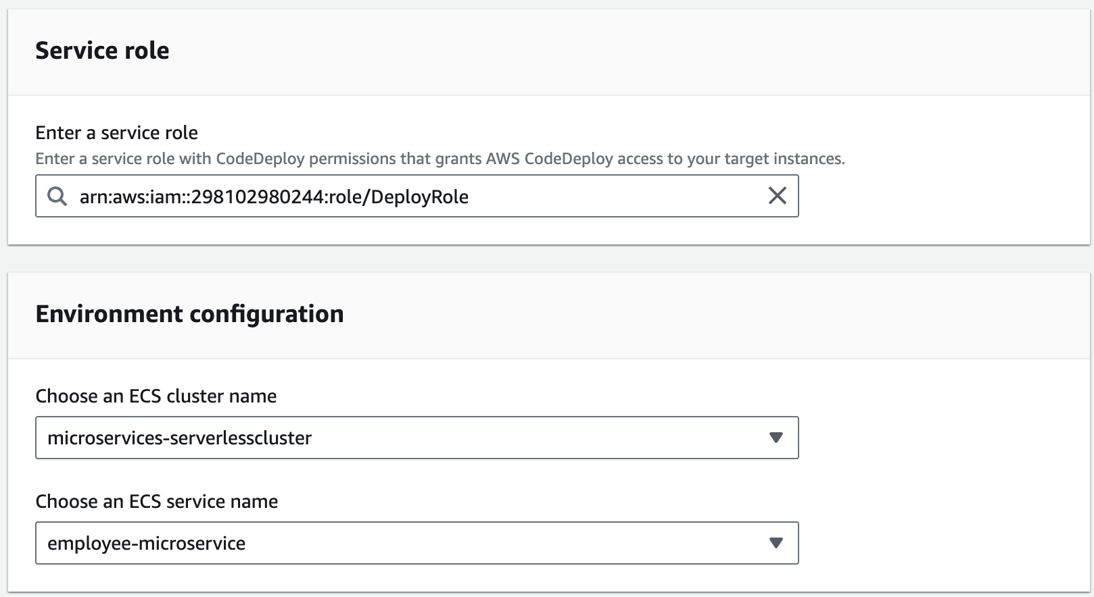

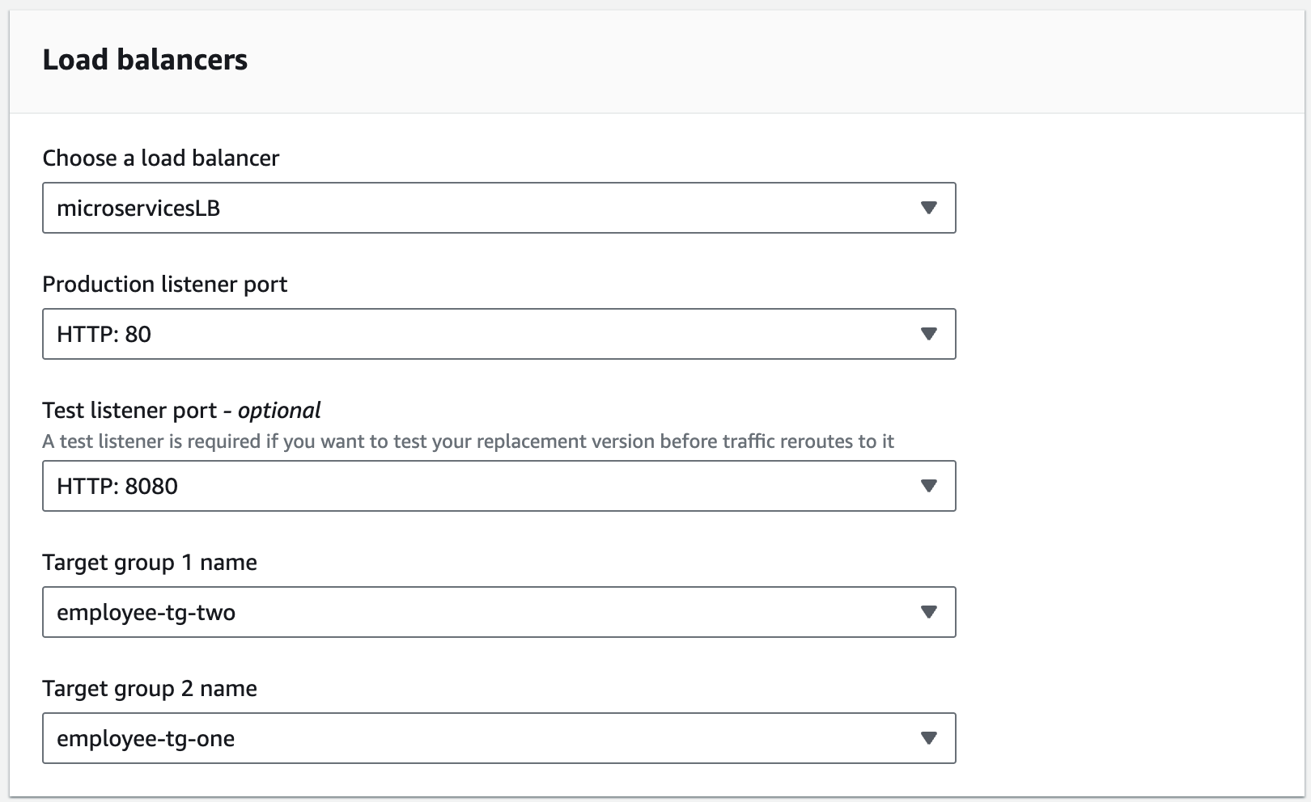 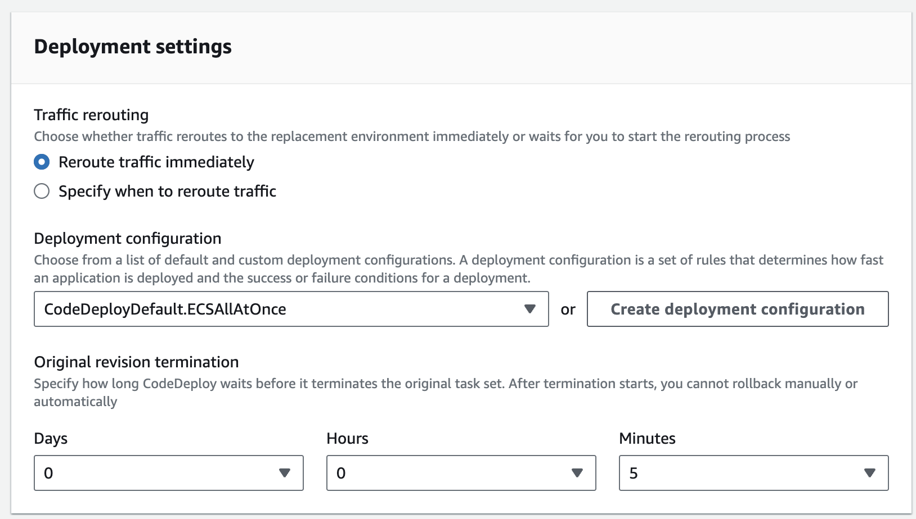

**Task 8.2: Create a pipeline for the *customer* microservice**

1. **In the CodePipeline console, create a *customer* pipeline with the following settings:**
2. 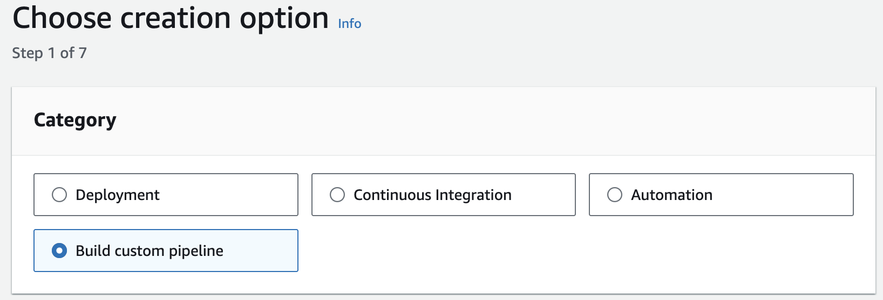
   * **Pipeline name: Enter update-customer-microservice**
   * **Service role: Choose the ARN for PipelineRole.**
   * 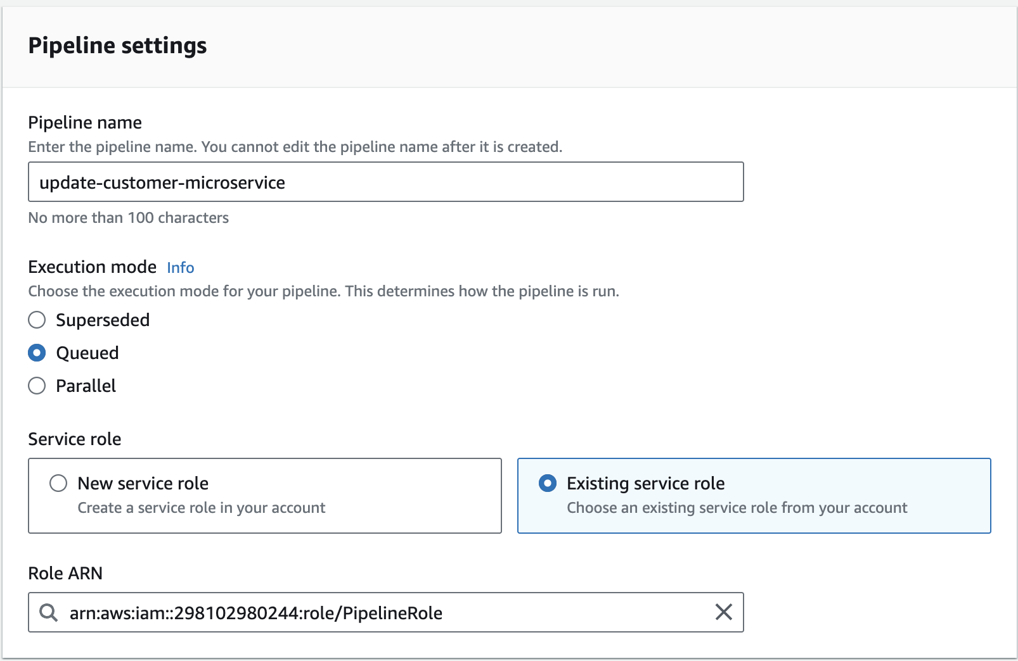
   * **Source provider: Choose AWS CodeCommit.**
     + **Repository name: Choose deployment.**

**Note: You have defined two CodeCommit repositories. The *deployment* repository contains the Amazon ECS task definition files and CodeDeploy AppSpec files that your pipeline will need, so that is the one you choose here.**

* + - **Branch name: Choose dev.**
    - 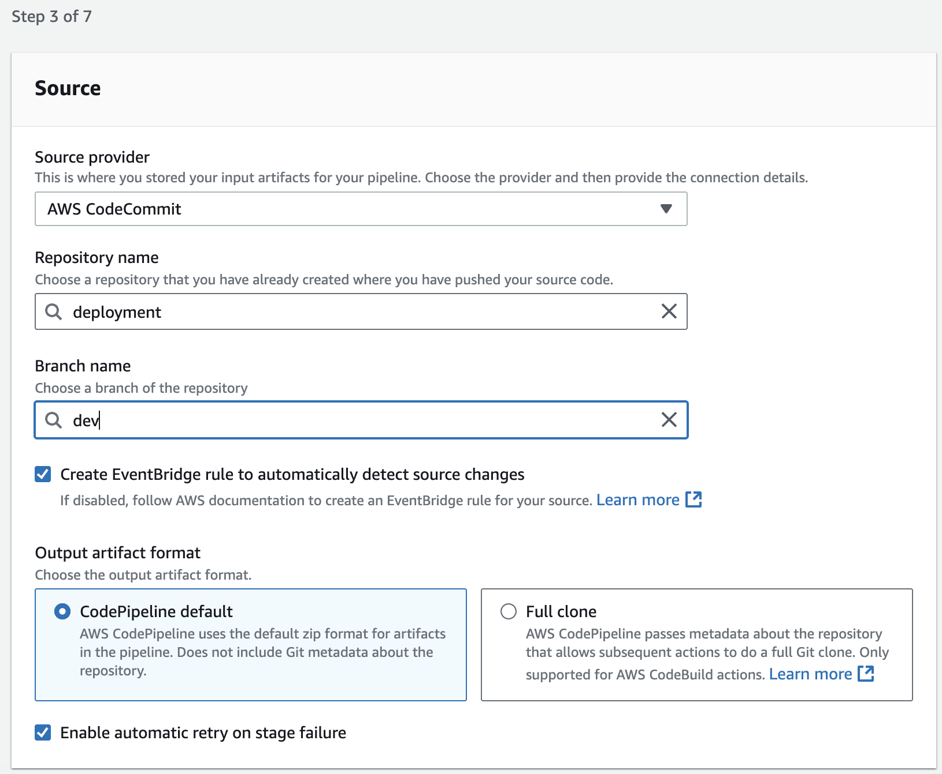

**Note: *Skip* the build&test stage.**

* + **Deploy provider: Amazon ECS (Blue/Green)**
    - **Region: US East (N. Virginia).**
    - 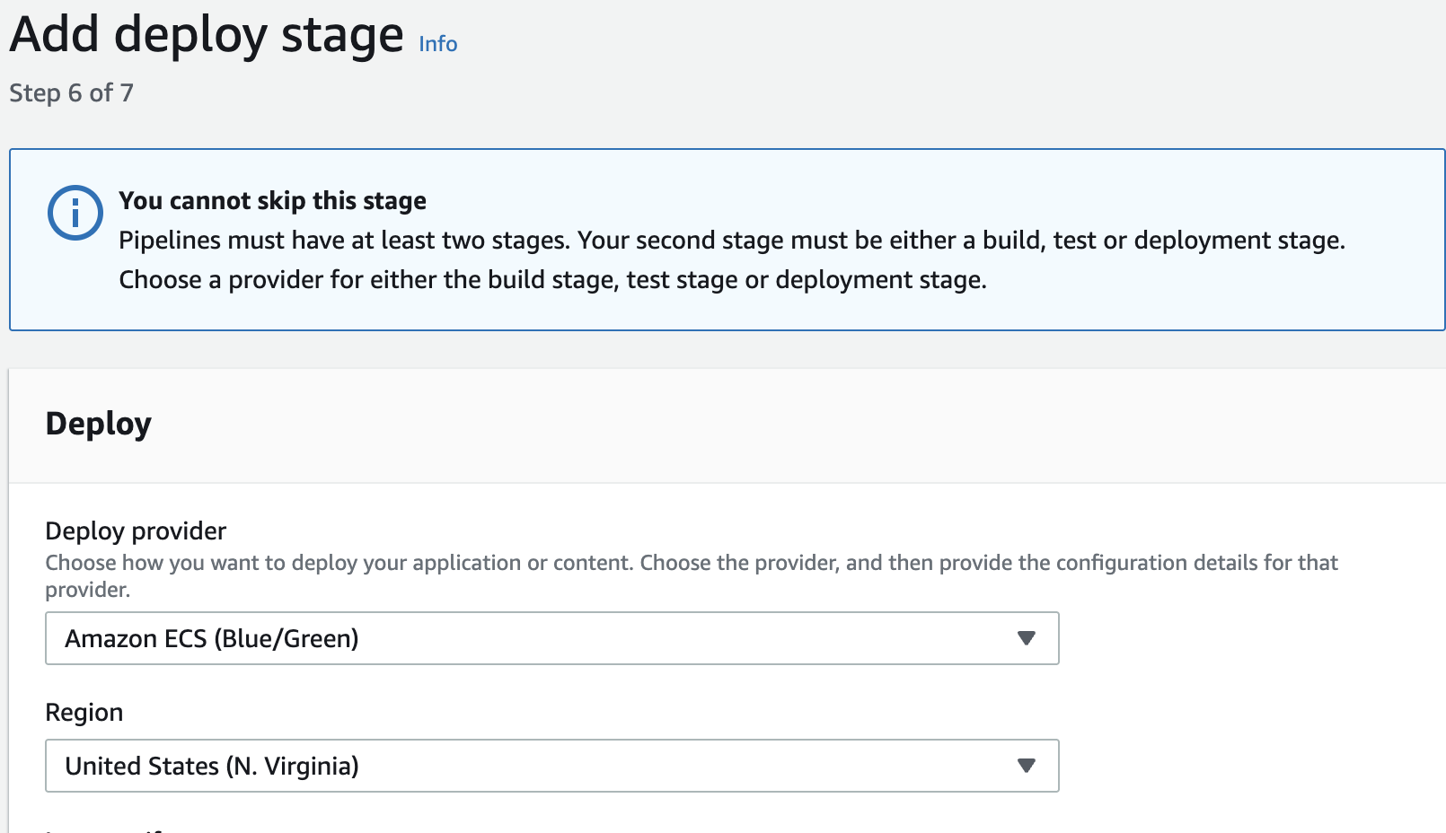
    - **AWS CodeDeploy application name: microservices**
    - **AWS CodeDeploy deployment group: microservices-customer**
    - 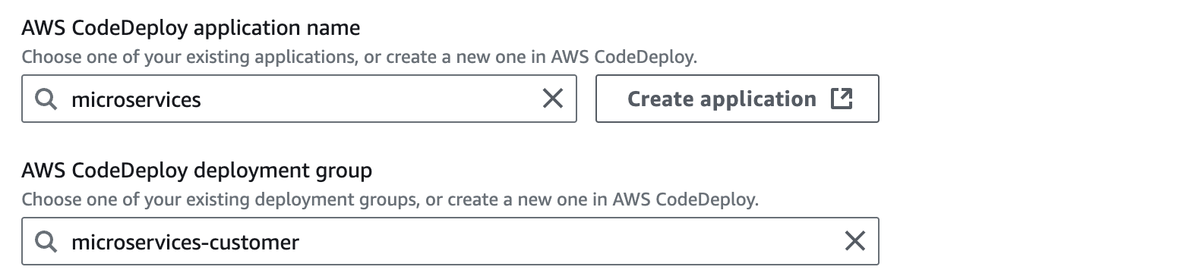
    - **Under Amazon ECS task definition:**
      * **Set a SourceArtifact with a value of taskdef-customer.json**
    - **Under AWS CodeDeploy AppSpec file:**
      * **Set a SourceArtifact with a value of appspec-customer.yaml**
      * 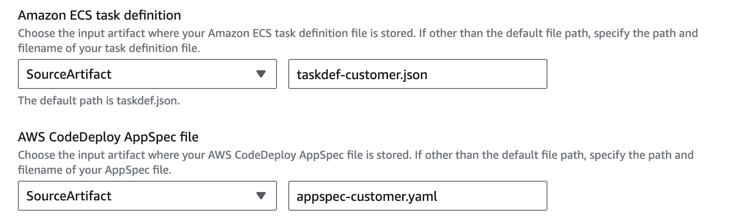

**Note: Leave the *Dynamically update task definition image* fields *blank* for now.**

1. **Note: After you create the pipeline, it will immediately start to run and will eventually fail on the *Deploy* stage. Ignore that for now and continue to the next step.**
2. Edit the update-customer-microservice pipeline to add another source.
   * In the **Edit: Source** section, choose **Edit stage**, then add an action with these details:
     + **Action name:** Image
     + **Action provider:** Amazon ECR
     + **Repository name:** customer
     + **Image tag:** latest
     + **Output artifacts:** image-customer
     + 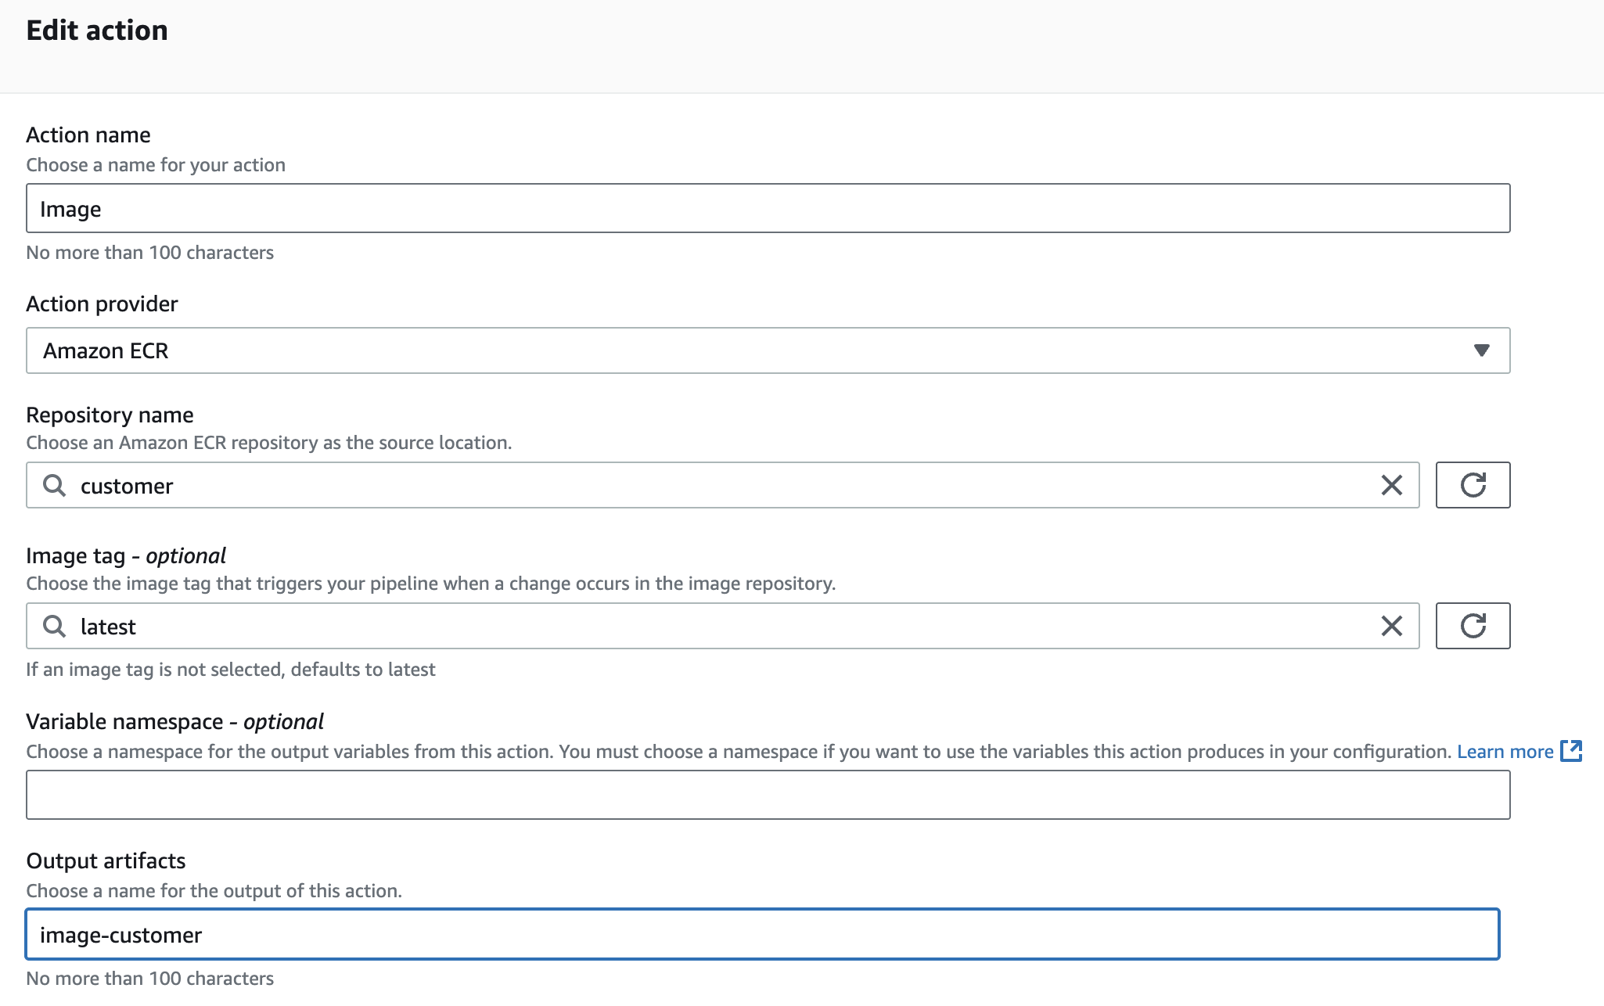
3. Edit the deploy action of the update-customer-microservice pipeline.
   * Edit the **update-customer-microservice** pipeline
     + In the **Edit: Deploy** section, choose **Edit stage**, then add an input artifact as described below:
       - On the **Deploy Amazon ECS (Blue/Green)** card, choose the edit (pencil) icon.
       - Under **Input artifacts**, choose **Add** and then choose **image-customer**.

**Note:** You should now have SourceArtifact and image-customer as listed input artifacts.

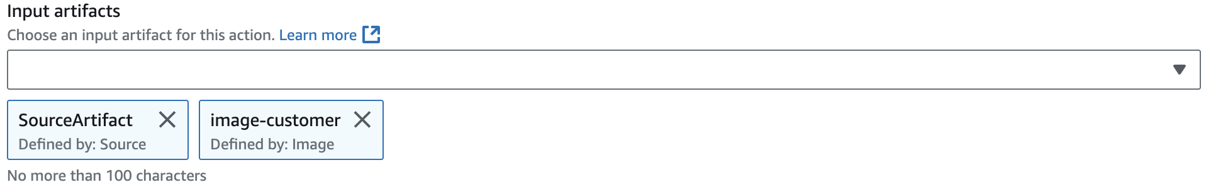

* + - Under **Dynamically update task definition image**, for **Input artifact with image details**, choose **image-customer**.
    - For **Placeholder text in the task definition**, enter IMAGE1_NAME 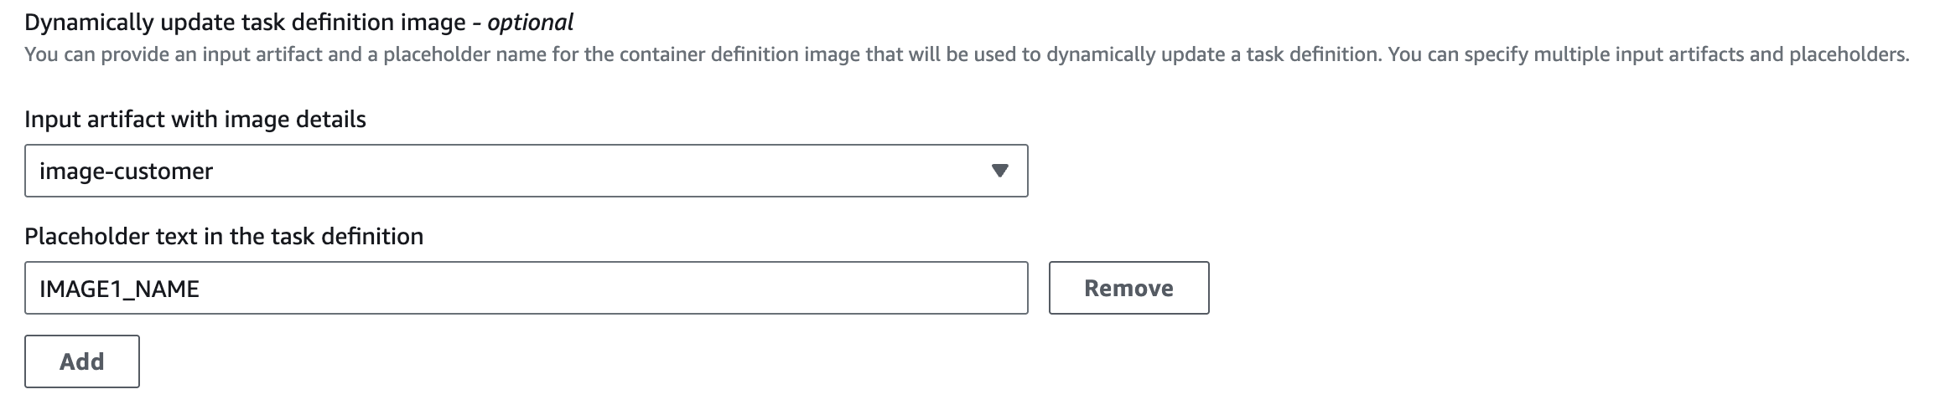

**Analysis:** Recall that in a previous phase, you entered the IMAGE1_NAME placeholder text in the taskdef-customer.json file before you pushed it to CodeCommit. In this current task, you configured the logic that will replace the placeholder text with the actual image name that the source phase of the CodePipeline returns.

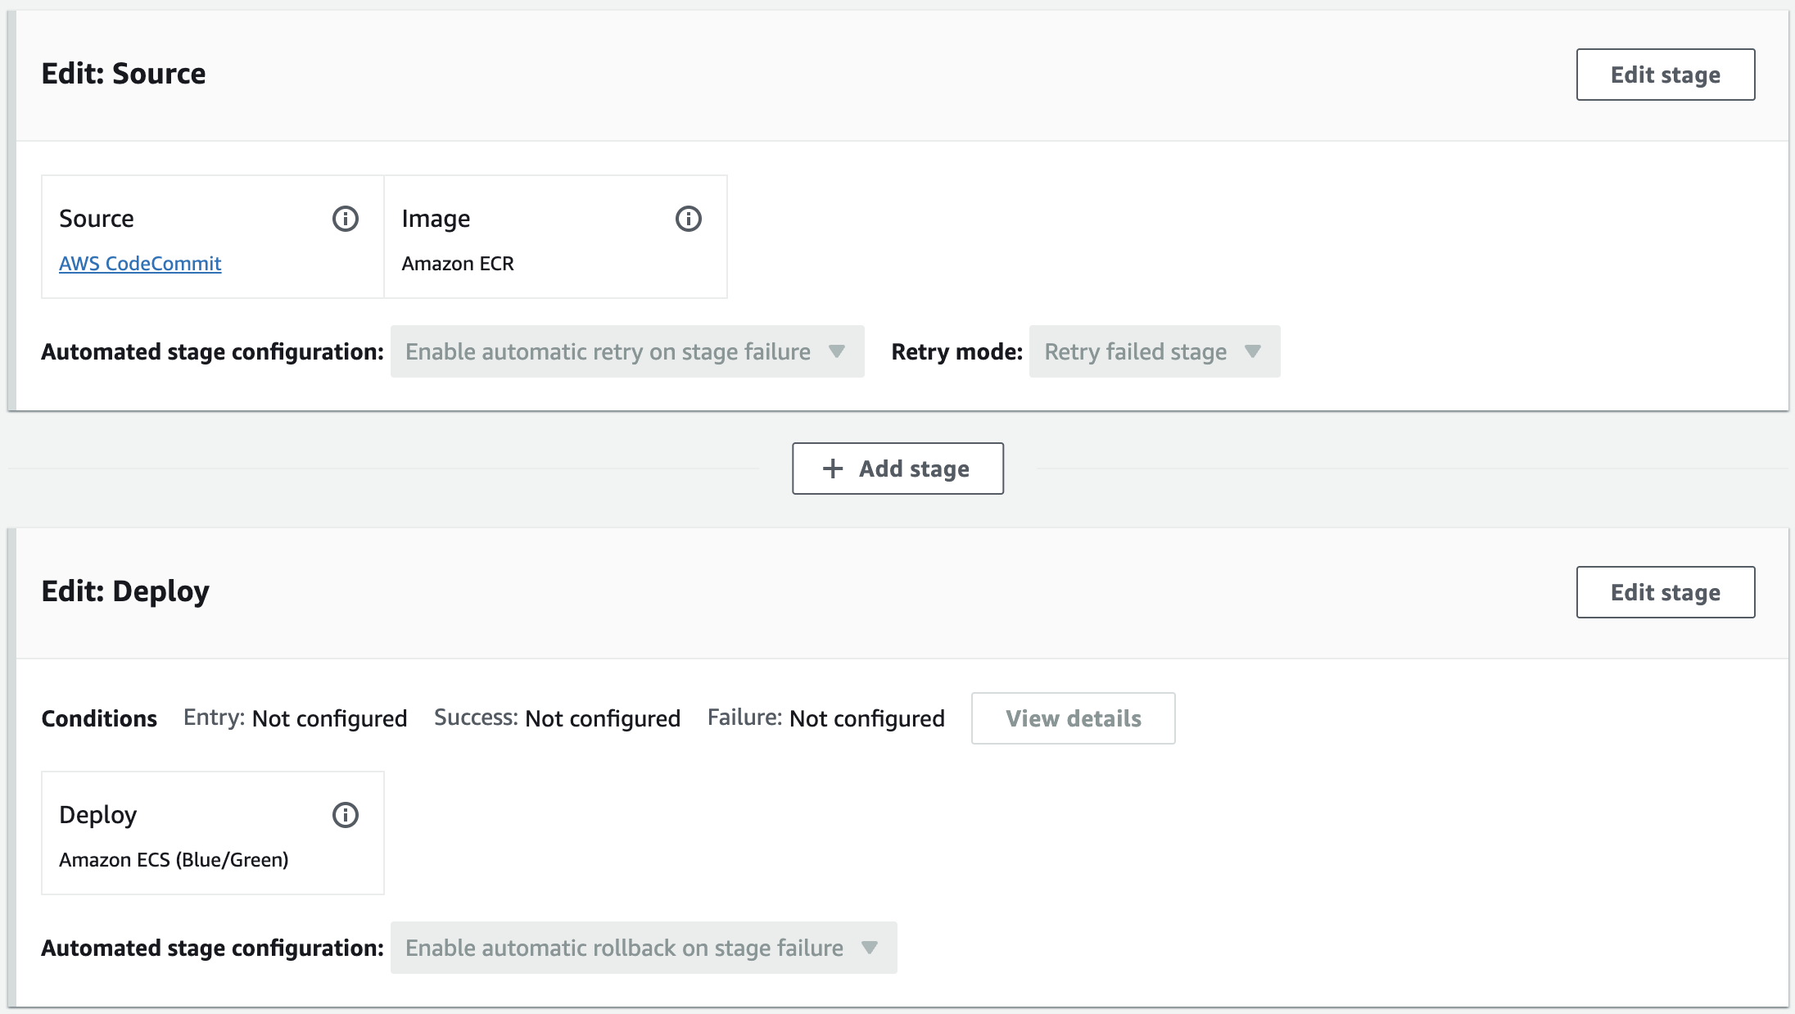

**Task 8.3: Test the CI/CD pipeline for the *customer* microservice**

After release change

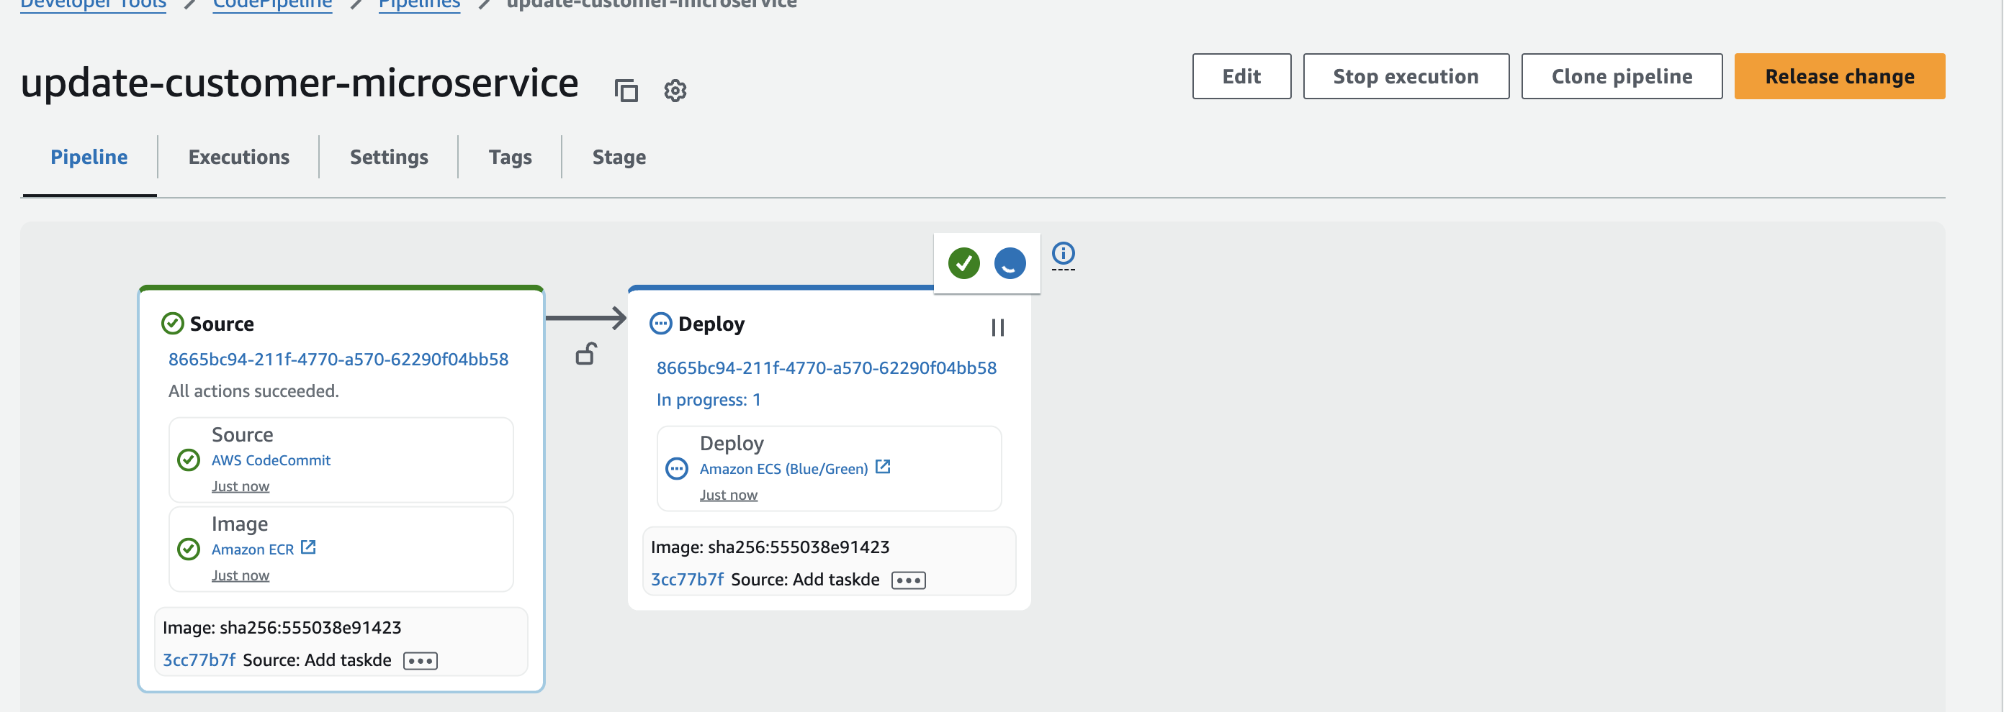

* Wait for the two *Source* tasks to show a status of *Succeeded - just now*.
* In the **Deploy** section, wait for a **Details** link to appear, and then click the link.

A CodeDeploy page opens in a new browser tab.

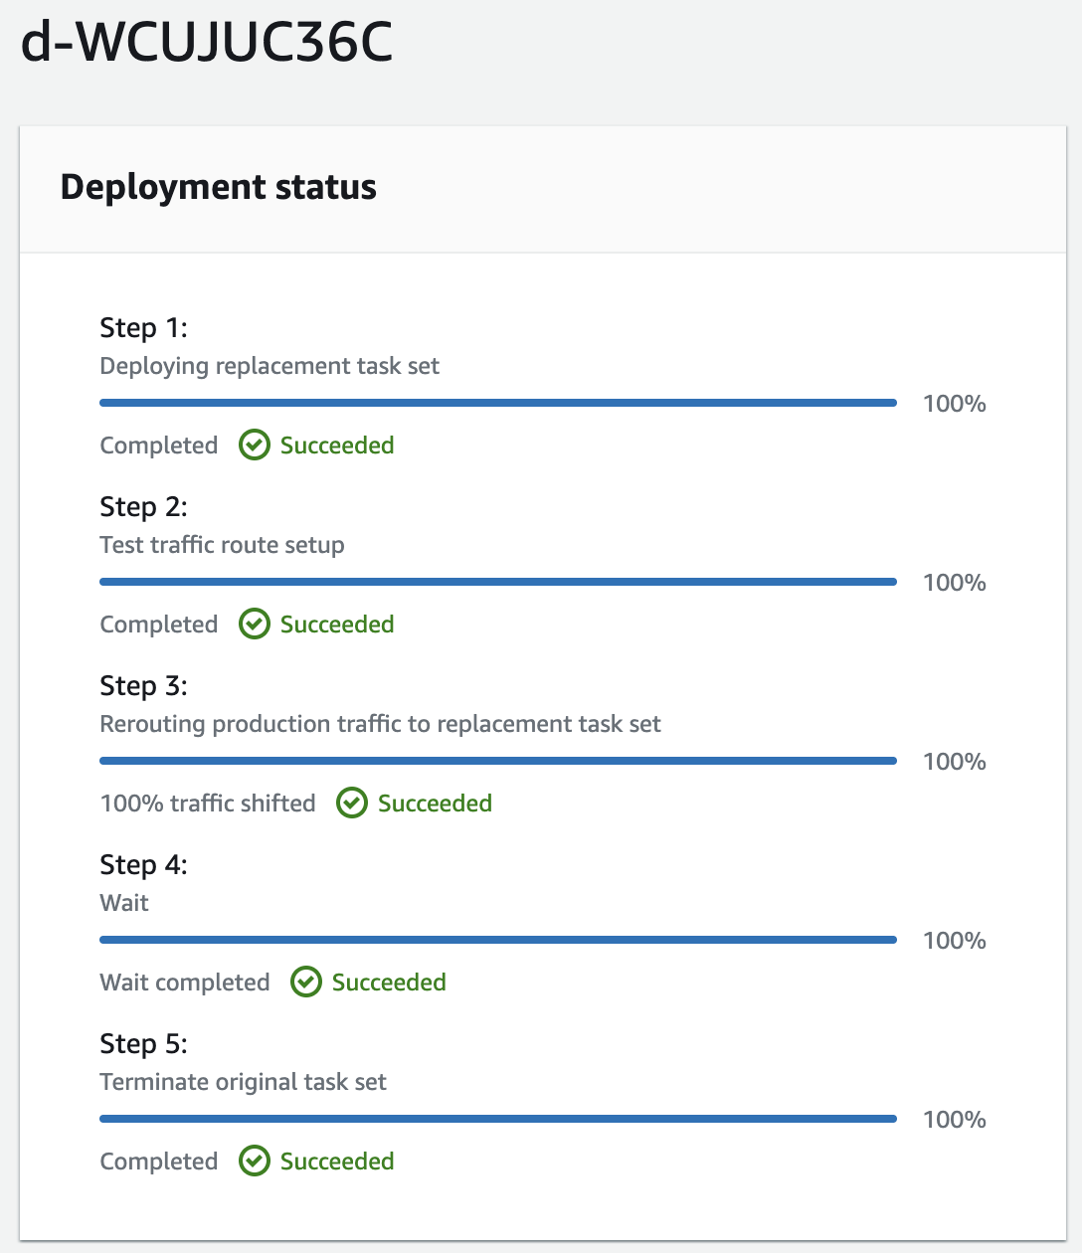

* **Locate the DNS name value of the microservicesLB load balancer, and paste it into a new browser tab.**

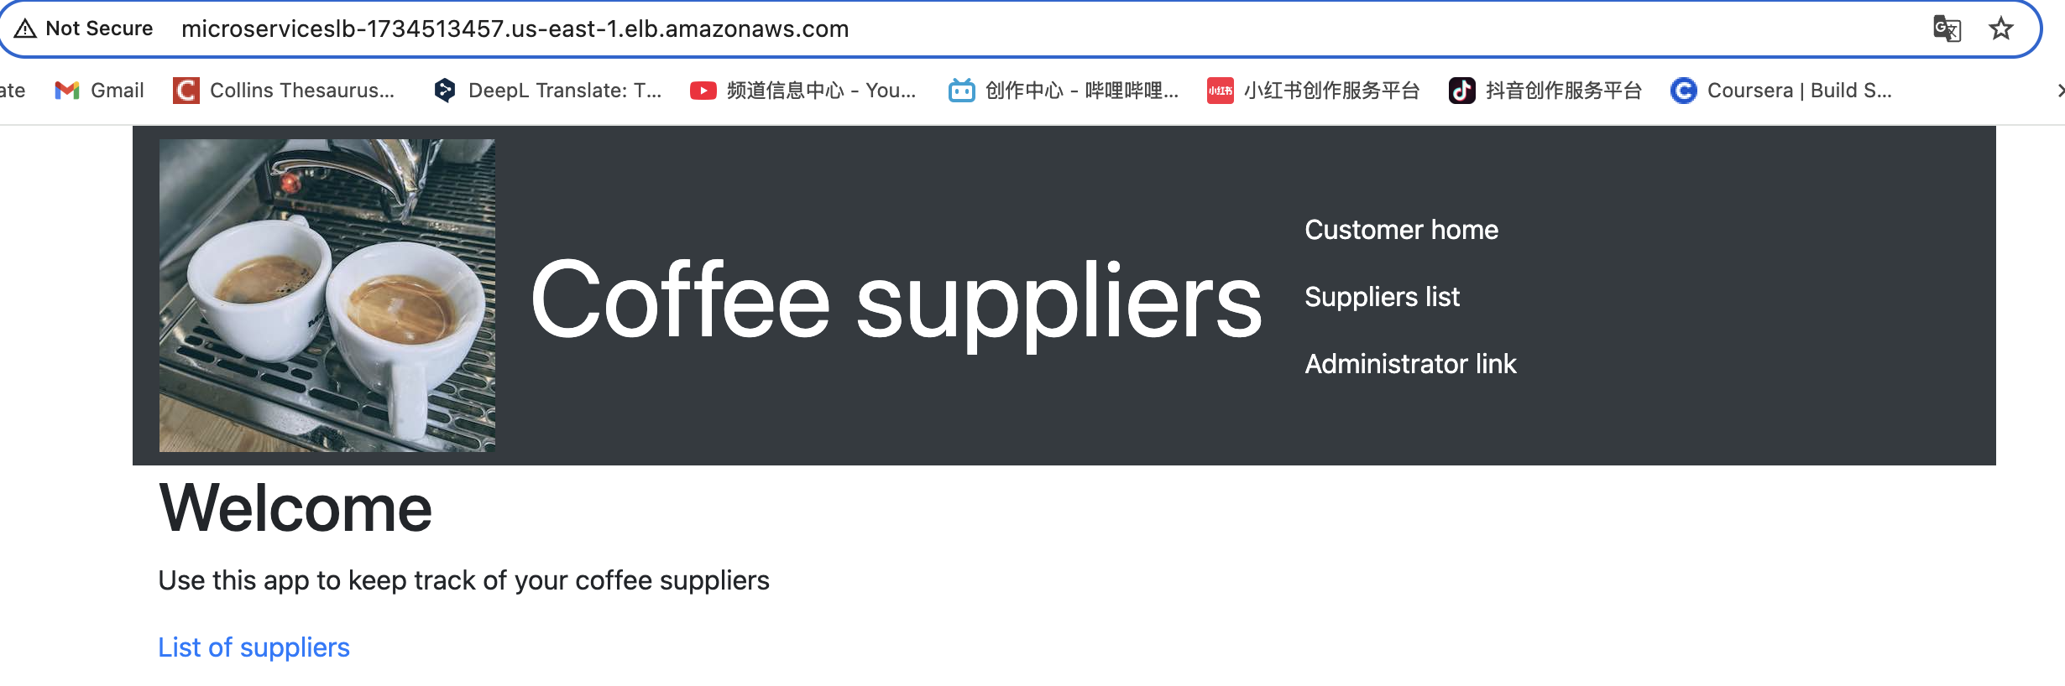

**The customer microservice loads. If it doesn't load, add :8080 to the end of the URL and try again.**

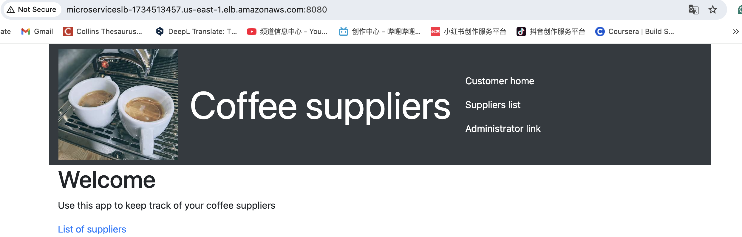

1. **Observe the running tasks in the Amazon ECS console.**
   * **Navigate to the Amazon ECS console.**
   * **In the clusters list, choose the link for microservices-serverlesscluster.**

**On the Services tab, notice that the *customer-microservice* service appears. The Deployments and tasks status will change as the blue/green deployment advances through its lifecycle events.**

* + **Choose the Tasks tab.**

**Here you can see the actual tasks that are running. You might have more than one task running per service that you defined.**

* + **Choose the link for one of the listed tasks. You might only have one.**

**Here you can see the actual container details and the configuration information, such as the IP addresses that are associated with the running container.**

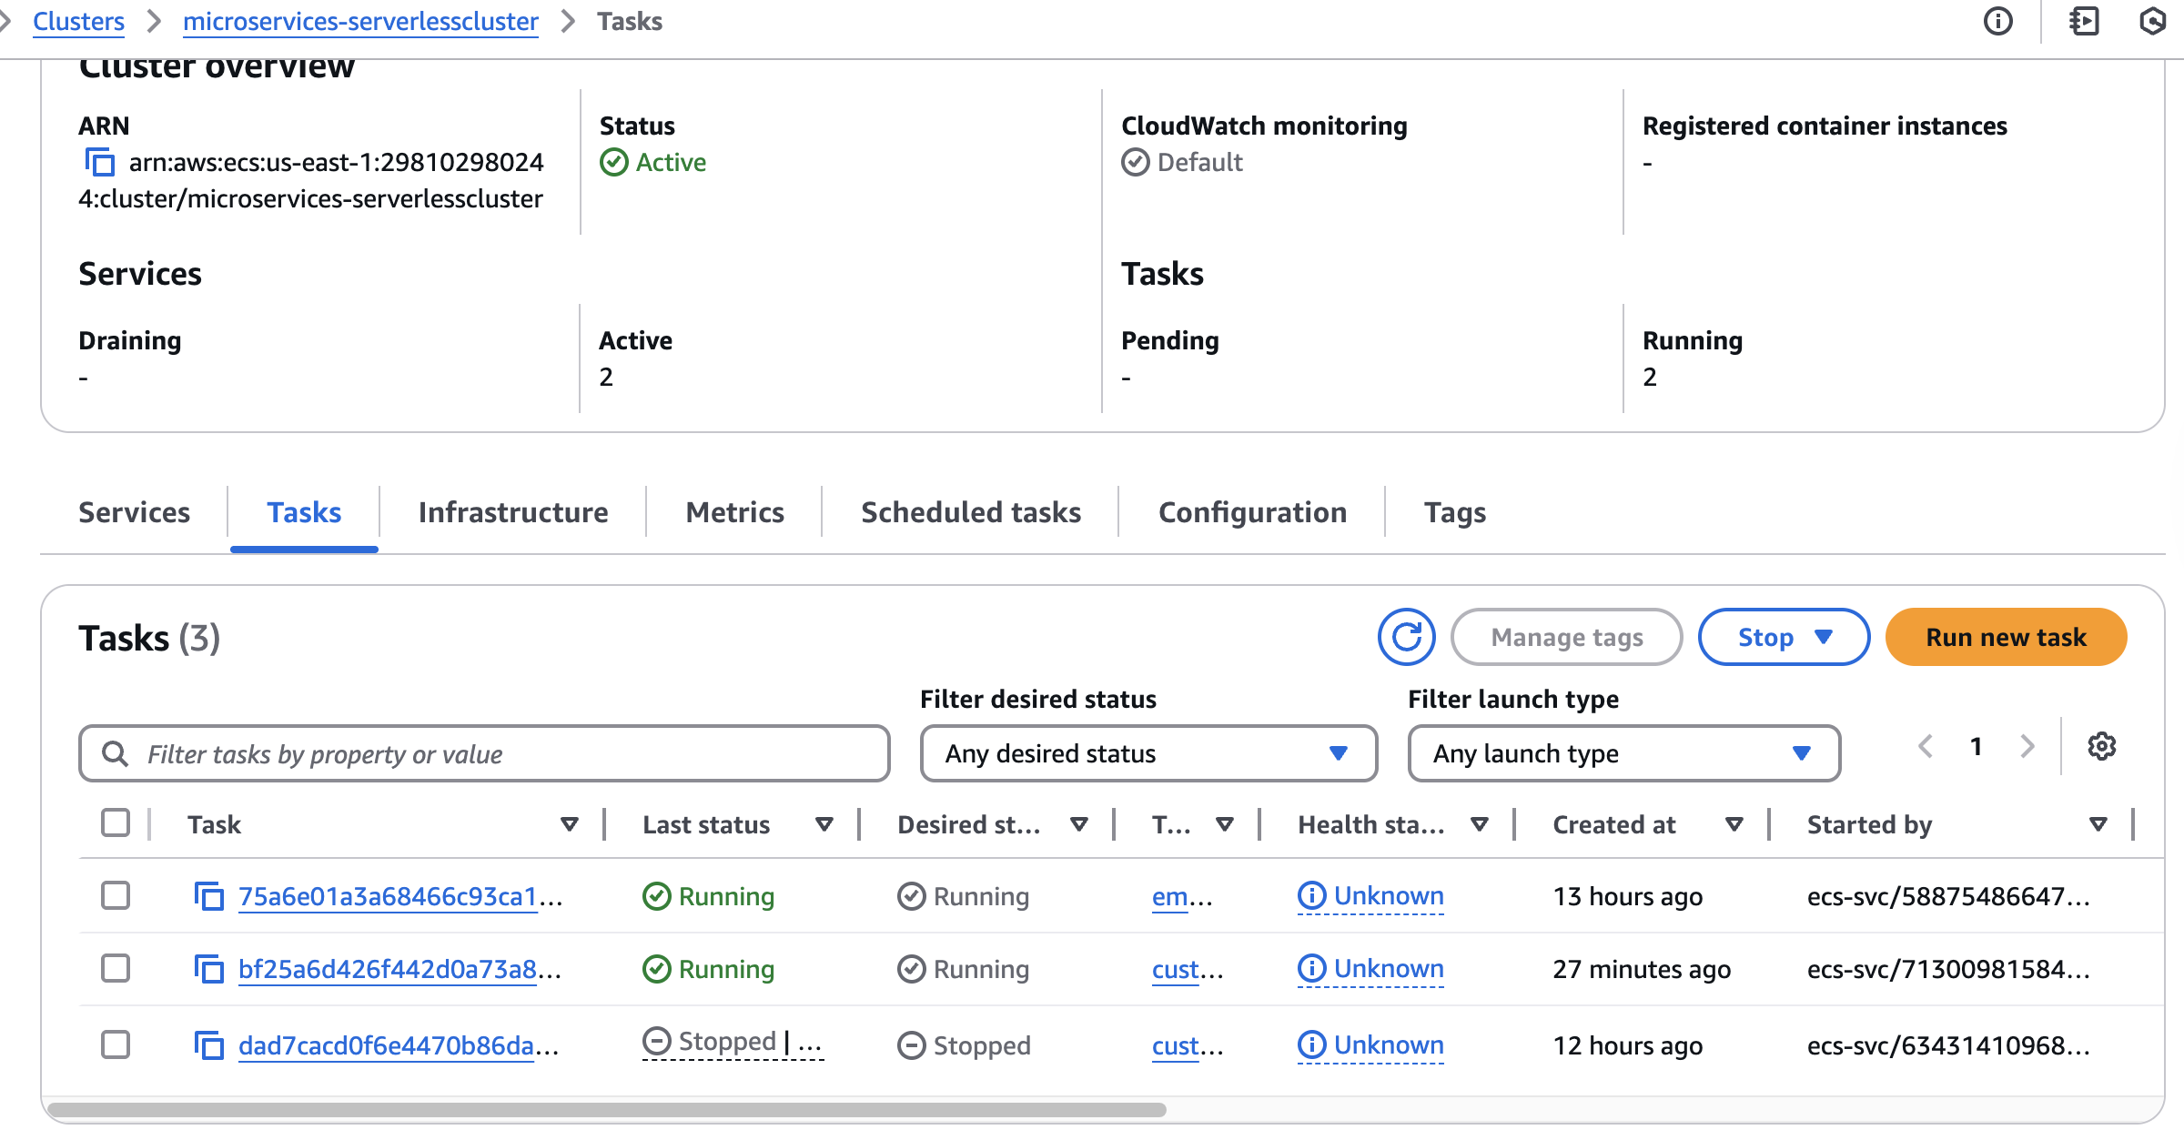

1. **Observe the load balancer and target group settings.**
   * **In the Amazon EC2 console, choose Target Groups.**

**You might notice that the *customer-tg-two* target group is no longer associated with the load balancer. This is because CodeDeploy is managing the load balancer listener rules and might have determined that some of the target groups are no longer needed.**

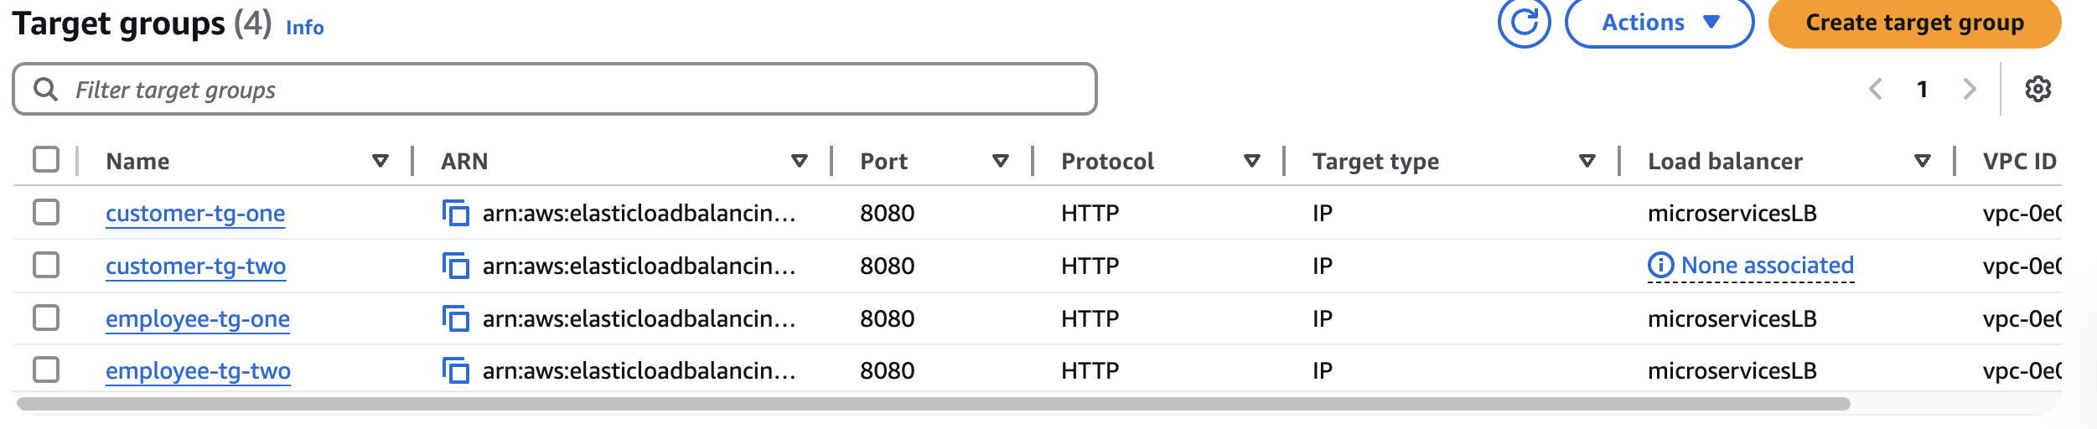

* + **Observe the HTTP:80 listener rules.**

**The default rule has changed here. The default "if no other rule applies" rule previously pointed to *customer-tg-two*, but now it points to *customer-tg-one*. This is because CodeDeploy actively managed your Application Load Balancer.**

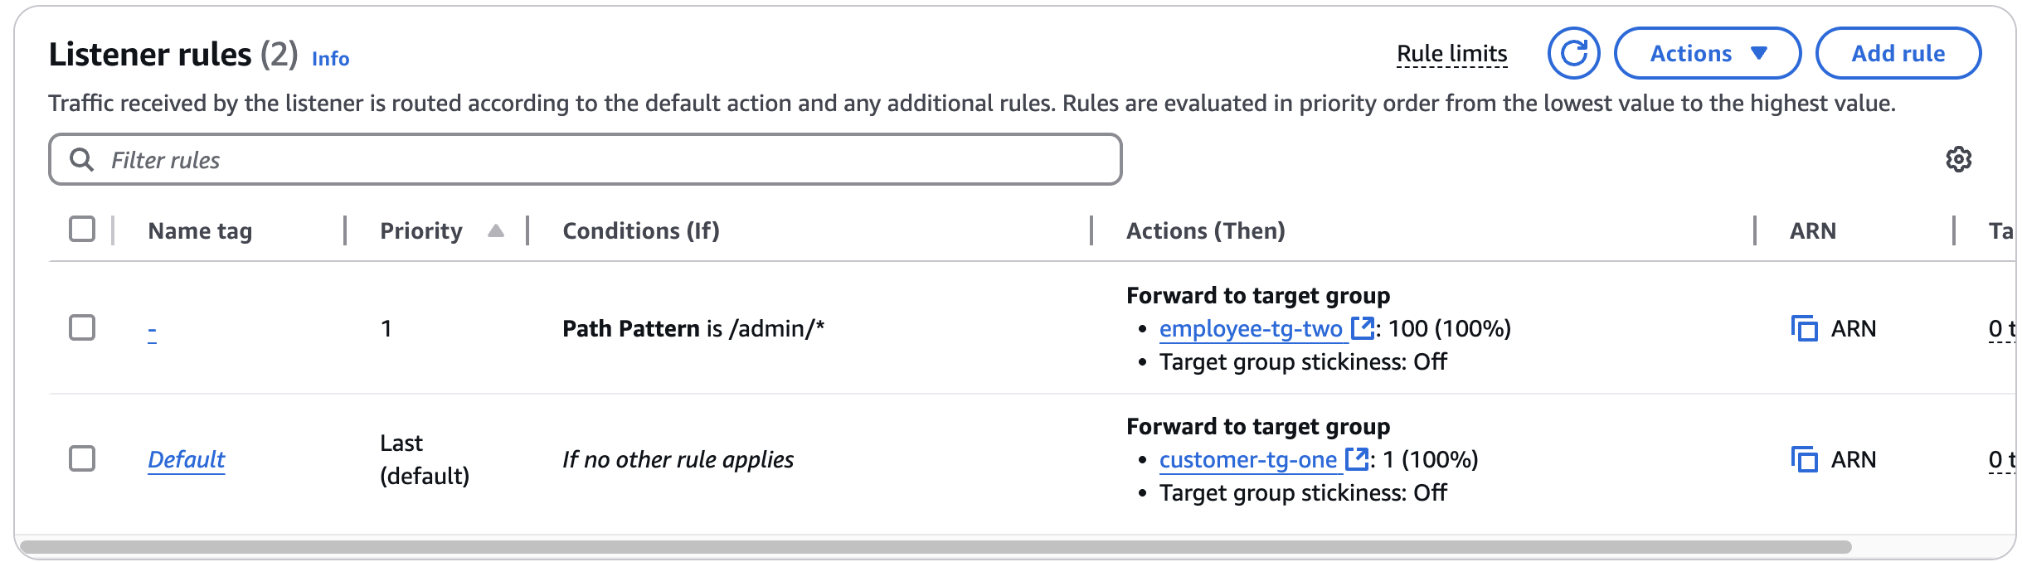

* + **Observe the HTTP:8080 listener rules.**

**The two rules still forward to the "one" target groups.**

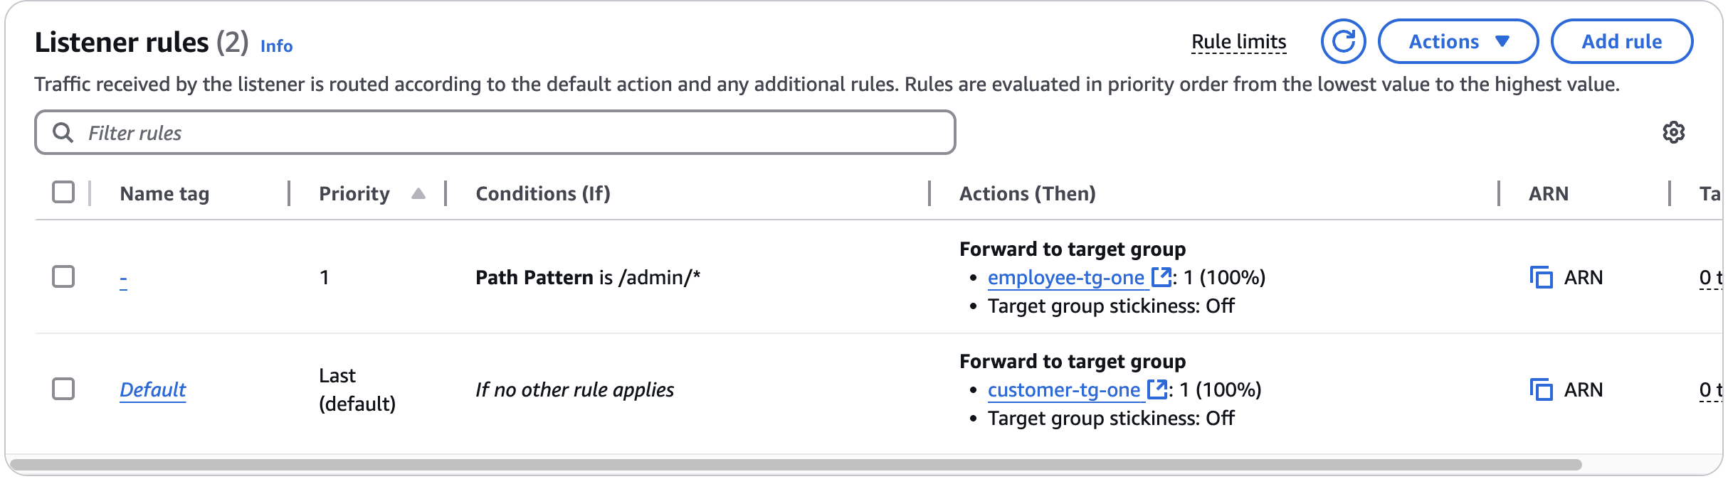

**Congratulations! You successfully deployed one of the two microservices to Amazon ECS on Fargate by using a CI/CD pipeline.**

**Task 8.4: Create a pipeline for the *employee* microservice**

1. **Create a pipeline for the *employee* microservice with the following specifications:**
   * **Pipeline name: update-employee-microservice**
   * 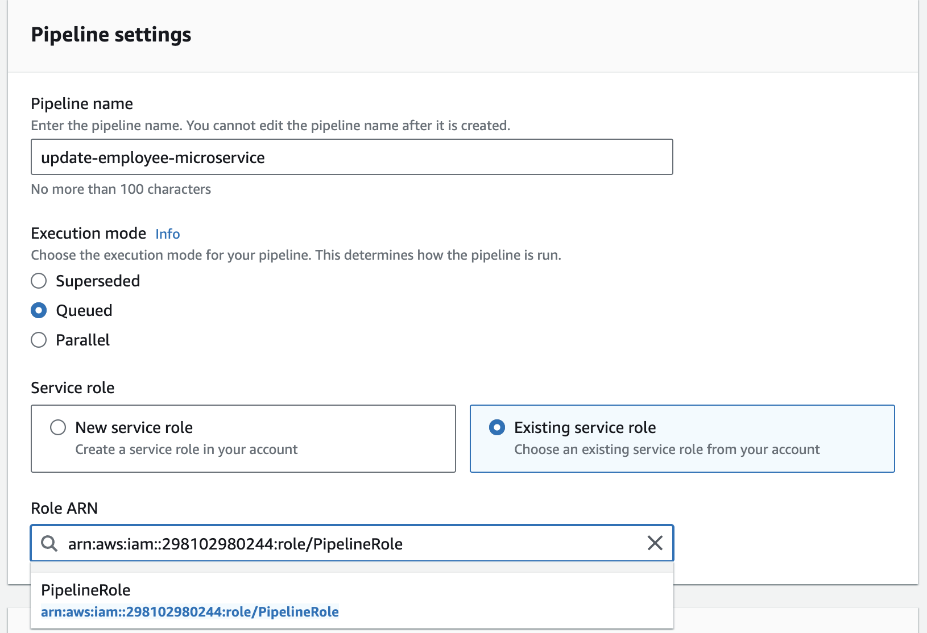
   * **Role ARN: PipelineRole**
     + **Source provider: AWS CodeCommit**
       - **Repository name: deployment**
       - **Branch name: dev**
       - 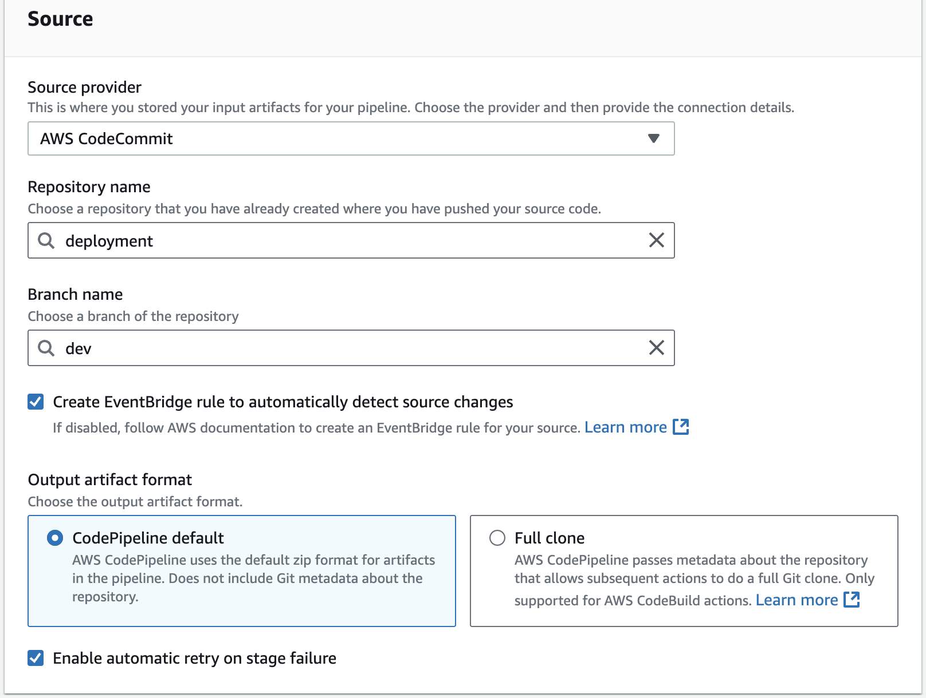
   * **Deploy provider: Amazon ECS (Blue/Green)**
   * 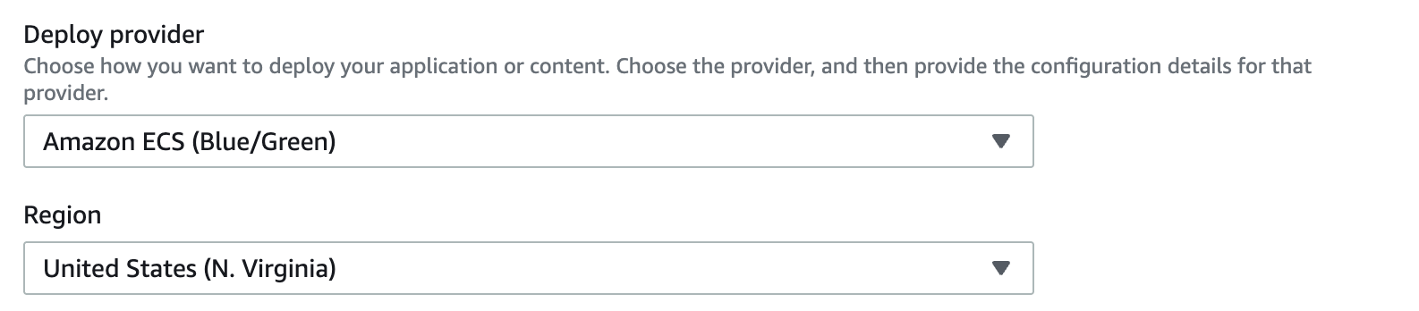
   * **AWS CodeDeploy application name: microservices**
   * **AWS CodeDeploy deployment group: microservices-employee**
   * **Amazon ECS task definition: SourceArtifact**
     + **Path: taskdef-employee.json**
     + **AWS CodeDeploy AppSpec file: SourceArtifact**
     + **Path: appspec-employee.yaml**
     + 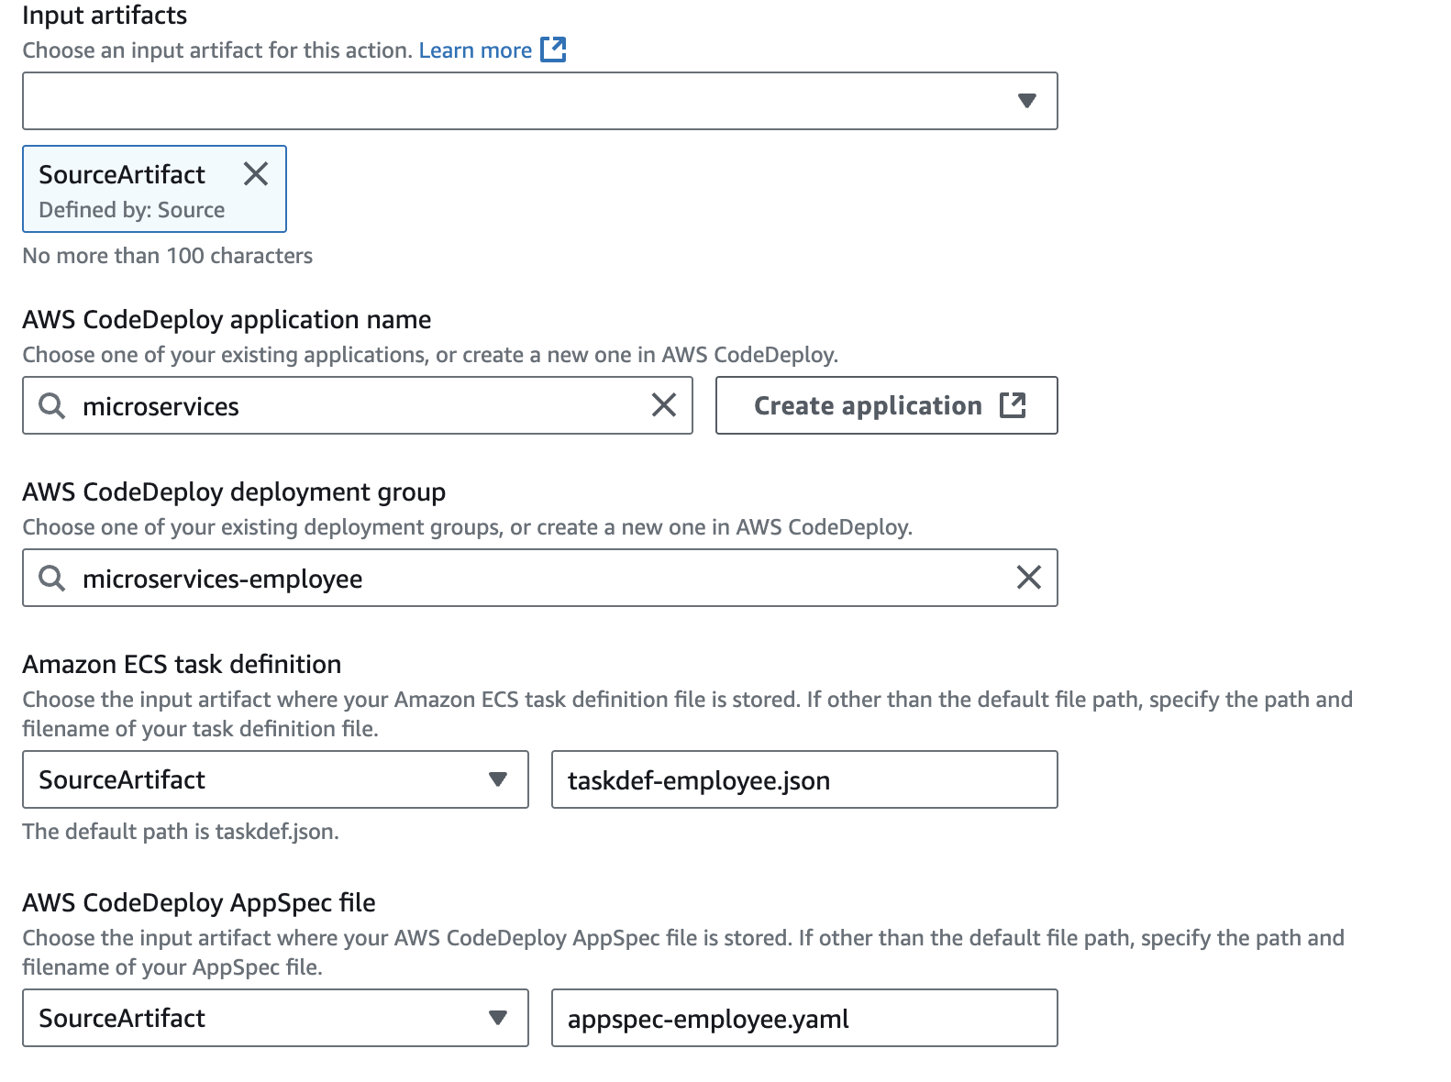
2. Add another source to the employee microservice pipeline. Add an action with the following details:
   * Action name: Image
   * Action provider: **Amazon ECR**
   * Repository name: **employee**
   * Image tag: **latest**
   * Output artifacts: image-employee

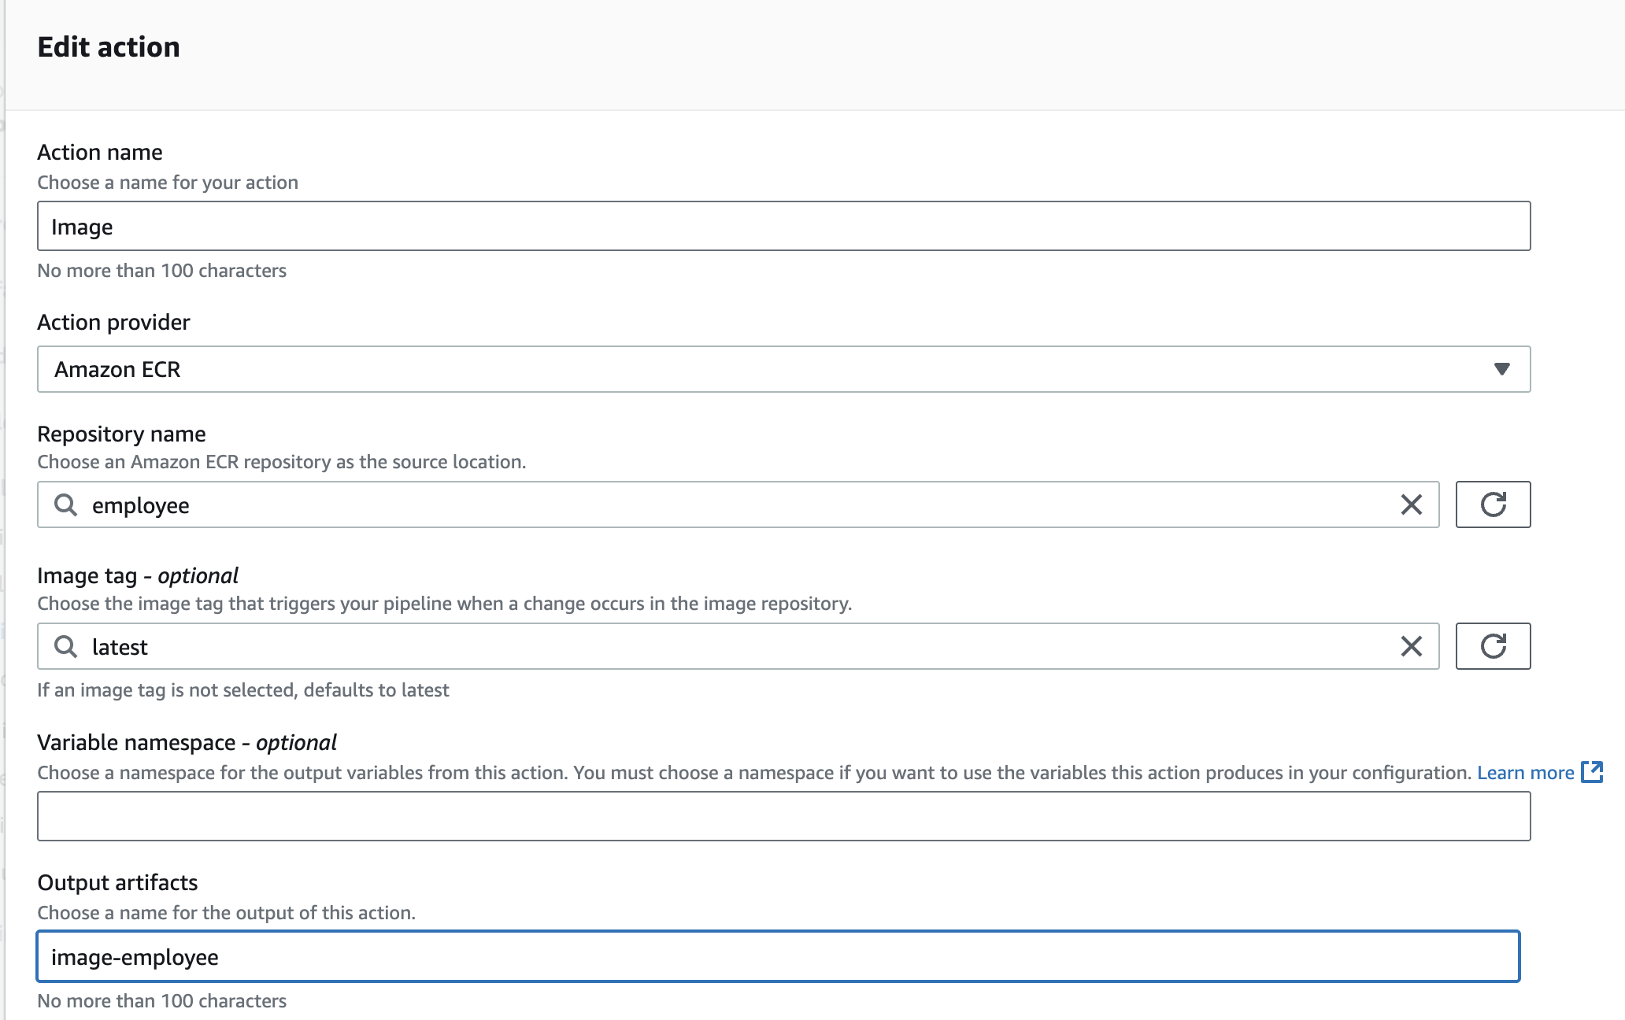

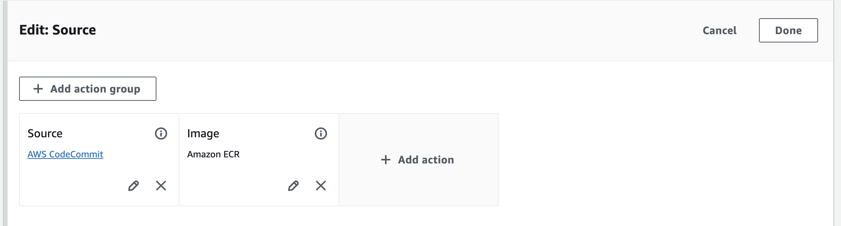

**Edit the Amazon ECS (Blue/Green) action in the deploy stage:**

* **Add another *input artifact* and choose image-employee.**
* 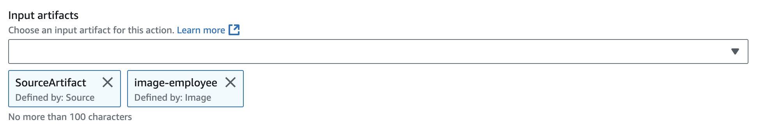
* **Under Dynamically update task definition image, for Input artifact with image details, choose image-employee.**
* **For Placeholder text in the task definition, enter IMAGE1_NAME**

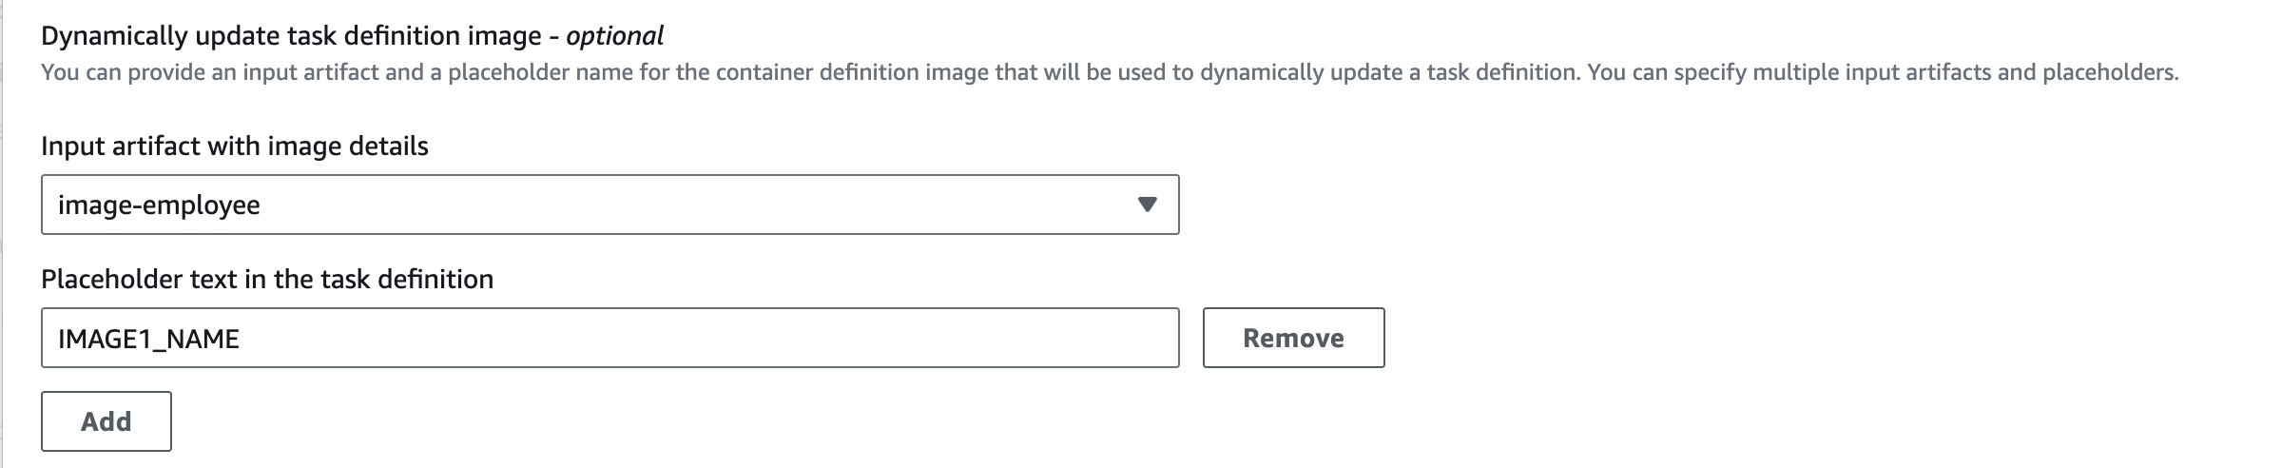

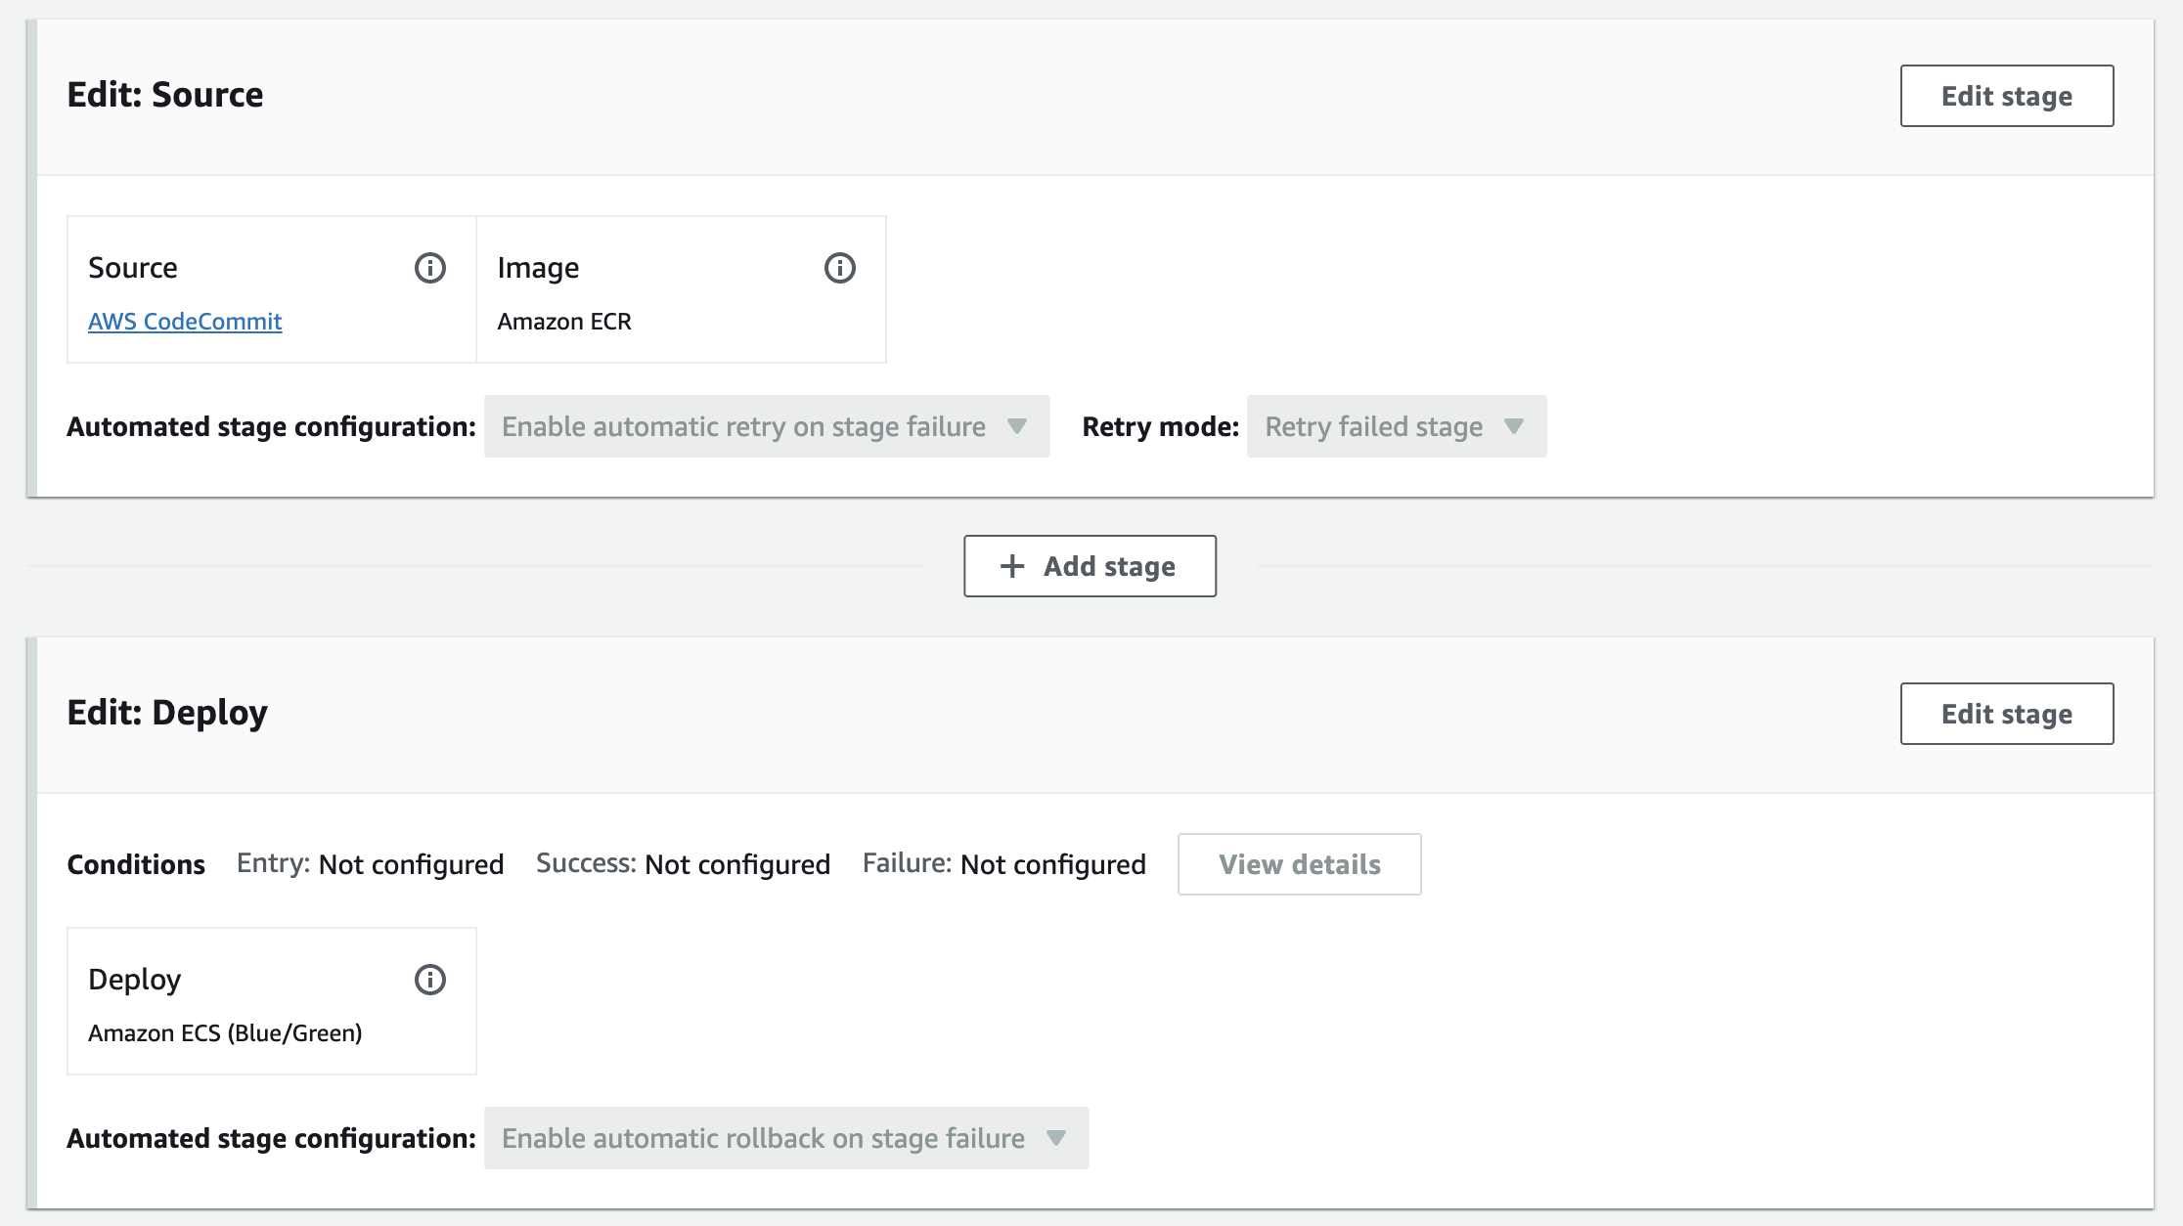

**Employee deploy success**

1. **Launch a deployment of the *employee* microservice on Amazon ECS on Fargate.**
   * **Use the *release change* feature to force a test of the pipeline.**
   * **Follow the progress in CodeDeploy. Within a few minutes, if everything was configured correctly, all of the *Deployment lifecycle events* should succeed.**

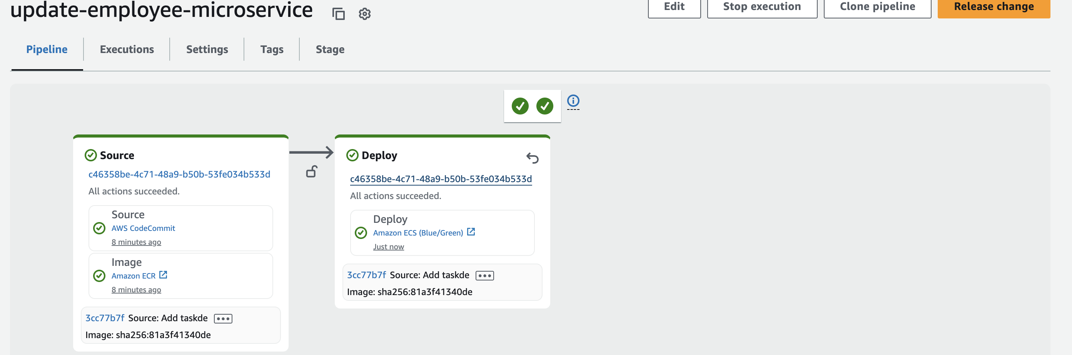

**Load the *employee* microservice in a browser tab.**

* **In the browser tab where the customer microservice is running, choose Administrator link.**

**Task 8.5: Test the CI/CD pipeline for the *employee* microservice**

**You are directed to a page in the format** [***http://microserviceslb-1734513457.us-east-1.elb.amazonaws.com***](http://microserviceslb-1734513457.us-east-1.elb.amazonaws.com)***/admin/suppliers*.**

**The employee microservice loads. If it doesn't load, try adding :8080 just after amazonaws.com in the URL.**

* **Choose List of suppliers or Suppliers list.**

**The suppliers page should load. This version of the page should *not* have the edit or add supplier buttons. All links in the café web application should now work because you have now deployed both microservices.**

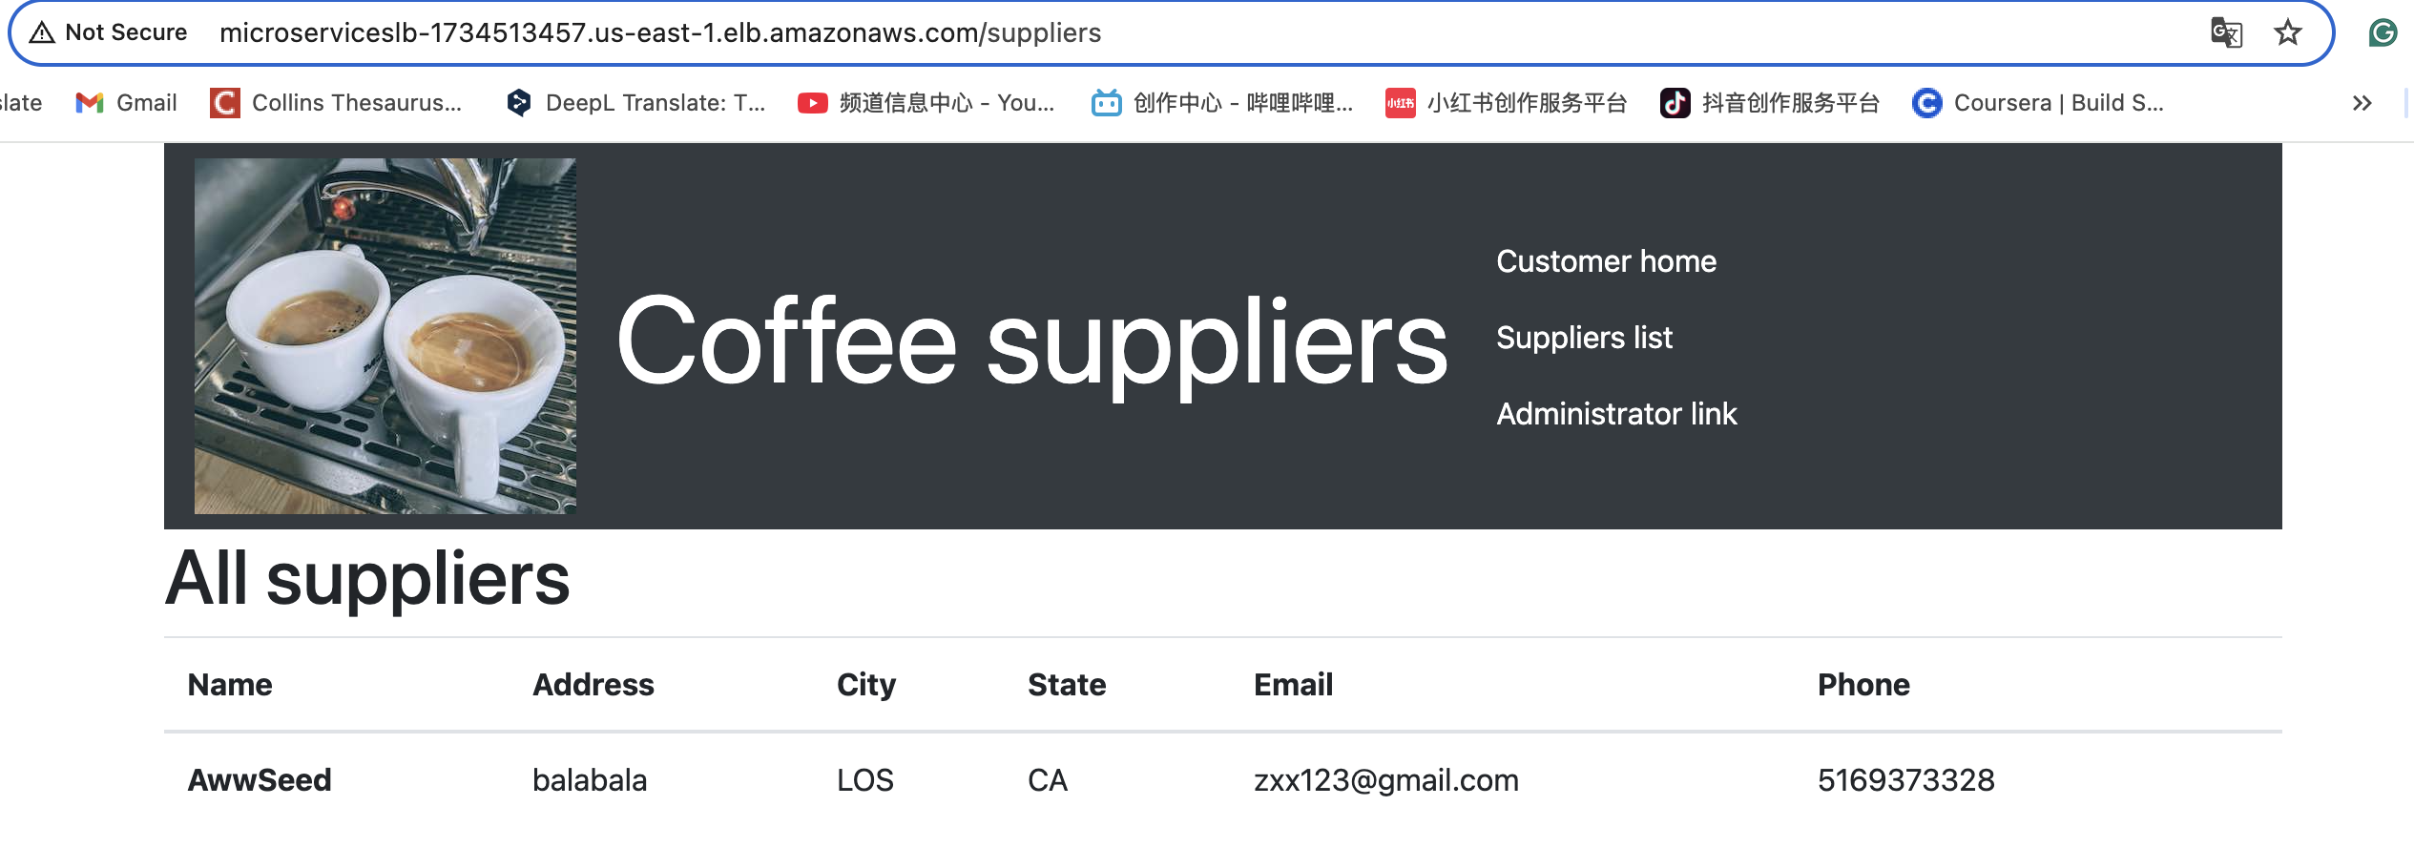

1. **Observe the running tasks in the Amazon ECS console.**

**The Deployments and tasks status will change as the blue/green deployment advances through its lifecycle events.**

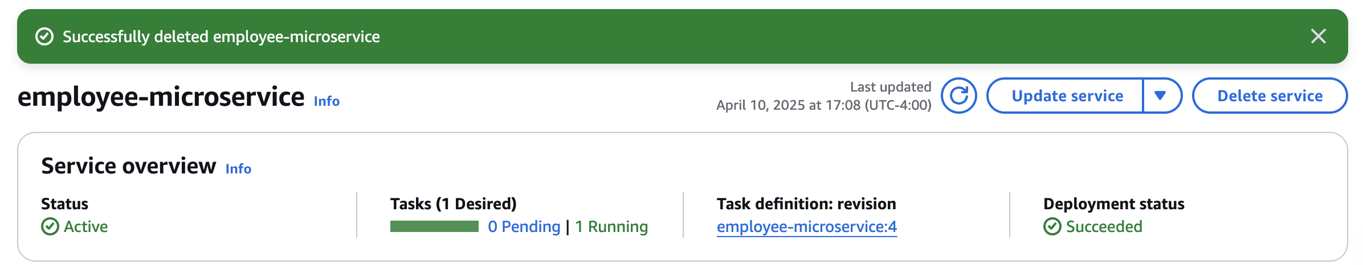

1. **Return to the CodeDeploy page to confirm that all five steps of the deployment succeeded and the replacement task set is now serving traffic.**
2. 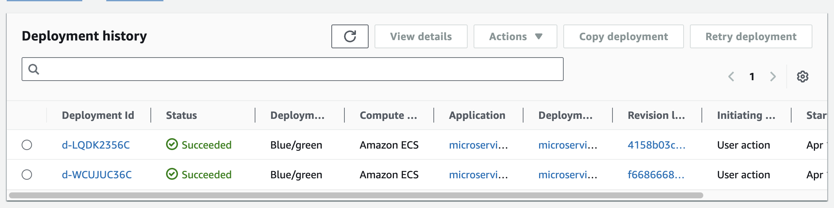

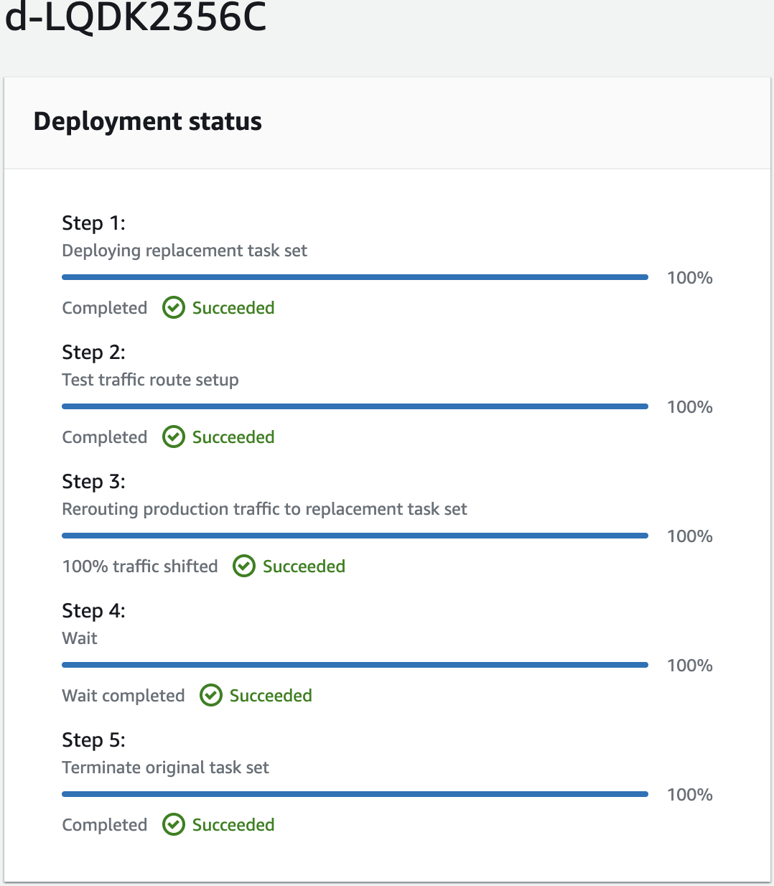 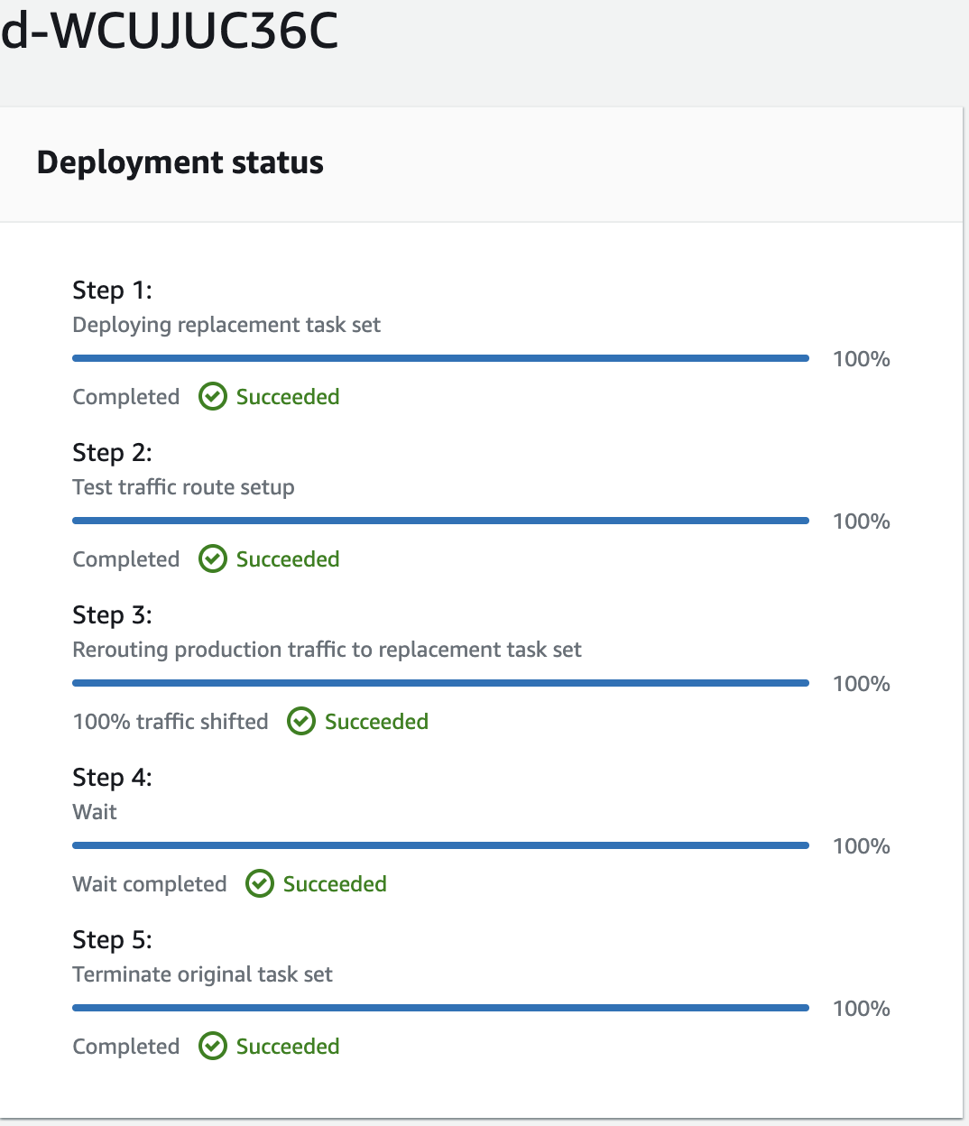

**Congratulations! You successfully deployed the employee microservice to Amazon ECS on Fargate by using a CI/CD pipeline.**

**Task 8.6: Observe how CodeDeploy modified the load balancer listener rules**

**Observe the load balancer and target group settings.**

* **In the Amazon EC2 console, choose Target Groups.**

**Note: If you already had the page open, refresh it.**

**Notice that the *customer-tg-two* target group is no longer associated with the load balancer. This is because CodeDeploy is managing the load balancer listener rules.**

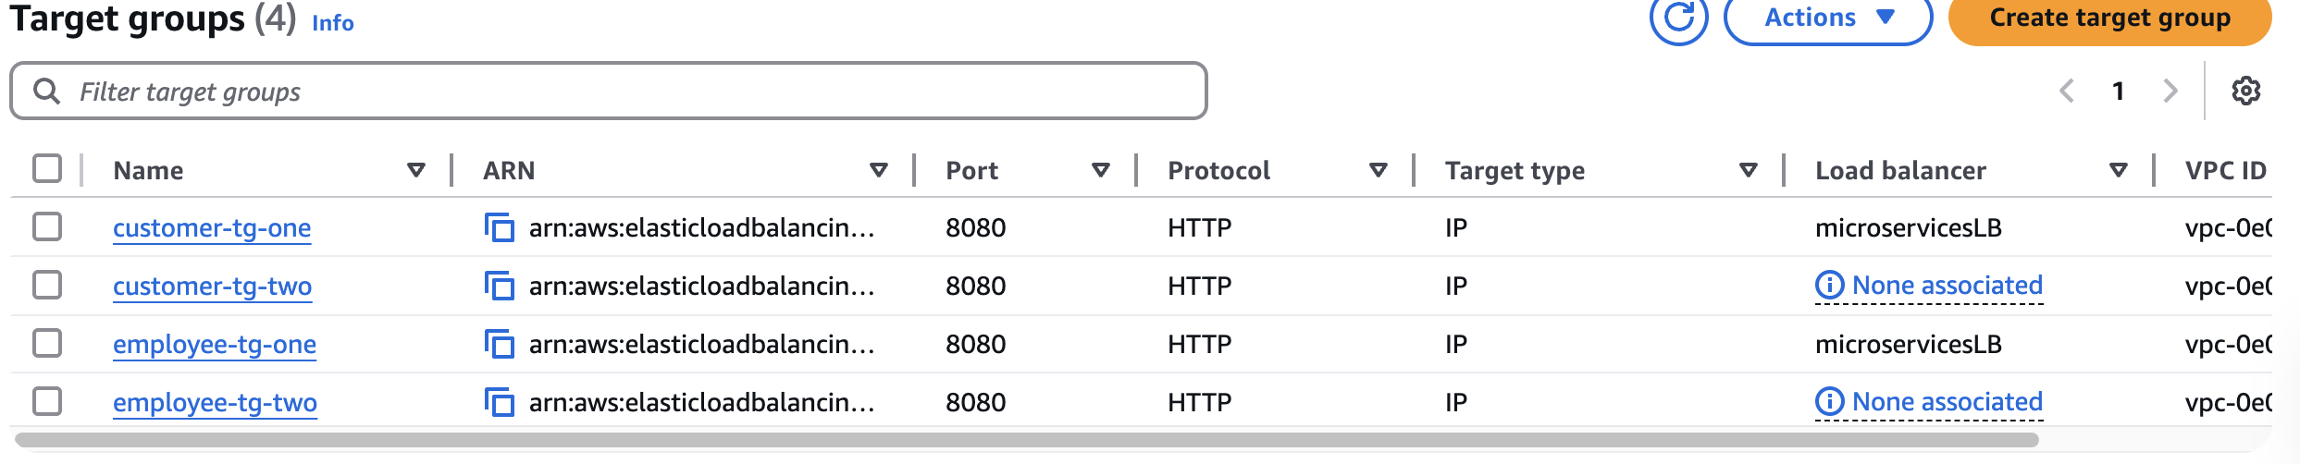

* **Note: If you are repeating this step, the target groups that are currently attached and unattached might be different.**
* **Observe the HTTP:80 listener rules.**
* 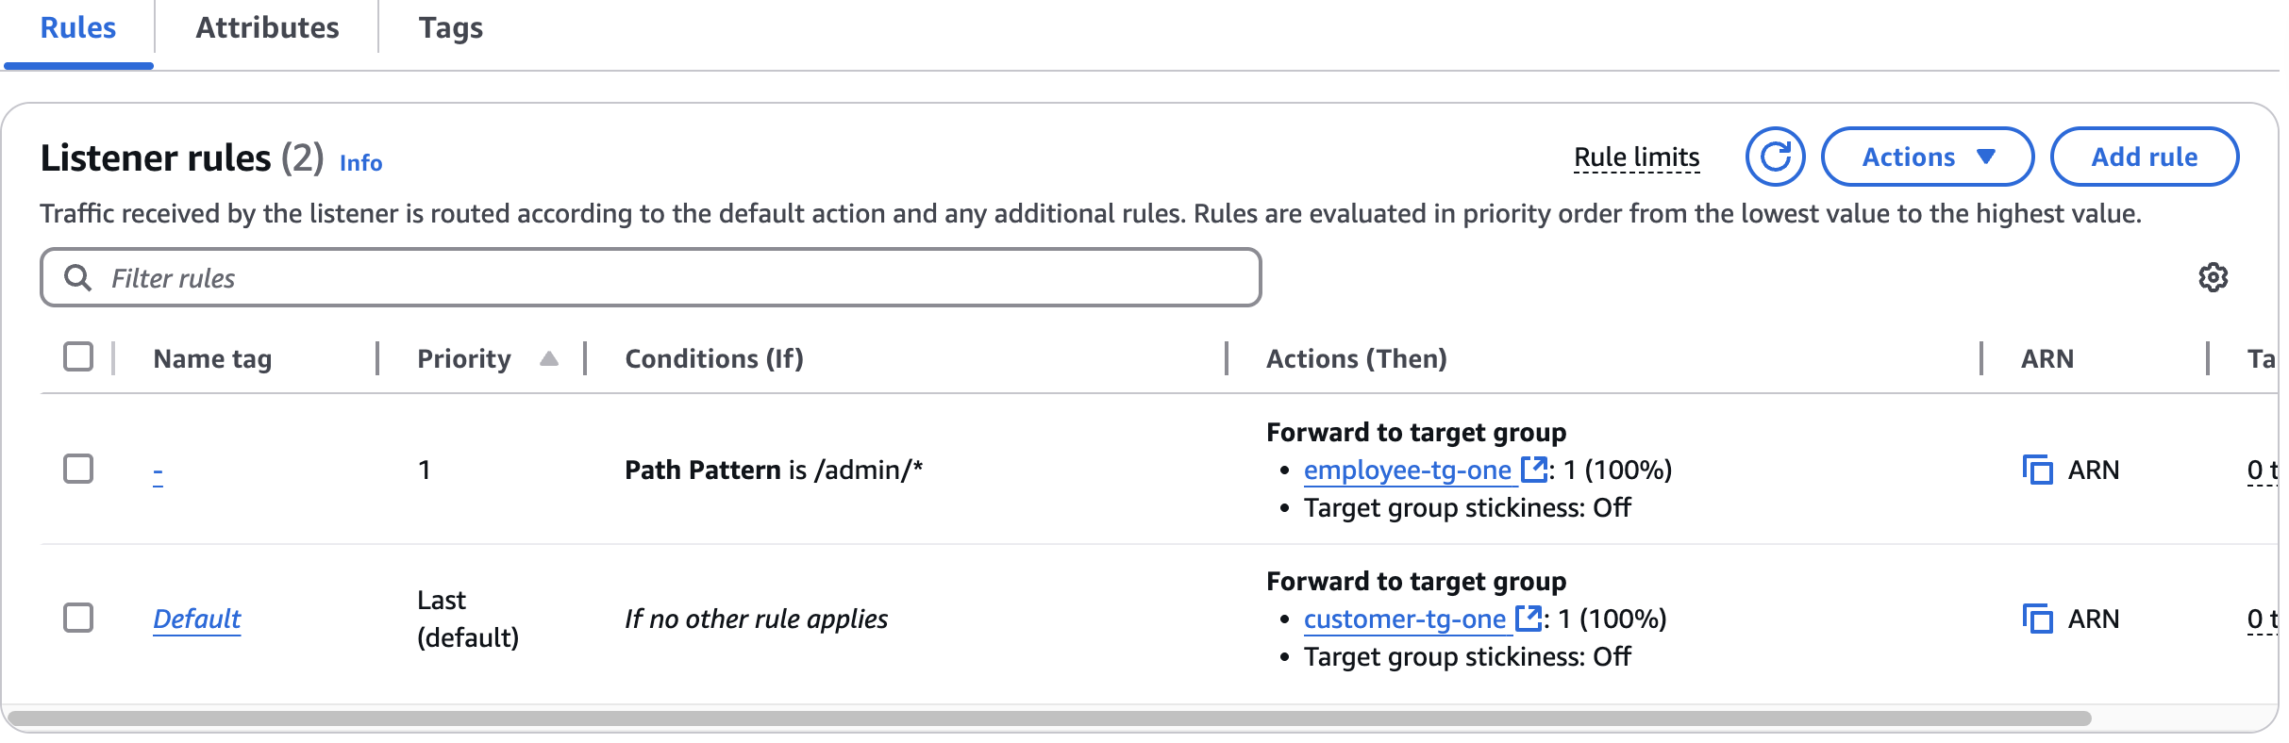

**The default rule has changed here. For the default "If no other rule applies" rule, the "forward to target group" previously pointed to *customer-tg-two*, but now it points to *customer-tg-one*.**

* **Observe the HTTP:8080 listener rules.**
* 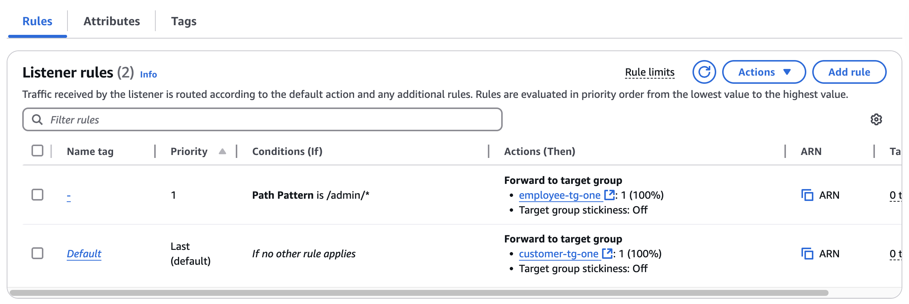

**The two rules still forward to the "one" target groups.**

**Phase 9: Adjusting the microservice code to cause a pipeline to run again**

**In this phase, you will experience the benefits of the microservices architecture and the CI/CD pipeline that you built. You will begin by adjusting the load balancer listener rules that are related to the *employee* microservice. You will also update the source code of the *employee* microservice, generate a new Docker image, and push that image to Amazon ECR, which will cause the pipeline to run and update the production deployment. You will also scale up the number of containers that support the *customer* microservice.**

**Task 9.1: Limit access to the *employee* microservice**

**In this task, you will limit access to the *employee* microservice to only people who try to connect to it from a specific IP address. By limiting the source IP to a specific IP address, only users who access the application from that IP can access the pages, and edit or delete supplier entries.**

1. **Confirm that all target groups are still associated with the Application Load Balancer.**

**In the Amazon EC2 console, check that all four target groups are still associated with the load balancer. Reassociate target groups as needed before going to the next step.**

**Tip: For details, see** [**Reassociating target groups with the load balancer**](https://labs.vocareum.com/web/3821956/3990151.0/ASNLIB/public/docs/lang/en-us/README.html?vockey=43e49371d90da503b054e6a3578a90402dbbe19314b8622fcb9b1a5d7e3bd5fd#app2) **in the appendix.**

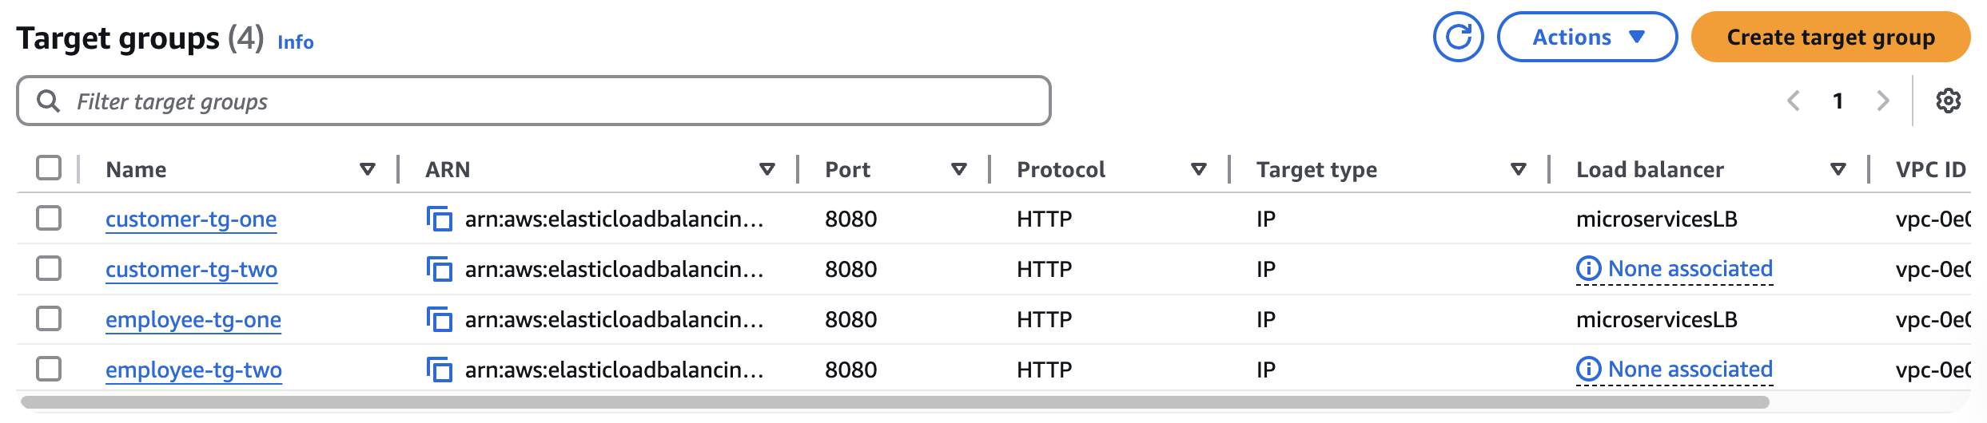

1. **Discover your public IPv4 address.**

**Tip: One resource you can use to do this is** [**https://www.whatismyip.com**](https://www.whatismyip.com/)**.**

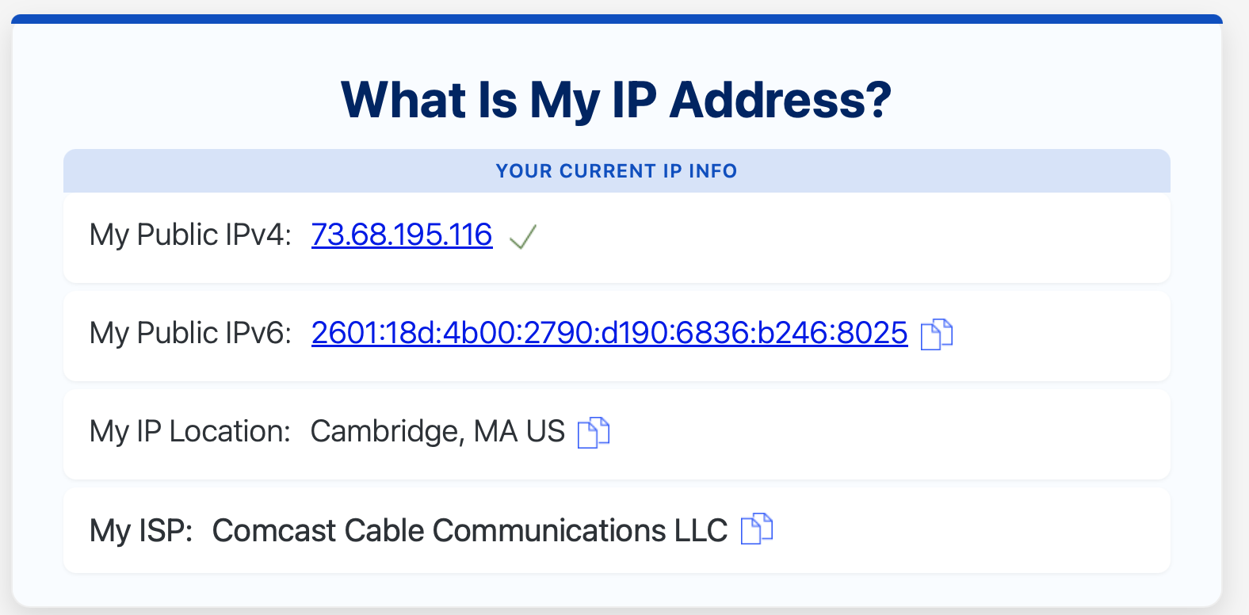  [**My Public IPv4: 73.68.195.116**](https://www.whatismyip.com/ip/73.68.195.116/)

1. **Edit the rules for the HTTP:80 listener.**

**For the rule that currently has "IF Path is /admin/*" in the details, add a second condition to route the user to the target groups only if the source IP of the request is your IP address.**

**Tip: For the source IP, paste in your public IPv4 address and then add /32. The following image shows an example:**

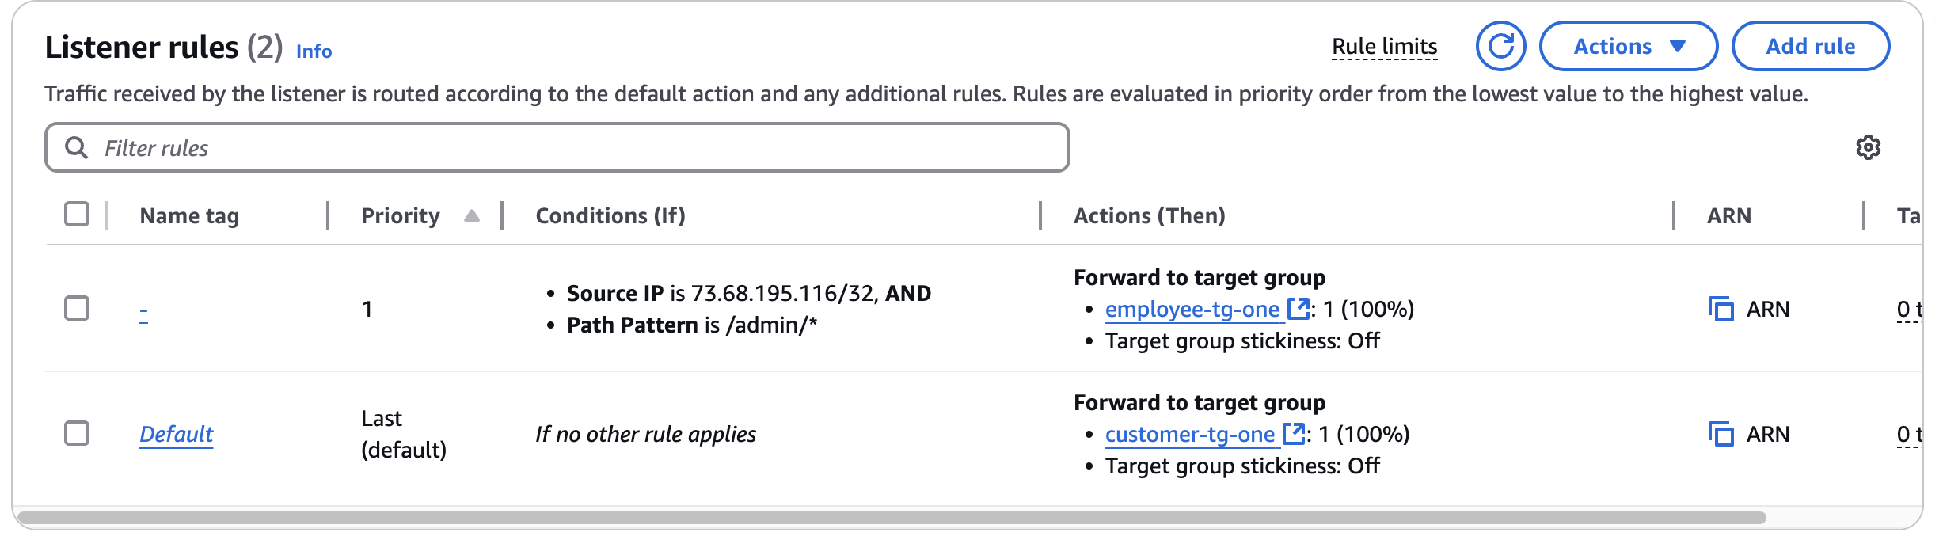

1. **Edit the rules for the HTTP:8080 listener.**

**Edit the rules in the same way that you edited the rules for the HTTP:80 listener. You want access to the employee target groups to be limited to your IP address.**

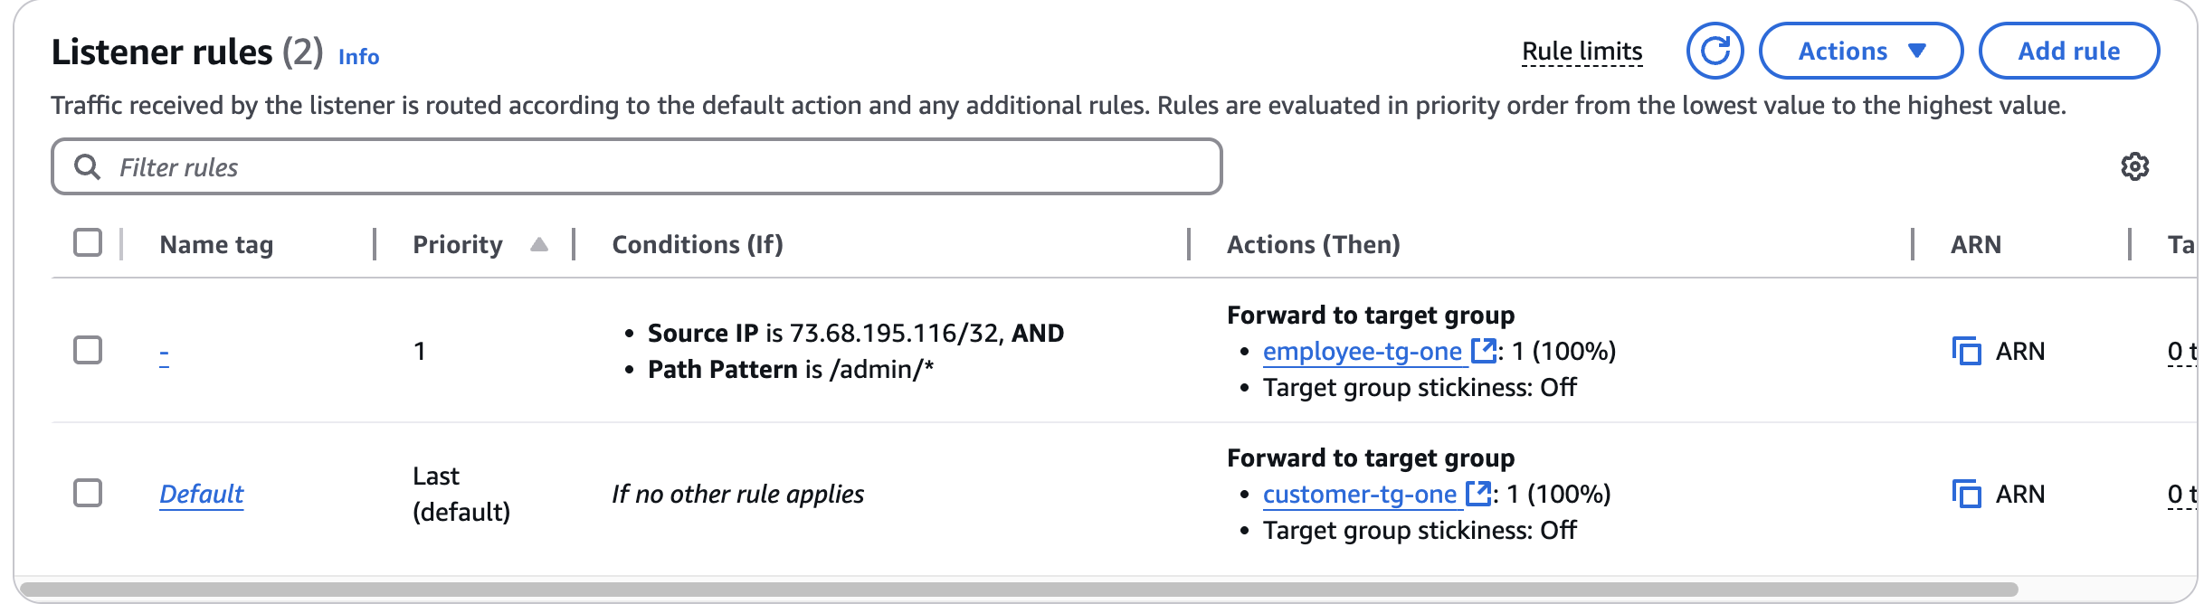

**Task 9.2: Adjust the UI for the *employee* microservice and push the updated image to Amazon ECR**

**In this task, you will adjust the deployed microservices.**

1. **Edit the employee/views/nav.html file.**
   * **On line 1, change navbar-dark bg-dark to navbar-light bg-light**
   * **Save the change.**
   * 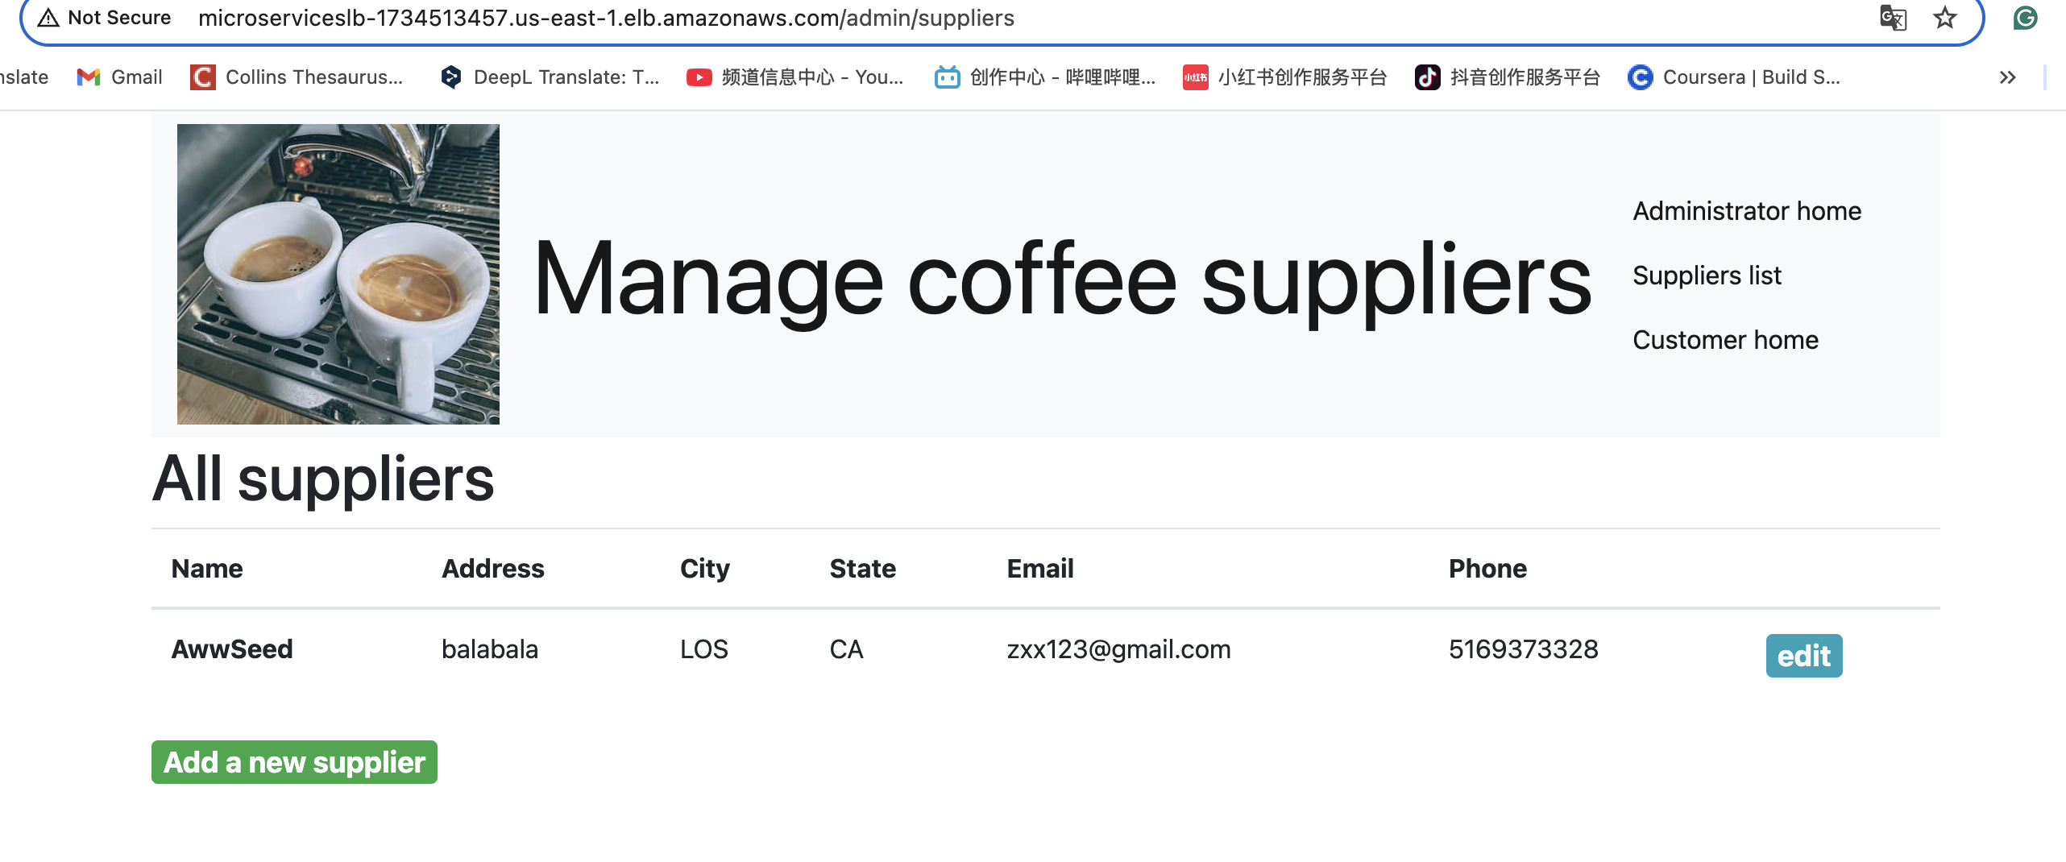

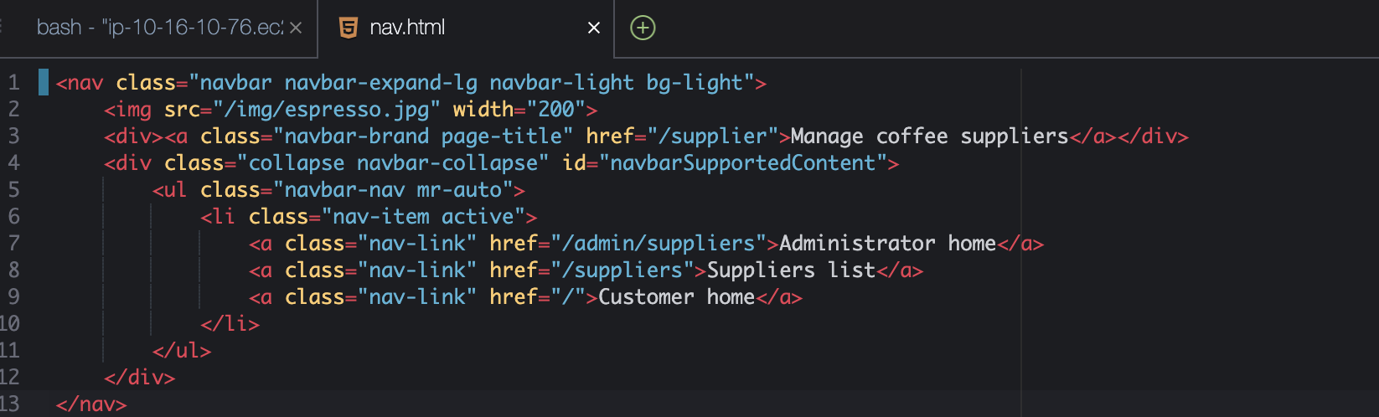

**To generate a new Docker image from the *employee* microservice source files that you modified and to label the image, run the following commands:**

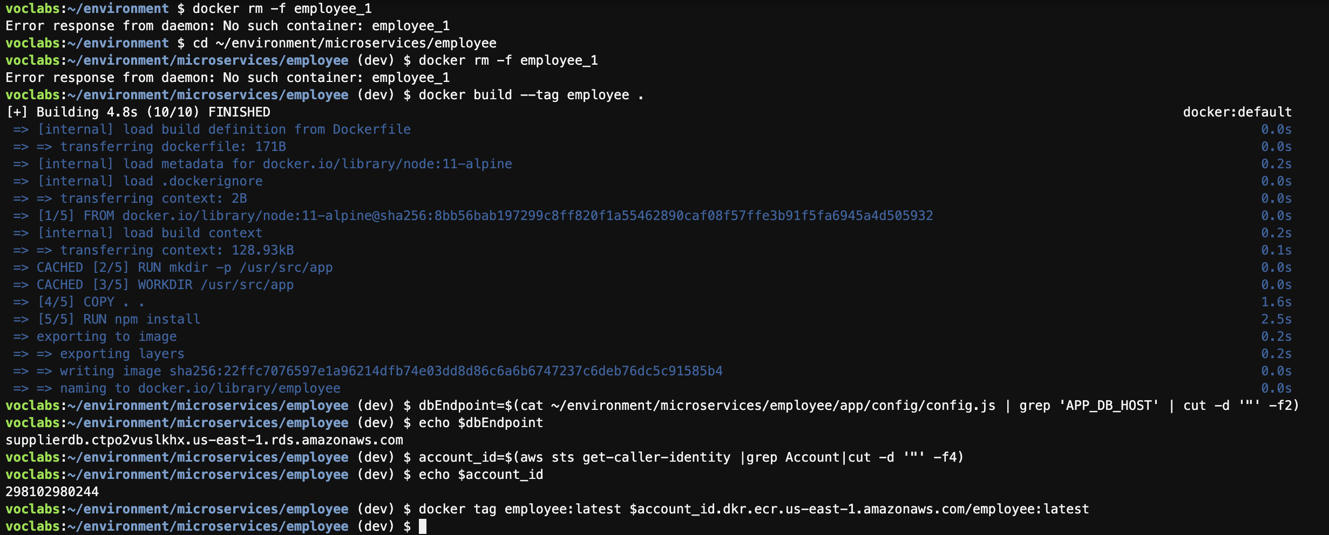

**Push an updated image to Amazon ECR so that the *update-employee-microservice* pipeline will be invoked.**

* **In the CodePipeline console, navigate to the details page for the *update-employee-microservice* pipeline. Keep this page open.**
* **To push the new employee microservice Docker image to Amazon ECR, run the following commands in your AWS Cloud9 IDE:**



**Confirm that the output is similar to the following：**

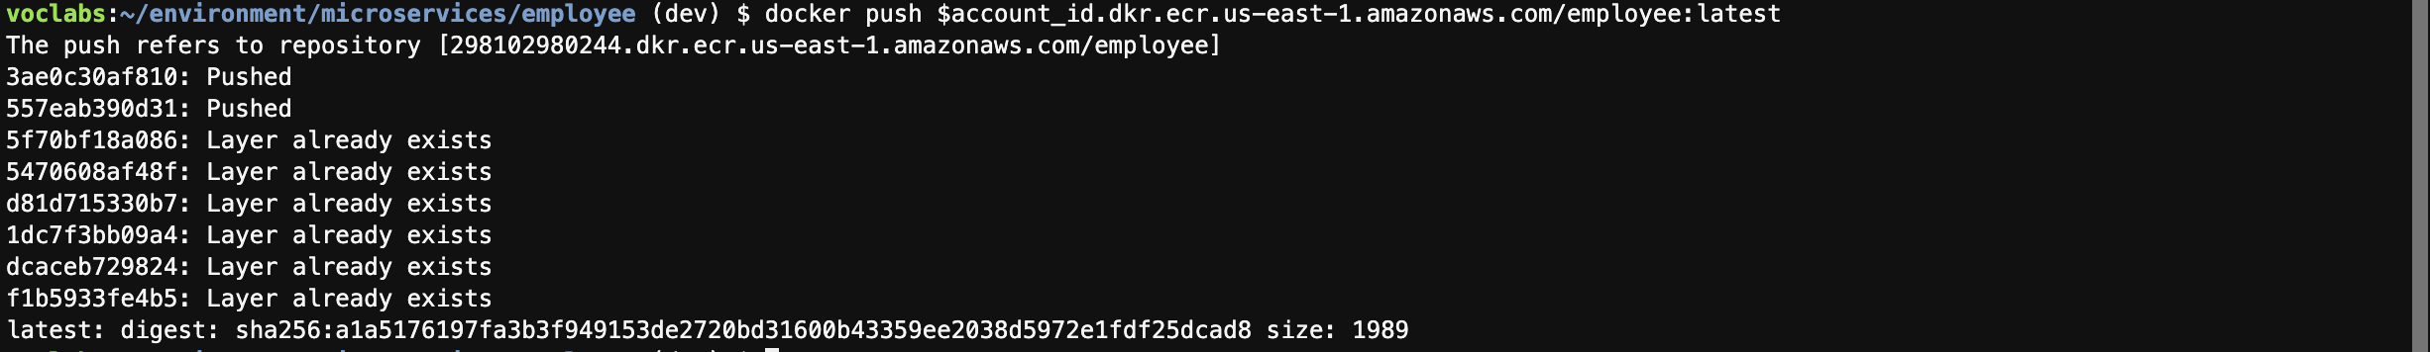

**At least one layer should indicate that it was pushed, which indicates that the image was modified since it was last pushed to Amazon ECR. You could also look in the Amazon ECR repository to confirm the last modified timestamp of the image that is tagged as the latest.**

**Task 9.3: Confirm that the *employee* pipeline ran and the microservice was updated**

1. **Observe the *update-employee-microservice* pipeline details in the CodePipeline console.**

**Notice that when you uploaded a new Docker image to Amazon ECR, the pipeline was invoked and ran. Note that the pipeline might take a minute or two to notice that the Docker image was updated before the pipeline is invoked.**

1. **Observe the details in the CodeDeploy console.**

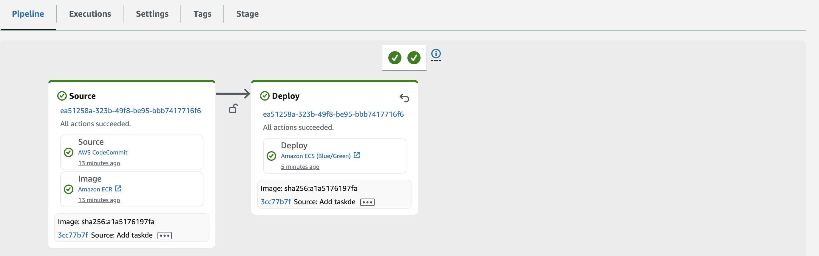

**Task 9.4: Test access to the *employee* microservice**

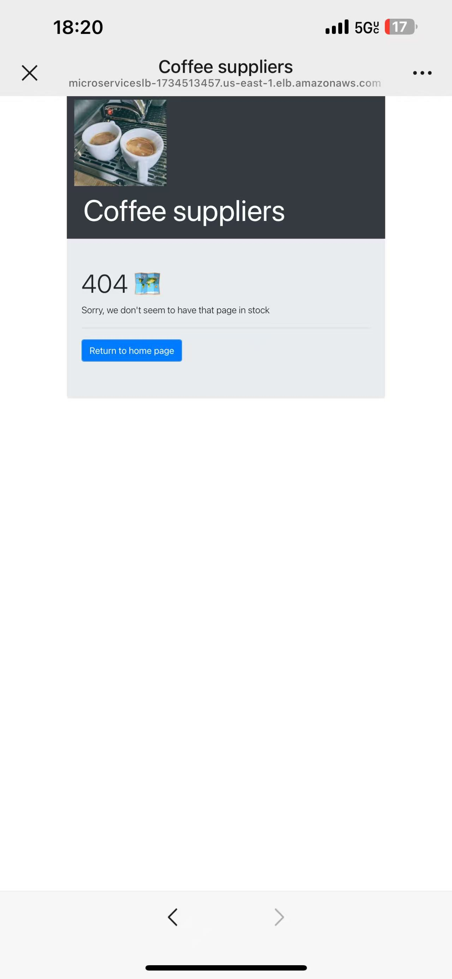 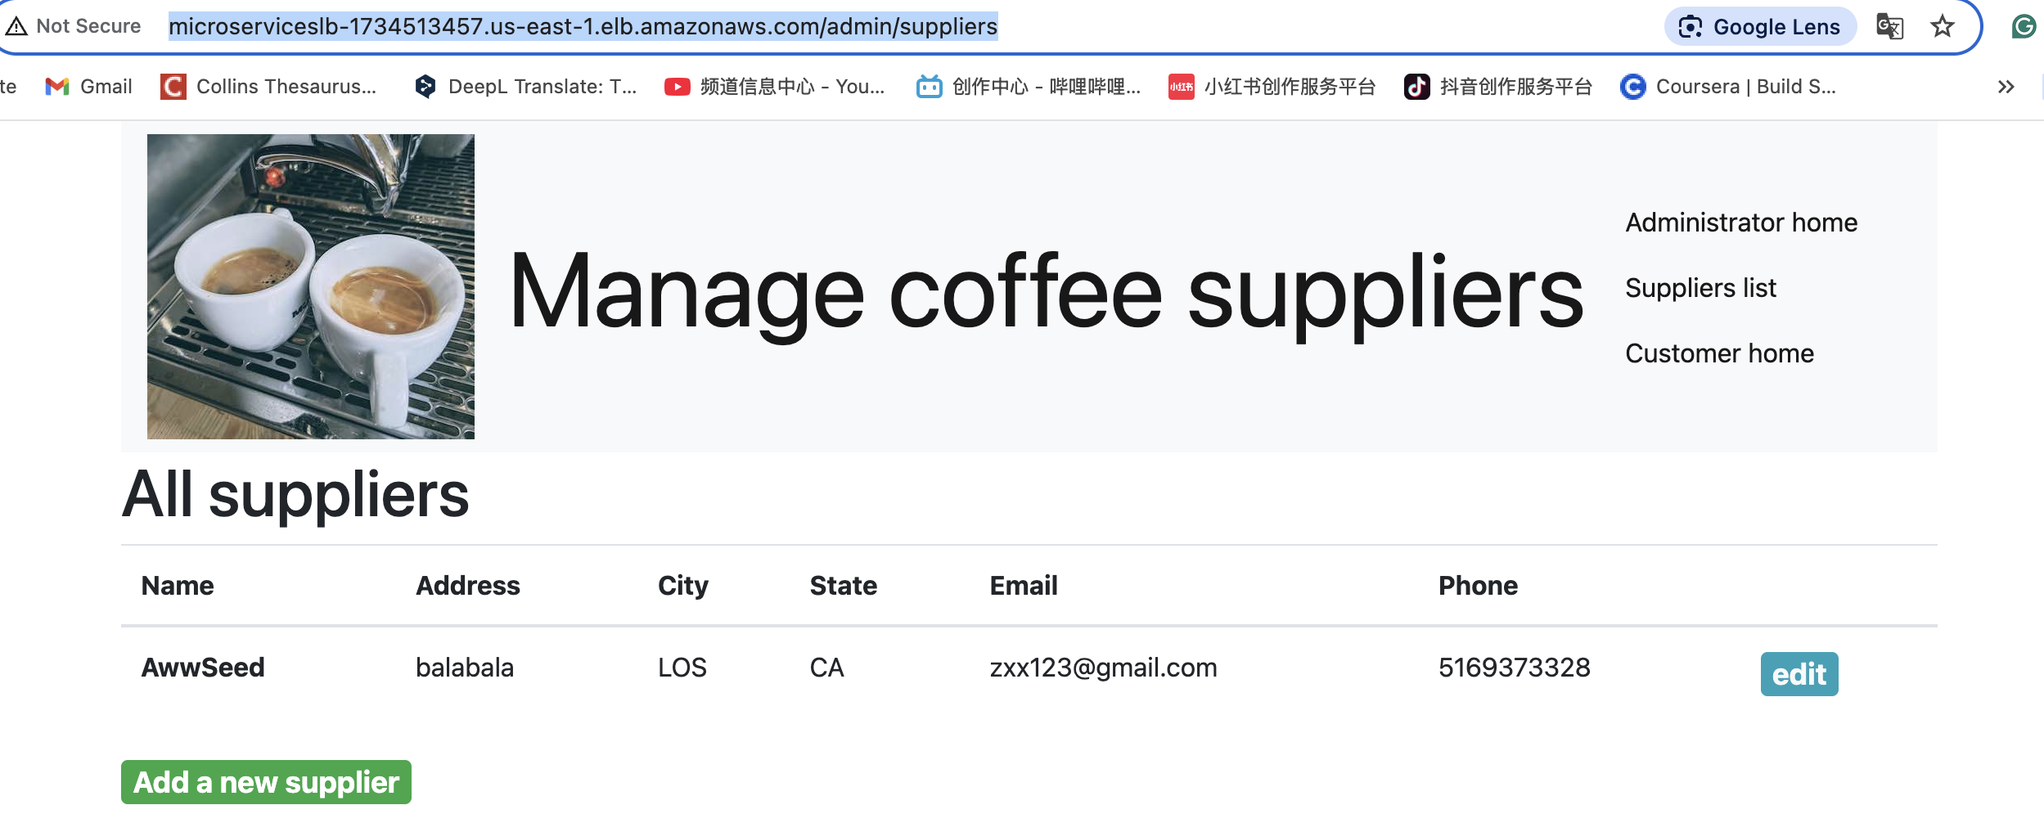

1. **Test access to the *employee* microservice pages at http://<alb-endpoint>/admin/suppliers and http://<alb-endpoint>:8080/admin/suppliers from the same device that you have used for this project so far. Replace *<alb-endpoint>* with the DNS name of the *microservicesLB* load balancer.**

**At least one of the two pages should load successfully.**

**Notice that the banner with the page title is a light color now because of the change that you made to the nav.html file. Pages that are hosted by the customer microservice still have the dark banner. This demonstrates that by using a microservices architecture, you could independently modify the UI or features of each microservice without affecting others.**

**Task 9.5: Scale the *customer* microservice**

[**Return to table of contents**](https://labs.vocareum.com/web/3821956/3990151.0/ASNLIB/public/docs/lang/en-us/README.html?vockey=43e49371d90da503b054e6a3578a90402dbbe19314b8622fcb9b1a5d7e3bd5fd#top)

**In this task, you will scale up the number of containers that run to support the *customer* microservice. You can make this change without causing the *update-customer-microservice* pipeline to run.**

**Update the *customer* service in Amazon ECS.**

* **Run the following command:**

**aws ecs update-service --cluster microservices-serverlesscluster --service customer-microservice --desired-count 3**

**A large JSON-formatted response is returned.**





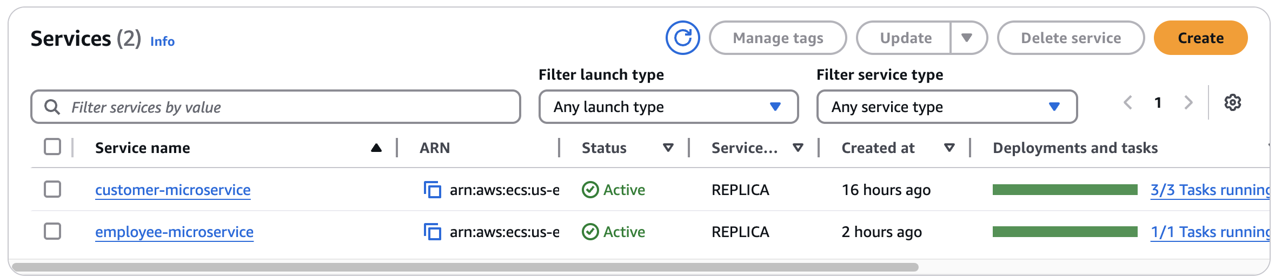

**Final git push  
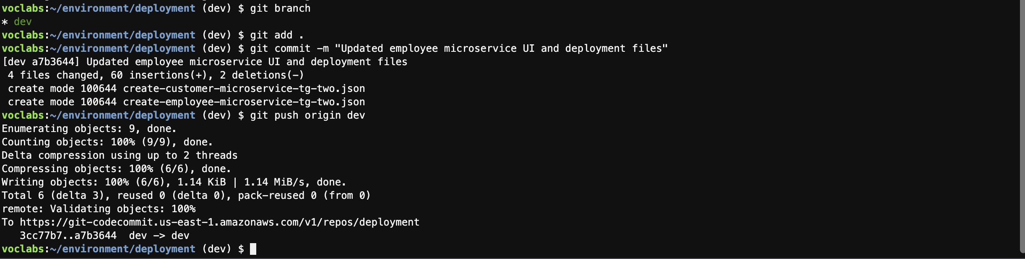**

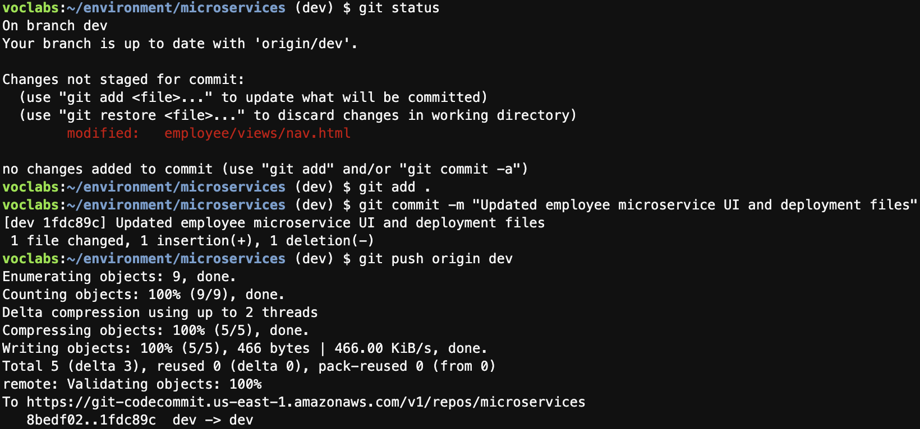

**All End.**

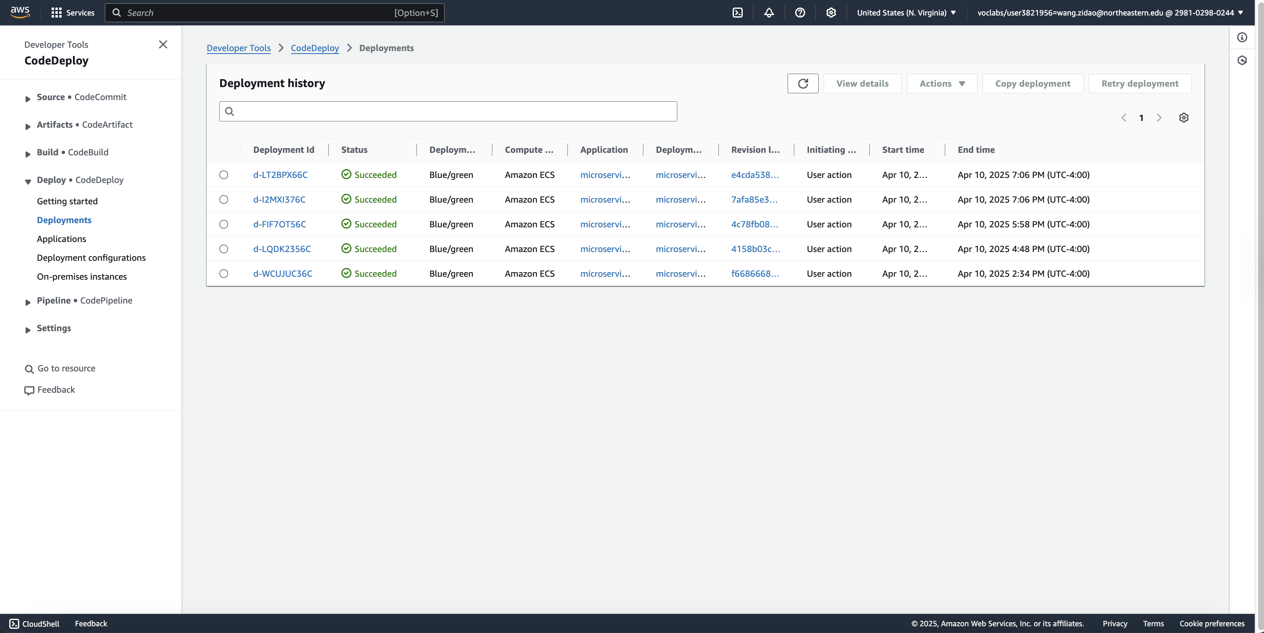

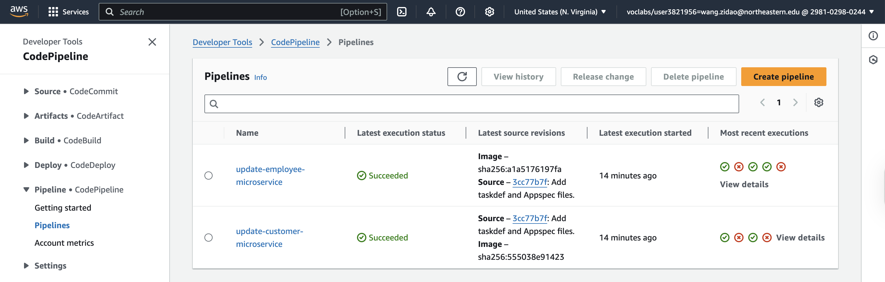

**For the Diagrams:**

**🔗 Architecture Components and How They Are Connected**

**1. Amazon VPC (Virtual Private Cloud)**

* **The entire application runs inside a LabVPC, which provides network isolation and control.**
* **It includes two public subnets where ECS tasks and the load balancer operate.**

**2. Amazon EC2**

* **One EC2 instance was used as the MonolithicAppServer, hosting the original monolithic Node.js application.**
* **Later, a Cloud9 EC2 instance was used for development (MicroservicesIDE), Docker builds, and code pushes.**

**3. AWS Cloud9**

* **You used this as your IDE to:**
  + **Split the monolithic app into customer and employee microservices.**
  + **Build and test Docker containers.**
  + **Push code to repositories and Docker images to ECR.**

**4. Amazon ECR (Elastic Container Registry)**

* **Two private repositories:**
  + **customer**
  + **employee**
* **Stores Docker images built from your microservice code.**
* **Tagged as latest and pushed from Cloud9.**

**5. Amazon ECS (Elastic Container Service) with Fargate**

* **Cluster: microservices-serverlesscluster**
* **Two ECS Services:**
  + **customer-microservice**
  + **employee-microservice**
* **Each service runs containers pulled from ECR and defined via task definitions.**
* **Uses Fargate to run containers serverlessly.**

**6. Application Load Balancer (ALB)**

* **ALB: microservicesLB**
* **Two listeners:**
  + **Port 80: Production**
  + **Port 8080: Test**
* **Path-based routing:**
  + **/admin/* → employee target groups**
  + **all others → customer target groups**
* **Four target groups are used to support blue/green deployment.**

**7. Amazon CodeCommit**

* **Two repositories:**
  + **microservices – Contains original code for customer and employee apps.**
  + **deployment – Contains ECS task definitions and CodeDeploy AppSpec files.**

**8. AWS CodeDeploy**

* **Application: microservices**
* **Two Deployment Groups:**
  + **microservices-customer**
  + **microservices-employee**
* **Manages blue/green deployment for each microservice.**

**9. AWS CodePipeline**

* **Two pipelines:**
  + **update-customer-microservice**
  + **update-employee-microservice**
* **Triggered by changes to CodeCommit (task/appspec) or new image in ECR.**
* **Orchestrates the full CI/CD process, deploying new container versions to ECS.**

**10. Amazon RDS (Relational Database Service)**

* **A MySQL-compatible database (COFFEE database).**
* **Stores supplier data accessed by both customer and employee microservices via the APP_DB_HOST env variable.**

**11. IAM Roles**

* **PipelineRole: Gives CodePipeline permission to interact with ECS, CodeDeploy, ECR.**
* **DeployRole: Used by CodeDeploy to manage ECS deployments.**
* **ExecutionRole: ECS uses this to pull images, send logs, etc.**

**12. Amazon CloudWatch**

* **Captures logs from ECS containers.**
* **Log group: awslogs-capstone for both services.**

**Workflow Summary**

1. **Developer changes code** in Cloud9 → commits to CodeCommit (microservices or deployment repo).
2. **Docker image is built** and pushed to ECR (customer or employee).
3. **CodePipeline detects change**, starts pipeline execution.
4. **CodeDeploy creates a new task set**, uses the **new image**, and assigns it to test target group.
5. After success, **traffic is shifted** to the new version.
6. Old task set is **terminated after 5 minutes** (blue/green completed).
7. **ALB handles routing** to appropriate service based on path (/admin for employee, others for customer).

**Draw the Figma Diagrams:**

**Overall Architecture Overview (Text Explanation)**

This microservices project transforms a monolithic Node.js application into two microservices—**Customer** and **Employee**—and deploys them on AWS Fargate using **ECS**, with a full **CI/CD pipeline** to automate deployments.

**你这个项目的核心目标是：**

* **将两个微服务（customer 和 employee）容器化后部署到 Amazon ECS Fargate 中；**
* **使用 CodePipeline + CodeDeploy 实现蓝绿部署（Blue/Green Deployment）；**
* **所有服务由 Application Load Balancer (ALB) 管理和路由；**
* **所有配置、镜像和代码通过 Cloud9 + CodeCommit + ECR 实现版本控制和 CI/CD；**
* **数据由后端的 Amazon RDS MySQL 提供。**